Waihi College

Senior NCEA Level One, Two and Three
Subject Information
2016

Contents…
The following pages will list out all the options that students are able to select at NCEA Level One at Waihi College. Each page will hold information on the core elements of each option.
All of the subjects are hyperlinked – you only need to click on them you will be taken to the right page. Each page has a return hyperlink to bring you back to this page.
Introduction
Helpful Website Links
Explanation of NCEA
Example of NCEA Certification
Example of NCEA Record of Achievement
Passing NCEA
NCEA Endorsement
Vocational Pathways
Gateway
University Entrance

NCEA Level One Courses -
Accounting
Advanced English
Advanced Mathematics
Agricultural Science
Agricultural Skills
Art Painting
Art Photography
Building and Construction
Computer Programming
Drama
English
Economics
Geography
Graphics
Health Education
History
Home Economics
Horticulture
Literacy
Maori
Mathematics
Media Design
Music
Numeracy
Orchard Management
Outdoor Education
Photography
Painting
Physical Education
Product Design
Science
SPEC (employment skills)
Sports Education
Textiles

NCEA Level Two Courses -
Accounting
Advanced English
Advanced Mathematics
Agriculture Skills
Automotive
Biology
Building and Construction
Catering
Chemistry
Childcare
Drama
English
English Skills
Fitness/Weight Training
Geography
Graphics
Health Education
History
Horticulture
Maori
Mathematics
Media Design
Music
Outdoor Education
Photography
Painting
Physical Education
Product Design
Physics
SPEC (employment skills)
Sports Education
Sustainability
Tools For Work
Travel & Tourism
Textiles
Urban Farming

NCEA Level Three Courses -

Accounting
Agriculture
Biology
Building and Construction
Calculus
Catering
Classics
Chemistry
Childcare
Drama
Ecological Studies
English
English Skills
Geography
Graphics
Health Education
History
Media Design
Music
Outdoor Education
Photography
Painting
Physical Education
Physics
SPEC (employment skills)
Statistics
Technology
Textiles
Travel and Tourism

Introduction Return To Contents
The following materials can be used by parents and students to better understand the structure and make up of each of the learning areas (subjects) being offered here at Waihi College in 2016. We believe that making good informed decisions about your programme of work is vital.
A really good place to start when making your selections on which learning areas you will choose is to talk with your teachers. You ideally will have a good idea of where you’d like your life to go once you have left school. There are many sources of good information that you can link with to help inform your choices.
Whilst no individual school is able to guarantee that you will be able to select all the areas you would like, here at Waihi College you will be able to access classes typically offered in most New Zealand High Schools. For those students unable to select an option there is the possibility of joining an online learning community/class.
The more carefully you make your selections as a student the more likely it is that you will have a stimulating, engaging and challenging timetable in 2016.

Helpful Links
There has been a concerted effort by the Ministry of Education to better provide information to our students on the vocational pathways and career choices. Here are some of the key websites that you can go to and be better informed. (click logos to follow links to websites)

Explanation of NCEA Return To Contents
NCEA stands for National Certificate of Educational Achievement. It is the formal qualification of New Zealand secondary educational system. NCEA has been around since 2002 and replaced School Certificate, Sixth Form Certificate and Bursary.
Throughout the year students will work to accumulate credits towards NCEA at levels One, Two and Three. These roughly follow, but not necessarily exclusively, to year’s 11, 12 and 13. At the end of each year students will be, provided they met the minimum requirements (see below), an actual qualification certificate. Here is an example of what an NCEA Certificate looks like…
Students will also be sent a record of results from the year. This will show the actual standards and the results that the student achieved in each standard. Here is an example of what the NCEA Record of Results looks like…
Here is a link to a promotional video explaining the basics of NCEA (click image to follow link)...
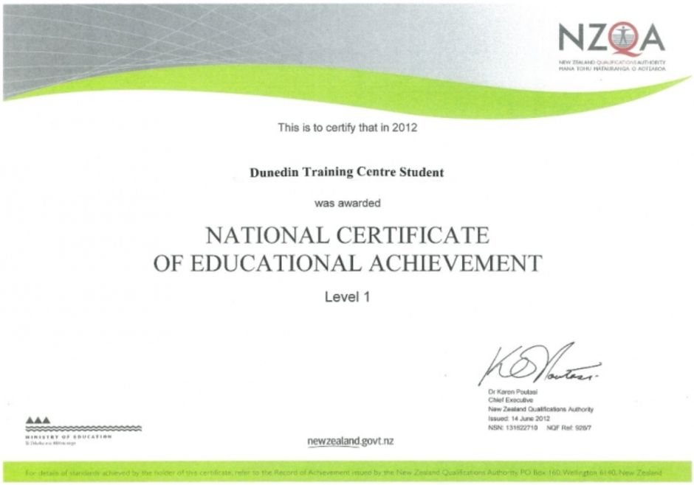
Certificates from NCEA Return To Contents
As the student progresses through their senior years at high school they will accumulate accreditation towards their NCEA certificate. Here is an example of what one certificate looks like.
To be awarded NCEA Level One a student will need to have a minimum of 80 credits (note credits from level two or three will count if needed). The Level One qualification will also need to have evidence that the student has minimal language and computation skills. As such the NCEA Level One qualification needs to have ten credits in ‘Numeracy’ and another ten credits in ‘Literacy’. Numeracy and Literacy are not necessarily gained in Mathematics and English.

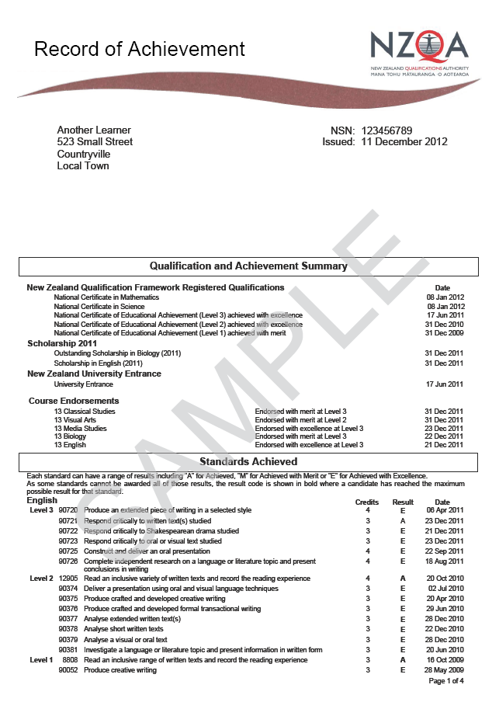
Record of Achievement
Additional every student will also be awarded a Record of Achievement. This is a transcript of all the passing results that have been accumulated over their studies. Here is an example of what a Record of Achievement looks like.
You can see that it begins with the overall qualifications (NCEA Levels One, Two and Three). There is acknowledgement of any overall endorsements. There is also course endorsement information.
Finally there is a list of all the passing standards and grades (and dates of passing) that the student has sat.
This Record of Achievement is a significant document and extends over many pages. Here is a link to see the full example for an example student who has gone through all three levels of NCEA.

Passing NCEA Return To Contents
It is important that students know what is expected for them to get through.
The statistics are that across all of New Zealand School the following pass rates exist for NCEA…
- 79% of all students in Year 11 will gain Level One in that year.
- 84% of all students in Year 12 will gain Level Two in that year.
- 76% of all students in Year 13 will gain Level Three in that year.
It is widely considered that the minimum school qualification any student needs is to have NCEA Level Two.
The key ingredients are…
- Good attendance (be in the right place at the right time).
- Good work attitude (be in class with the right gear and ready to learn).
- Good organisation (have assignments ready and in on time & prep up for any test/exams).
- Good timetable selection (picking subjects that are your strengths and engage you).
- Good balance in life (not too much sport/socialising/part time work).
- Good communication (seek help early it is available for you).

NCEA Endorsement Return To Contents
To encourage and reward students to gain Merit or Excellence grades NCEA has formal acknowledgement in its qualification for students to be endorsed. To gain an endorsement is a prestigious result. In order for a student to gain an overall endorsement at any level of NCEA they will need to have at least 50 credits.
That is if they were to have 50 or more ‘Excellence’ credits at level one they will pick up the qualification of “NCEA Level One achieved with Excellence”. If the student was to have say 50 or more ‘Excellence and Merit’ credits then they’ll be endorsed “NCEA Level One achieved with Merit”.
Approximate numbers of students gaining endorsement…
- At Level One between 27-35% of all students gain endorsement with Merit, and, between 7-15% of all students gain endorsement with Excellence. At decile three 11-21% Merit and 2-5% Excellence.
- At Level Two between 19-26% of all students gain endorsement with Merit, and, between 5-12% of all students gain endorsement with Excellence. At decile three 6-14% Merit and 1-4% Excellence. It is harder to gain endorsement at Level Two.
- At Level Three between 20-24% of all students gain endorsement with Merit, and, between 5-8% of all students gain endorsement with Excellence. At decile three 8-10% Merit and 1-3% Excellence.
The value of gaining an endorsement can be reflected financially by the automatic scholarship offered by Waikato University to all school leavers. They offer two scholarships call; “Waikato Academic Merit School Leavers Scholarship” valued at $3000 for those endorsed Level Three with Merit. And the “Vice Chancellors Academic Excellence School Leavers Scholarship” valued at $5000.

A subject endorsement can be gained in a calendar year in any specific subject. This is done by gaining 14 or more credits (including at least 3 credits externally) at Merit/Excellence.
Vocational Pathways Return To Contents
The Ministry of Education and NZQA have created a highly engaging and useable set of resources called Vocational Pathways. They can best be described as a planned method of getting the skills and experiences that will best get you into a future job.
Students that know what they want to be in life generally find subject selection an easier process – they pick subjects that are best suited to their pathway. If you are not sure of what career/job/vocation you would like a great place to start is the Careers website…
From here you can navigate through pretty much any job you can think of. It will tell you lots of information from job prospects, income streams, places to train, and subjects at school to pick (see the circle above).
We have used the Vocational Pathway Builder to create bar graphs for all of our courses. This will show you which of the vocational pathways the subjects move towards. You will see that some subjects are very specific to a particular pathway (say Horticulture is solely in the “Primary Industry” pathway).
Here are some greater details on the Vocational Pathways…
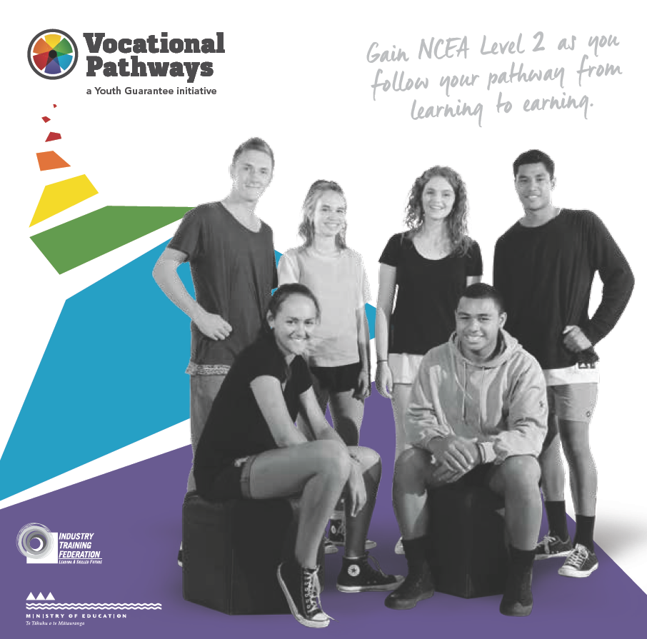
Gateway Return To Contents
The Gateway programme is a Government initiative introduced for senior school students. It is designed to strengthen the pathway for students from school to workplace learning. Gateway is not a work experience programme nor is it a programme for under achievers. It is designed to assist schools to make learning relevant to the needs of all students and to ensure that young people have a smooth transition from school to work.
Students have an opportunity to work in such industries as Building, Engineering, Farming, Childcare, Retail, Motor Engineering, Horticulture, Electrical, Hospitality, Plumbing, Catering and Hair Dressing.
Gateway students spend one day a week in the workplace, during which time they are assessed for credits on the National Qualifications Framework which count towards both industry and NCEA qualifications.
Some formal documentation can be found at ‘The Gateway Handbook’
There are tangible benefits from being in Gateway. Students are funded by the Ministry (there are no fees for students on Gateway). The Ministry will fund trade related materials. For example a student on Gateway as a builder will be funded for all trade unit standard (these save a future apprentice lots of money) there may be a possibily for funding for some equipment (say boots or builder aprons etc).
Practically a student on Gateway will commit to at least 80 hours (typically one day a week for ten week period). In these 80 hours they work with an ITO such as (BCITO or FITO) on theory Unit Standards as well as practical experience on the job. Gateway students are expected to gain 20 credits in their Pathway. The students will need to complete a signed contract with the school, employer and themselves and family.
2016 had students on Gateways with such employers or trades as; Early Childcare, Building, Retail, Farming, Panel Beating, Chef/Catering and Electrical.
If you are thinking that Gateway may be a good opportunity for you next year please see Mr Willoughby. Click here for his email brentw@waihicol.school.nz.

University Entrance Return To Contents
Students intending on further education at University need to ensure that they have ‘University Entrance’. Essentially this is a specified additional layer to the Level Three NCEA Qualification. The specifics are that students will need all of the following…
- NCEA Level 3 (the standard 80 credits)
- Three subjects - at Level 3, made up of: 14 credits each, in three approved subjects (*see the list below).
- Literacy - 10 credits at Level 2 or above, made up of: 5 credits in reading and 5 credits in writing
- Numeracy - 10 credits at Level 1 or above.
University Approved Subjects available at Level Three at Waihi College (you will need 14 credits from three)…

- L3 Accounting
- L3 Agriculture
- L3 Biology
- L3 Calculus
- L3 Catering
- L3 Chemistry
- L3 Drama
- L3 English
- L3 Geography
- L3 Graphics
- L3 Health
- L3 Horticulture
- L3 Media Design
- L3 Music
- L3 Art Photography
- L3 Art Painting
- L3 Physical Education
- L3 Physics
- L3 Maths with Statistics
- L3 Technology (Product)
- L3 Textiles

UE Literacy - Typically this means that students intending to go to University will need to have a successful year of Level Two English (or specifically target standards from other subjects). Here is a link to the specific standards offering Reading and Writing Literacy (click here). In reading through the courses students may notice that next to some standards UE Literacy has been indicated with - (UE Reading and Writing)
It is important that early on in the year that students intending to go to University check that they’ve eligble to gain this qualification.

Level One Advanced English Return To Contents
Purpose – English at Waihi College seeks to nurture the key skills you have, and develop then so that you can live and learning today and in the future. English is about thinking; using language, symbols and texts; participating and contributing; relating to others and managing self.
Pathway – This leads to Level Two Advanced English or Level Two English. It also provides access to Level Two History.
Recommended Entry – Positive results form Year 10 English (your teacher will indicate).
Course Outline – Pathway to Level Two English is designed for those students who will study English at higher NCEA levels for academic purposes. All standards offered here contribute credits for Level One Literacy.
Course Fees – There are no course fees.
Assessment Information – 21 Credits (8 External) The standards will be chosen from -
90052 : Produce creative writing, Level 1, 3 credits
90053 : Produce formal writing, Level 1, 3 credits
90850 : Show understanding of specified aspect(s) of studied visual or oral text(s), using supporting evidence, Level 1, 4 credits
90851 : Show understanding of significant aspects of unfamiliar written text(s) through close reading, using supporting evidence, Level 1, 4 credits
90854 : Form personal responses to independently read texts, supported by evidence, Level 1, 4 credits
90856 : Show understanding of visual and/or oral text(s) through close viewing and/or listening, using supporting evidence, Level 1, 3 credits

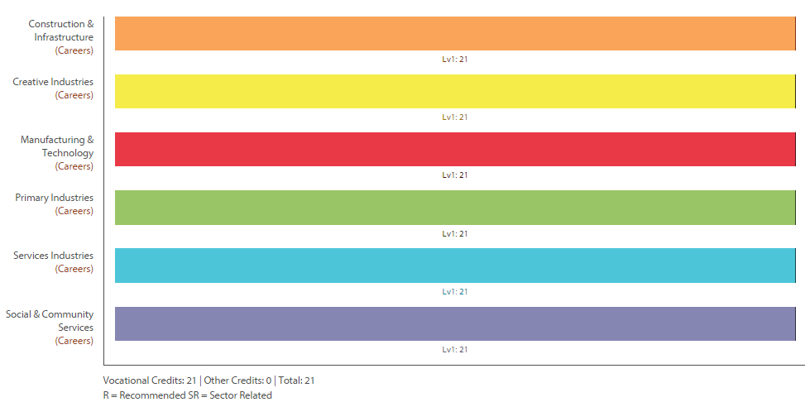

Level One English Return To Contents
Purpose – English at Waihi College seeks to nurture the key skills you have, and develop then so that you can live and learning today and in the future. English is about thinking; using language, symbols and texts; participating and contributing; relating to others and managing self.
Pathway – This course provides Level One Literacy and will be the last year of formal English curriculum. Students intending on taking further English will need to be in Level One Advanced English.
Recommended Entry – Year 10 teachers will recommend students for the appropriate class Level One Class.
Course Outline – Level one English is designed for those students who wish to develop their reading, writing and speaking skills. All standards offered here contribute credits for Level 1 Literacy.
Course Fees – There are no course fees
Assessment Information – 20 Credits (4 External). The standards include-
26622 : Write to communicate ideas for a purpose and audience, Level 1, 4 credits
26624 : Read texts with understanding, Level 1, 3 credits
90053 : Produce formal writing, Level 1, 3 credits
90851 : Show understanding of significant aspects of unfamiliar written text(s) through close reading, using supporting evidence, Level 1, 4 credits
90855 : Create a visual text, Level 1, 3 credits
90857 : Construct and deliver an oral text, Level 1, 3 credits

Level One Economics Return To Contents
Purpose – To develop knowledge and skills in Business and Economics.
Pathway – This course can lead to tertiary study and/or a career in business.
Recommended Entry – Satisfactory completion of Year 10 Mathematics.
Course Outline – Economics has been described as “The study of mankind in the ordinary business of life.” We investigate the unseen driving forces which push our society along, why businesses do what they do, and our role as individuals and consumers. What part does government play? An understanding of these things is a great help making sense of the world around us.
Course Fees – $20.
Assessment Information – 24 Credits (12 External) -
- 90983 : Demonstrate understanding of consumer choices, using scarcity and/or demand, Level 1, 4 credits
- 90984 : Demonstrate understanding of decisions a producer makes about production, Level 1, 5 credits
- 90985 : Demonstrate understanding of producer choices using supply, Level 1, 3 credits
- 90986 : Demonstrate understanding of how consumer, producer and/or government choices affect society, using market equilibrium, Level 1, 5 credits
- 90987 : Demonstrate understanding of a government choice where affected groups have different viewpoints, Level 1, 4 credits
- 90988 : Demonstrate understanding of the interdependence of sectors of the New Zealand economy, Level 1, 3 credits

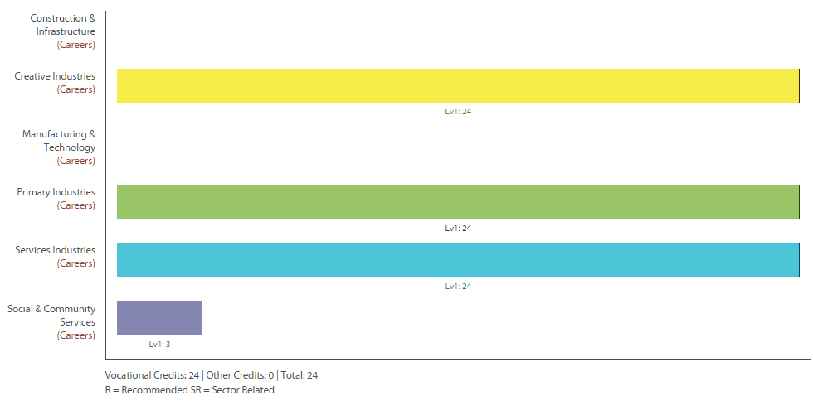
Level One Literacy Return To Contents
Purpose – To provide Waihi College students with basic reading writing and speaking skills for Level One Literacy.
Pathway – This course provides Level One Literacy and leads to Level Two English Skills class.
Recommended Entry – English (Advanced English, English or Literacy) is compulsory for all Year 11’s. Teachers will recommend students for the appropriate class.
Course Outline – This couse is for students who do not find English easy or naturally accessible. It includes standards needed for Level One Literacy, which is required to pass NCEA at Level One. As well, a number of other studies will be undertaken in reading, writing and the oral and visual areas, which could lead to internally assessed standards.
Course Fees – There are no course fees.
Assessment Information – 15 Credits (none External) -
1293 : Be interviewed in an informal one-to-one, face-to-face interview, Level 1, 2 credits
10792 : Write formal personal correspondence, Level 1, 3 credits
26622 : Write to communicate ideas for a purpose and audience, Level 1, 4 credits
26624 : Read texts with understanding, Level 1, 3 credits
26625 : Actively participate in spoken interactions, Level 1, 3 credits

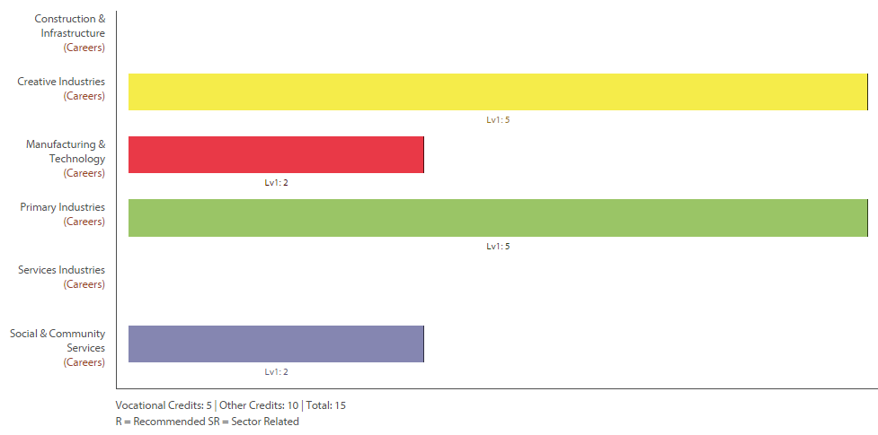

Level One Advanced Mathematics Return To Contents
Purpose – To develop knowledge and skills of Mathematical Techniques
Pathway – This course leads into Level Two Advanced Mathematics, Level Two Mathematics.
Recommended Entry – Very good to excellent grades in Year 10 Mathematics.
Course Outline – The Level One Advanced Mathematics course is a mixture of internal and external standards. It is designed for students who will be aiming for the higher grades of Merit and Excellence in their assessments. The internal will include; using numbers to argue an idea; using ratio and angles to measure distances; using the statistical inquiry cycle and manipulation of algebraic expressions. The external assessments will focus on Algebra and graphing.
Course Fees – Workbooks (approximately $15) and a calculator.
Assessment Information – 22 Credits (8 External) The standards will be chosen from -
91026 : Apply numeric reasoning in solving problems, Level 1, 4 credits
91027 : Apply algebraic procedures in solving problems, Level 1, 4 credits
91028 : Investigate relationships between tables, equations and graphs, Level 1, 4 credits
91029 : Apply linear algebra in solving problems, Level 1, 3 credits
91032 : Apply right-angled triangles in solving measurement problems, Level 1, 3 credits
91035 : Investigate a given multivariate data set using the statistical enquiry cycle, Level 1, 4 credits

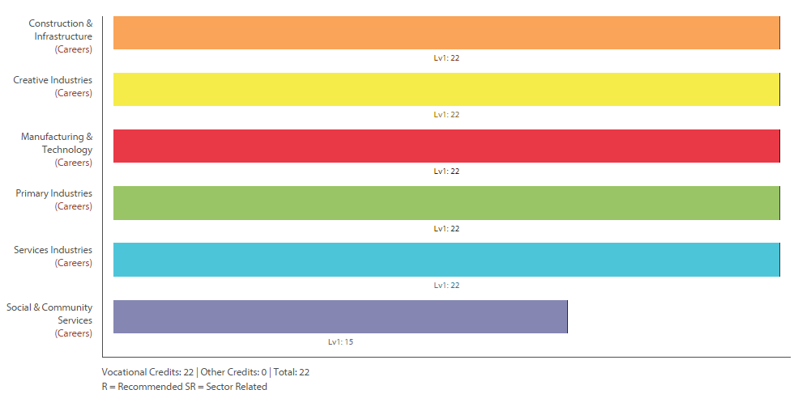

Level One Agriculture Science Return To Contents
Purpose – To use science in the field to solve real-life farming business problems, and to contribute towards achieving NCEA Level One.
Pathway – The following year, Level Two Agricultural Science, and any Level Two agriculture or horticulture course. This course is not necessarily for those who want to spend their time as farmers.
Recommended Entry – This course only works if you have the ability to be self-directed. Good communication skills needed. If you are a person who achieves more under closer supervision, we recommend the Agriculture Skills course, where you can get training in self-management.
Course Outline – You will form small groups to study different parts of large experiments, and large investigations. Then you will join as a class to present your findings. You will be in control of as much of the process as you want. The teachers are there to provide a beginning and an end, information, and guidance. There are 14 credits at Level Two (possible).
You will be answering the following questions:
• What conditions and feeding practices do new calves like best?
• What’s the best pasture for Waihi?
• How will we feed 10 - 15 billion people in 2050?
Course Fees – $50 towards materials and field trips, including careers events and NZ Fieldays.
Assessment Information – 25 compulsory credits, optional credits, all internal -
Compulsory Standards (All students)
23540 : Demonstrate knowledge of hazards, hazard control, and the consequences of injury workplace, L2, 5 credits
23541 : Locate hazards, describe safety procedures, and demonstrate safe practices in a rural workplace, L2, 5 crds
90918 : Carry out a practical agricultural or horticultural investigation, Level 1, 4 credits
90155 : Demonstrate knowledge of pasture/crop management practices, Level 1, 4 credits
90157 : Demonstrate practical skills used in agricultural or horticultural production, Level 1, 4 credits
90160 : Demonstrate knowledge of the environmental impact of primary production management practices, L1, 3 crds
Optional Standards (with negotiation with teacher)
19138 : Monitor and interpret weather information, Level 2, 4 credits
90921 : Demonstrate knowledge of livestock management practices, Level 1, 5 credits
90919 : Demonstrate knowledge of soil management practices, Level 1, 4 credits
90920 : Demonstrate knowledge of the geographic distribution of agricultural and horticultural primary production in New Zealand, Level 1, 3 credits
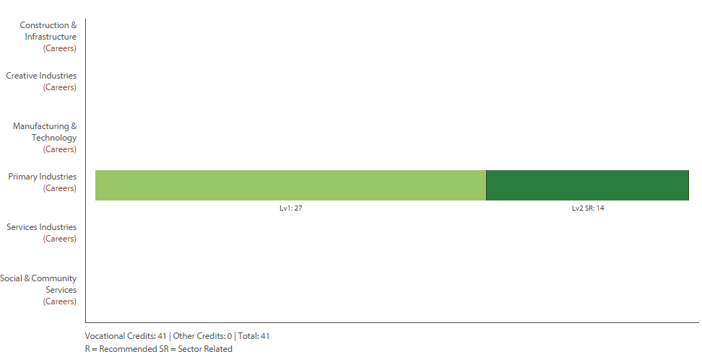

Level One Orchard Management Return To Contents
Purpose – To use science in the field to solve real-life orchard business problems, and to contribute towards achieving NCEA Level One.
Pathway – The following year, Level Two Orchard Management, and any Level Two agriculture or horticulture course. This course is not necessarily for those who want to spend their time as orchardists.
Recommended Entry – This course only works if you have the ability to be self-directed. It is also scientific and requires good communication skills. If you are a person who achieves more under closer supervision, we recommend the Agriculture Skills course, where you can get training in self-management.
Course Outline – Double Course – two lines on your timetable. Includes multiple chances to attain NCEA Level One literacy and numeracy. You will form small groups to study different parts of large experiments, and large investigations. Then you will join as a class to present your findings. You will be in control of as much of the process as you want. The teachers are there to provide a beginning and an end, information, and guidance. In addition, you will learn all the physical techniques of managing a kiwifruit orchard – which are similar to other fruit orchards.
Assessment Information – 42 credits -
12393 : Hand thin fruit to optimise crop loading, Level 2, 5 credits
21212 : Harvest a fruit crop under supervision, Level 2, 5 credits
21219 : Operate and maintain orchard hand pruning equipment and ladders or stools, Level 2, 5 credits
90155 : Demonstrate knowledge of pasture/crop management practices, Level 1, 4 credits
90157 : Demonstrate practical skills used in agricultural or horticultural production, Level 1, 4 credits
90160 : Demonstrate knowledge of the impact of primary production management practices, L1, 3crds
90918 : Carry out a practical agricultural or horticultural investigation, Level 1, 4 credits
90919 : Demonstrate knowledge of soil management practices, Level 1, 4 credits
90920 : Demonstrate knowledge of the geographic distribution of agricultural and horticultural primary production in New Zealand, Level 1, 3 credits
90924 : Demonstrate knowledge of horticultural plant management practices and related plant physiology, L1, 5 crds 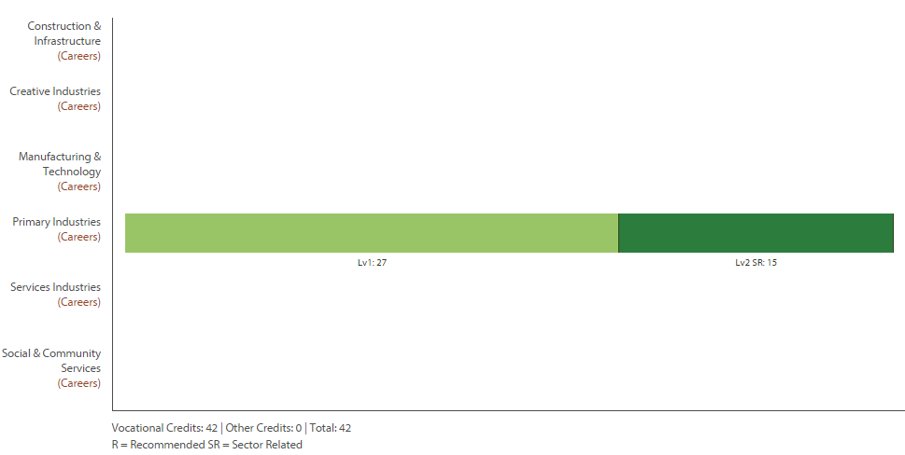
Level One & Two Agriculture Skills Return To Contents
Purpose – To learn work skills and safety for farm labouring, & to contribute towards achieving NCEA L1 & L2.
Pathway – Training at an agricultural school like Telford or Taratahi, or straight into farm work or L2 Horticulture.
Recommended Entry – Open – bring along a can do attitude.
Course Outline – Doing a Dairy Farm Gateway placement is a compulsory part of this course.
The bulk of the course is doing fencing practice and learning quad and tractor safety, most of the unit standards available are NCEA Level Two. We offer training and opportunities to improve your self-management skills, to enable you to take more control of your school time. We also offer help with literacy, and expect you to improve your literacy on the course. But your literacy level is not a barrier to achieving. We offer non-written assessments.
Course Fees – $50 towards materials and field trips, including careers events and NZ Fieldays.
Assessment Information – 41 compulsory credits, all internal (further credits available in Gateway) -
Compulsory Standards (All students)
19044 : Demonstrate knowledge of the legal requirements and hazards associated with tractor use, Level 2, 3 credits
23540 : Demonstrate knowledge of hazards, hazard control, and the consequences of injury rural workplace, L2, 5 crds
23541 : Locate hazards, describe safety procedures, and demonstrate safe work practices in rural workplace, L2, 5 crds
24557 : Demonstrate knowledge of the safe operation of a quad bike, Level 2, 3 credits
24822 : Install wooden battens for fencing, Level 2, 4 credits
24832 : Open and draw out a coil of wire, tie knots, join wire, and prepare wire for transport and storage, L2, 5crds
24833 : Identify and maintain fencing tools & equipment, & id fencing construction materials & wire types, L2, 3crds
24834 : Replace a broken post, and repair a broken wire in fences, Level 2, 5 credits
24836 : Describe non-electric fences, fence support materials, and safe practices in fencing, Level 2, 2 credits
27602 : Ride a quad bike on flat terrain in controlled conditions under close supervision, Level 1, 3 credits
27608 : Drive a basic wheel tractor on flat terrain under close supervision, Level 1, 3 credits
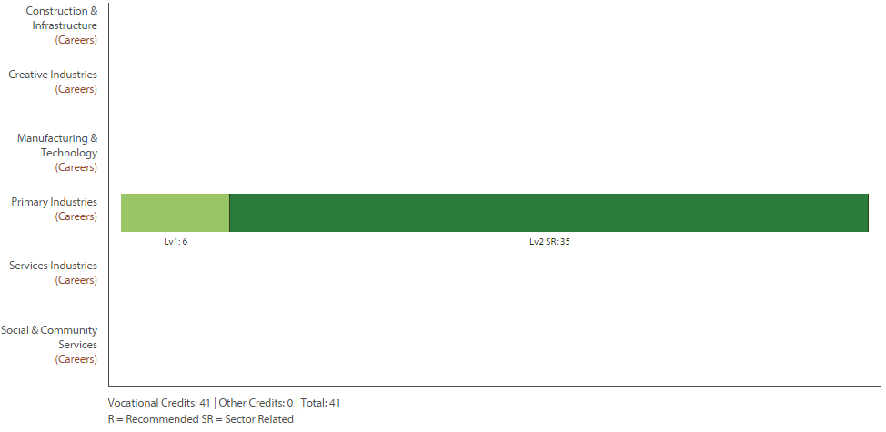
Level One Mathematics Return To Contents
Purpose – To develop knowledge and skills of Mathematical Techniques
Pathway – This course leads into Level Two Advanced Mathematics, or Level Two Mathematics .
Recommended Entry – Good to Very Good grades in Year 10 Mathematics.
Course Outline – The Level One Advanced Mathematics course is a mixture of internal and external standards. It is designed for students who have a good ability in Mathematics and will be aiming for the grades of Achieve and Merit in their assessments. The internal will include; using numbers to argue an idea; using ratio and angles to measure distances; using the statistical inquiry cycle and manipulation of algebraic expressions. The external assessment (which is run in September not November) will focus on Algebra.
Course Fees – Workbooks (approximately $15) and a calculator.
Assessment Information – 23 Credits (0 External) The standards will be chosen from -
91026 : Apply numeric reasoning in solving problems, Level 1, 4 credits
91029 : Apply linear algebra in solving problems, Level 1, 3 credits
91030 : Apply measurement in solving problems, Level 1, 3 credits
91032 : Apply right-angled triangles in solving measurement problems, Level 1, 3 credits
91035 : Investigate a given multivariate data set using the statistical enquiry cycle, Level 1, 4 credits
91036 : Investigate bivariate numerical data using the statistical enquiry cycle, Level 1, 3 credits
91038 : Investigate a situation involving elements of chance, Level 1, 3 credits
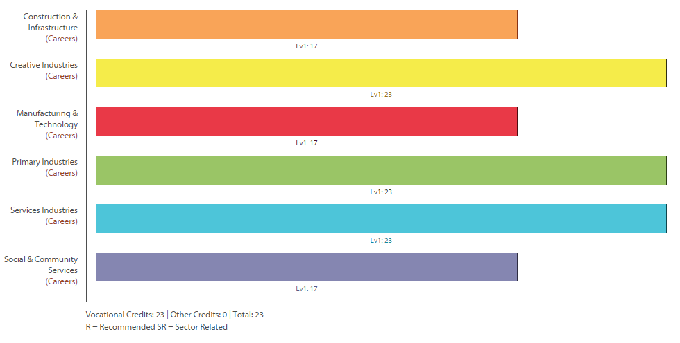

Level One Numeracy Return To Contents
Purpose – To develop knowledge and skills of Mathematical Techniques that can be applied in real life situations.
Pathway – This course doesn’t prepare students for any Level Two standards. Students in Level One Numeracy will be able to complete a full academic Level One course the following year.
Recommended Entry – Year 10 Mathematics.
Course Outline – This course is suited to students who sometimes find Mathematics difficult. It is a year-long course that covers a range of topics involving Number, Statistics and Measurement skills. To obtain the NCEA ‘Numeracy’ component of the qualification students will need to pass the complete package of the three Numeracy standards (10 credits in total). Some additional, internally assessed Achievement Standards may be taught with a possibility of gaining an extra eleven credits.
Course Fees – Workbooks (approximately $5) and a calculator which is absolutely essential.
Assessment Information – 21 Credits (none External) The standards will be chosen from -
26623 : Use number to solve problems, Level 1, 4 credits
26626 : Interpret statistical information for a purpose, Level 1, 3 credits
26627 : Use measurement to solve problems, Level 1, 3 credits
91026 : Apply numeric reasoning in solving problems, Level 1, 4 credits
91035 : Investigate a given multivariate data set using the statistical enquiry cycle, Level 1, 4 credits
91036 : Investigate bivariate numerical data using the statistical enquiry cycle, Level 1, 3 credits
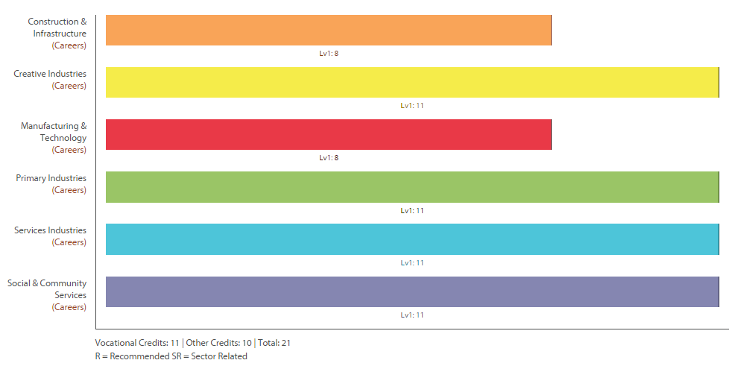
Level One Horticulture Return To Contents
Purpose – To develop Waihi College students knowledge and skills in Horticulture.
Pathway – This course leads towards Level Two Horticulture.
Recommended Entry – Nil – but students must be prepared to get their hands dirty.
Course Outline – Horticulture involves learning how to grow plants, how plants function, how to get nutrients from the soil and ways to grow better plants. There are three parts to this course…
- Practical – hands on gardening in small gardens in the farm unit.
- Gardening around the school grounds.
- Theory and classwork.
Course Fees – There are no course fees.
Assessment Information – 19 Credits (9 External). One standard is a level two paper -
- US1: Prepare and sow outdoor seedbeds manually, (Internal 5 credits), Production Horticulture
- Level Two AS21027: Plant and care for bedding plants, bulbs or herbaceous perennials, (Internal 10 credits), Horticulture
- 23783: Grow and maintain plants in containers from seed, (Internal 5 credits), Production Horticulture
- 90919: Demonstrate knowledge of soil management practices, (External 4 credits), Agricultural and Horticultural Science 1.3
- 90924: Demonstrate knowledge of horticultural plant management practices and related plant physiology, (External 5 credits), Agricultural and Horticultural Science 1.10
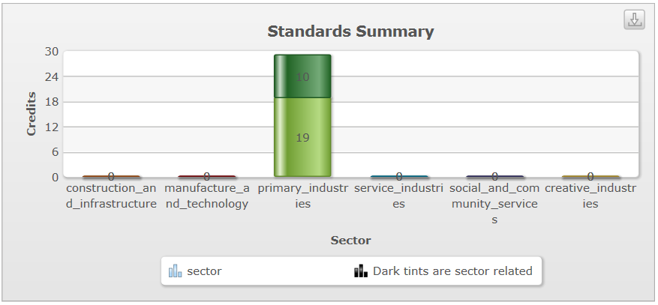

Level One Science Return To Contents
Purpose – To gain a solid grounding in the Sciences, and to start to more fully understand how scientific knowledge and understanding is vital in solving the major challenges facing humankind – disease treatment and prevention, climate change, the need for clean energy and the need for clean water
Pathway – This course leads towards Level Two Biology (through passing both 90949 & 90950), Level Two Chemistry (through passing external 90944), Level Two Physics (through 90940).
Recommended Entry – Nil – but students must be prepared to get their hands dirty.
Course Outline – This course aims to provide a good grounding in the basics of Science, with a term each spent on Physics, Chemistry and Biology. We aim to complete the work for one external and one internal each term. A practical investigation linked to graph plotting skills (that provides four numeracy credits) will be carried out during the same term as study for Physics (motion, forces, energy and power). A research assignment on carbon cycling (relevant to climate change) will accompany the study of Chemistry (atoms and ions, acids and bases). A further research assignment on microorganisms that cause disease will be carried in addition to the study of Genetics.
Course Fees – There are no course fees.
Assessment Information – 24 Credits (12 External) -
- 90935 : Carry out a practical physics investigation that leads to a linear mathematical relationship, with direction, Level 1, 4 credits
- 90940 : Demonstrate understanding of aspects of mechanics, Level 1, 4 credits
- 90944 : Demonstrate understanding of aspects of acids and bases, Level 1, 4 credits
- 90948 : Demonstrate understanding of biological ideas relating to genetic variation, Level 1, 4 credits
- 90950 : Investigate biological ideas relating to interactions between humans and micro-organisms, Level 1, 4 credits
- 90953 : Demonstrate understanding of carbon cycling, Level 1, 4 credits
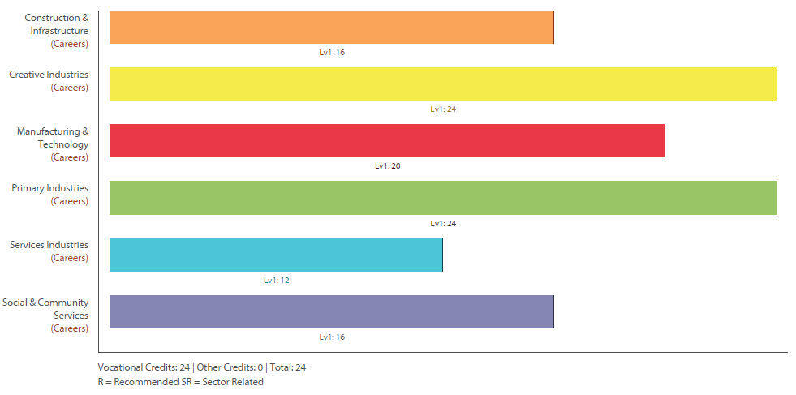
Level One Geography Return To Contents
Purpose – Purpose – Geography gives students a multidisciplinary or holistic view of the world, combining knowledge, skills, and understandings of the physical and social sciences. It fosters a curiosity about place and space, and provokes questions about natural and cultural environments and their interconnectedness. Geography provides opportunities through fieldwork for first-hand investigations of places, environments, and human activities. It helps students make sense of complex issues such as climate change, ageing populations, urban growth, land conflicts, globalisation, and sustainability.
Pathway – This course can lead to Level Two Geography.
Recommended Entry – Satisfactory completion of Year 10 Social Studies.
Course Outline – This course consists of both Natural and Human Geography. The course looks at natural events (volcanic eruptions etc.), sustainability (tourism), global issues (electronic waste, access to safe water etc.) and local geographic topics (shopping, mining). Skills to do with using maps and a variety of other information sources are followed up and these are applied in research work. This course is designed for students who are interested in the world around them and how people interact with the environment.
Course Fees – Fees for a one day field trip to Rotorua (approximately $50).
Assessment Information – 21 Credits (8 External) -
91007 : Demonstrate geographic understanding of envrnmts that shaped by extreme natural event(s), L1, 4 crds
91009 : Demonstrate geographic understanding of the sustainable use of an environment, Level 1, 3 credits
91010 : Apply concepts and basic geographic skills to demonstrate understanding of environment, L1, 4 crd
91011 : Conduct geographic research, with direction, Level 1, 4 credits
91012 : Describe aspects of a contemporary New Zealand geographic issue, Level 1, 3 credits
91013 : Describe aspects of a geographic topic at a global scale, Level 1, 3 credits

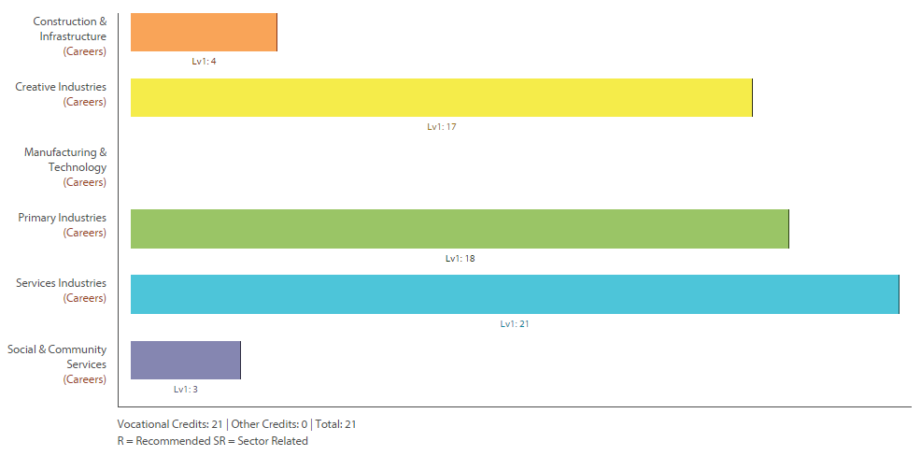
Level One History Return To Contents
Purpose – To develop knowledge and skills in History.
Pathway – This course can lead to Level Two History.
Recommended Entry – Satisfactory completion of Year 10 Social Studies. This course has no prerequisites although good literacy skills and an interest in current affairs are helpful.
Course Outline – These courses topics are selected from: the origins of World War Two; New Zealand and the World; Ireland; Black Civil Rights; and Stalin. The internally assessed topics focus on research and perspectives. The externally assessed topics involve interpretation, New Zealand identity and essay writing. Skills from History are applicable in many other fields where organisation and essay skills are required.
Course Fees – There are no course fees.
Assessment Information – 24 Credits (12 External) -
- 91001: Carry out an investigation of an historical event, or place, of significance to New Zealanders, (Internal 4 credits), History 1.1
- 91002: Demonstrate understanding of an historical event, or place, of significance to New Zealanders, (Internal 4 credits), History 1.2
- 91003: Interpret sources of an historical event of significance to New Zealanders, (External 4 credits), History 1.3
- 91004: Demonstrate understanding of different perspectives of people in an historical event of significance to New Zealanders, (Internal 4 credits), History 1.4
- 91005: Describe the causes and consequences of an historical event, (External 4 credits), History 1.5
- 91006: Describe how a significant historical event affected New Zealand society, (External 4 credits), History 1.6

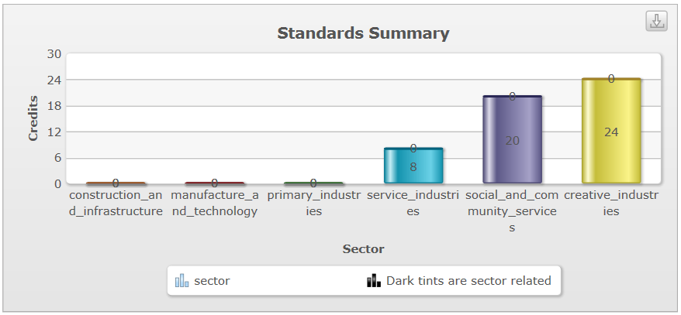

Level One Accounting Return To Contents
Purpose – To develop knowledge and skills in Accounting.
Pathway – This course can lead to Level Two Accounting.
Recommended Entry – Satisfactory completion of Year 10 Mathematics.
Course Outline – This is a very practical subject aimed at anyone who intends being involved with running their own (or someone else’s) business. It teaches the basic processes of bookkeeping and how to compile and interpret financial statements. Students will be exposed to many different business concepts. It can be taken as a stand-alone course or used as a stepping stone towards tertiary study in commerce/business.
Course Fees – $10 Course Materials.
Assessment Information – 18 Credits (9 External) -
90977 : Process financial transactions for a small entity, Level 1, 5 credits
90978 : Prepare financial statements for sole proprietors, Level 1, 5 credits
90979 : Prepare financial information for a community organisation's annual general meeting, Level 1, 4 credits
90980 : Interpret accounting information for sole proprietors, Level 1, 4 credits
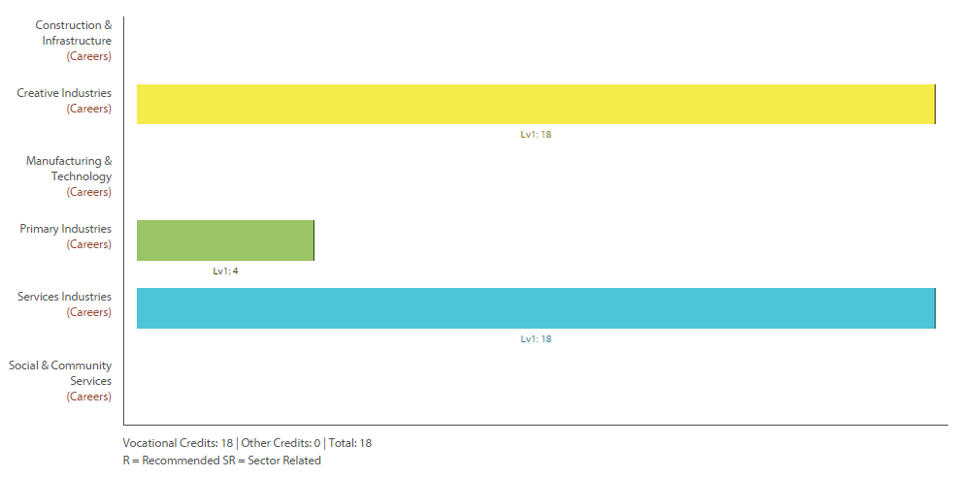

Level One Physical Education Return To Contents
Purpose – To develop knowledge and skills in Physical Education.
Pathway – This course can lead to Level Two Physical Education and/or Level Two Sports Education.
Recommended Entry – Good participation and a keen interest in Year 10 Physical Education.
Course Outline – This course allows students to look at what affects their participation in activities as well as introducing them to anatomy and biomechanics. Some students will have the opportunity to participate in a ski trip to Mount Ruapehu to look at responsible behaviours and skill learning. This class is based on theory as well as practical.
Course Fees – A total of $400 for workbook and ski trip.
Assessment Information – 19 Credits (0 External Even though there are no externals this course is one of a few internally only assessed courses that can still pick up a course endorsement) -
90962 : Participate actively in a variety of physical activities and explain factors that influence own participation, Level 1, 5 credits
90963 : Demonstrate understanding of the function of the body as it relates to the performance of physical activity, Level 1, 5 credits
90964 : Demonstrate quality movement in the performance of a physical activity, Level 1, 3 credits
90968 : Demonstrate, and show understanding of, responsible behaviour for safety during outdoor education activities, Level 1, 3 credits
90970 : Demonstrate self management strategies and describe the effects on participation in physical activity, Level 1, 3 credits
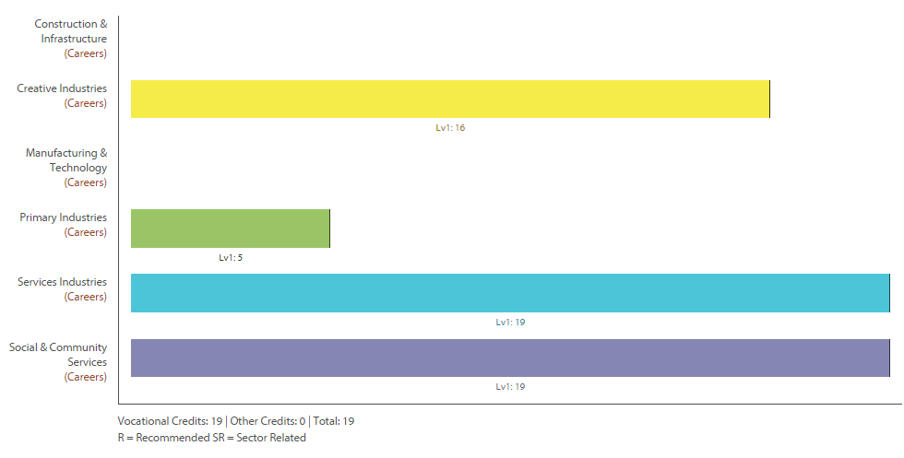

Level One Health Education Return To Contents
Purpose – To develop knowledge and skills in Health Education.
Pathway – This course can lead to Level Two Health Education.
Recommended Entry – Participation in Year 10 Health Education.
Course Outline – This course offers the opportunity to experience and participate in a wide range of activities, in a variety of contexts including; Sex Education, Hauora, Interpersonal Skills, Drug and Nutrition. The main focus of this course is to equip the students with the foundation knowledge of health if you wish to pursue this area in the future as well as improving a variety of interpersonal skills.
Course Fees – There are no course fees.
Assessment Information – 19 Credits (8 External) -
90971 : Take action to enhance an aspect of personal well-being, Level 1, 3 credits
90972 : Demonstrate understanding of influences on adolescent eating patterns to make health-enhancing recommendations, Level 1, 4 credits
90974 : Demonstrate understanding of strategies for promoting positive sexuality, Level 1, 4 credits
90975 : Demonstrate understanding of issues to make health-enhancing decisions in drug-related situations, Level 1, 4 credits
91097 : Demonstrate understanding of ways in which well-being can change and strategies to support well-being, Level 1, 4 credits

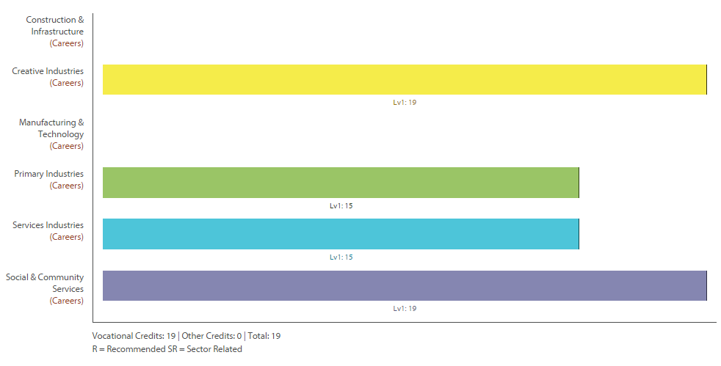
Level One Sports Education Return To Contents
Purpose – To develop knowledge and skills in Sports Education.
Pathway – This course can lead to Level Two Sports Education or Level Two Physical Education.
Recommended Entry – Good participation and a keen interest in Year 10 Physical Education.
Course Outline – Through maximum participation in a wide variety of sports students will develop skills, co-ordination and fitness thereby increasing their self-confidence and self-discipline. They will learn to work as a team and develop leadership skills while being inclusive and socially responsible. Sports covered are ultimate, swimming, athletics, turbo touch, badminton, basketball, table tennis, tennis and fitness studies.
Course Fees – There are no course fees.
Assessment Information – 19 Credits (0 External Even though there are no externals this course is one of a few internally only assessed courses that can still pick up a course endorsement) -
90962 : Participate actively in a variety of physical activities and explain factors that influence own participation, Level 1, 5 credits
90964 : Demonstrate quality movement in the performance of a physical activity, Level 1, 3 credits
90965 : Demonstrate understanding of societal influences on physical activity and the implications for self and others, Level 1, 4 credits
90966 : Demonstrate interpersonal skills in a group and explain how these skills impact on others, Level 1, 4 credits
90968 : Demonstrate, and show understanding of, responsible behaviour for safety during outdoor education activities, Level 1, 3 credits

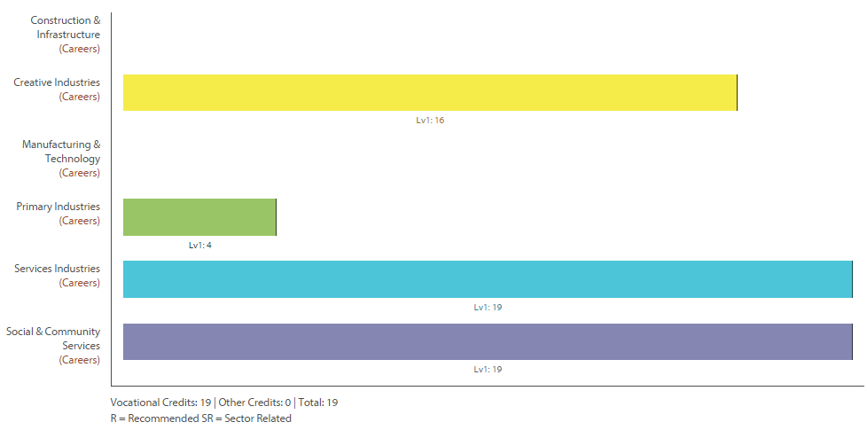

Level One Outdoor Education Return To Contents
Purpose – To develop knowledge and skills in Outdoor Education.
Pathway – This course can lead to Level Two Physical Education, Level Two Sports Education or Level Two Outdoor Education.
Recommended Entry – Good participation and a keen interest in Year 10 Physical Education.
Course Outline – This is a practical and theory based course using both achievement standards and unit standards, aimed to develop your knowledge and skills in the great outdoors through activities and outings in our local environment. You will learn self-management skills and how to prepare yourself for a range of outdoor activities including surfing, kayaking, mountain biking, tramping and camping. As Waihi College has our own fleet of bikes and kayaks there will be plenty of opportunity to develop your knowledge and skills in these disciplines. While the course focuses on experience and the development of personal skills and teamwork in the outdoors, students will also learn about aspects of leadership and risk management.
Course Fees – $365.
Assessment Information – 21 Credits (0 External no endorsement in this option class.) -
425 : Experience day tramps, Level 2, 3 credits 426 : Experience camping, Level 2, 3 credits
470 : Demonstrate personal and social development through participation in a low ropes course programme, Level 2, 3 credits 6400, 6401,6402 Basic First Aid 5 Credits
20137 : Mountain bike on easy to intermediate terrain, Level 1, 1 credits
20138 : Select, set up and maintain a mountain or cycle touring bike, Level 2, 3 credits
90964 : Demonstrate quality movement in the performance of a physical activity, Level 1, 3 credits
90966 : Demonstrate interpersonal skills in a group and explain how these skills impact on others, Level 1, 4 credits
90967 : Demonstrate strategies to improve the performance of a physical activity and describe the outcomes, Level 1, 3 credits
90970 : Demonstrate self management strategies and describe the effects on participation in physical activity, Level 1, 3 credits
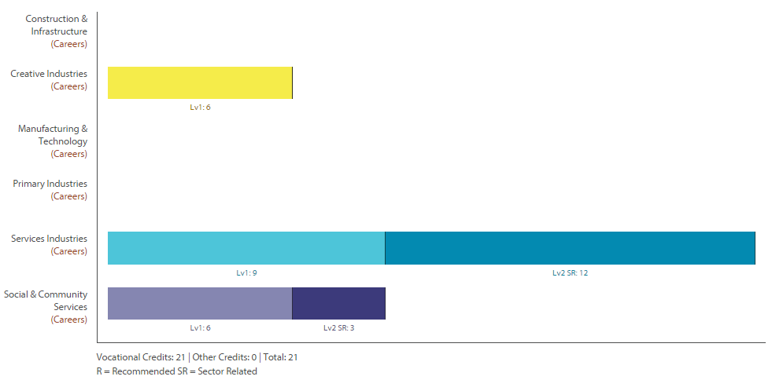
Level One Art Photography Return To Contents
Purpose – To develop knowledge and skills in a range of visual arts.
Pathway – This course can lead to Level Two Art Painting or Level Two Art Photography.
Recommended Entry – Year 10 Art.
Course Outline – This course challenges the student to develop art works and express ideas in a range of art making media through the study of a number of artists’ works. The primary drawing method is photography, and photographs are reinterpreted in other media and styles. The student develop basic darkroom and digital photography skills, use some Photoshop processes, learn printmaking processes, extend their tonal painting skills and learn to communicate ideas through their art works.
Course Fees – $20 for materials and equipment. Students will also need printing credit.
Assessment Information – 26 Credits (12 Credits are externally assessed as a portfolio of work not an examination) -
- 90913 : Demonstrate understanding of art works from Maori and other cultural contexts using art terminology, Level 1, 4 credits
- 90914 : Use drawing methods and skills for recording information using wet and dry media, Level 1, 4 credits
- 90915 : Use drawing conventions, Level 1, 6 credits
- 90916 : Produce a body of work informed by established practice, which develops ideas, using a range of media, Level 1, 12 credits

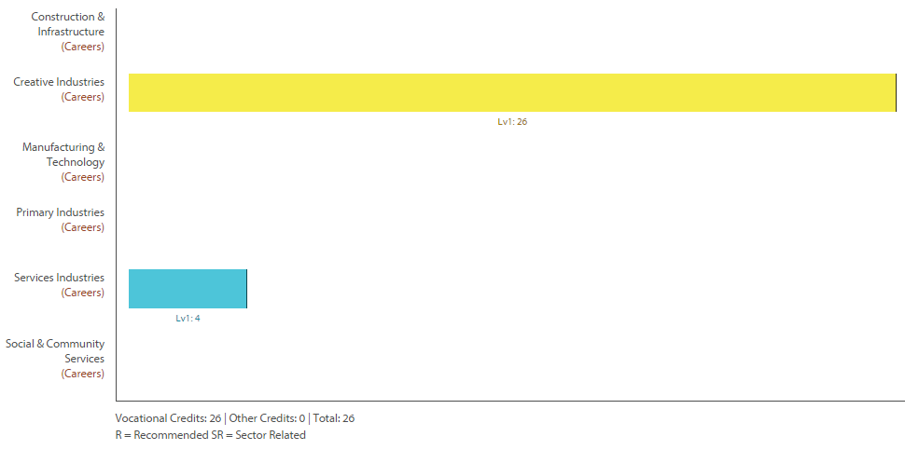

Level One Art Painting Return To Contents
Purpose – To develop knowledge and skills in a range of visual arts.
Pathway – This course can lead to Level Two Art Painting or Level Two Art Photography.
Recommended Entry – Year 10 Art.
Course Outline – This course challenges the student to develop art works and express ideas in a range of art making media through the study of a number of artists’ works. Students extend their existing drawing and painting skills and learn printmaking processes. These skills are then applied in mixed media artworks which communicate ideas.
Course Fees – $40 for materials and equipment.
Assessment Information – 26 Credits (12 Credits are externally assessed as a portfolio of work not an examination) -
- 90913 : Demonstrate understanding of art works from Maori and other cultural contexts using art terminology, Level 1, 4 credits
- 90914 : Use drawing methods and skills for recording information using wet and dry media, Level 1, 4 credits
- 90915 : Use drawing conventions, Level 1, 6 credits
- 90916 : Produce a body of work informed by established practice, which develops ideas, using a range of media, Level 1, 12 credits

Level One Drama Return To Contents
Purpose – To develop knowledge and skills in Drama. To establish academic and professional pathways.
Pathway – This course can lead to Level Two Drama.
Recommended Entry – Year 10 Drama is recommended. Important to have an established interest in drama, production and/or live performance.
Course Outline – The Level One Drama programme offers some unique opportunities for students to engage with the skills and technologies of dramatic play, and students will attend professional theatrical productions as part of their coursework. All credits offered count towards literacy requirements and the course begins an academic pathway which is suitable for any students anticipating tertiary study. The programme also seeks to offer first hand experiences of Drama related professions and enables students to form professional relationships with potential employers.
Course Fees – $20 materials and $48 Field Trip (Red Leap).
Assessment Information – 18 Credits of which 4 are externally assessed (note all standards offered in Level One Drama contribute to the Literacy component of NCEA level one). Additional performing arts technology units in areas such as lighting, construction and set design can be made available for students who signal their interest.
90009 : Perform an acting role in a scripted production, Level 1, 5 credits
90011 : Demonstrate understanding of the use of drama aspects within live performance, Level 1, 4 credits
90997 : Devise and perform a drama, Level 1, 5 credits
90999 : Select and use features of a drama/theatre form in a performance, Level 1, 4 credits

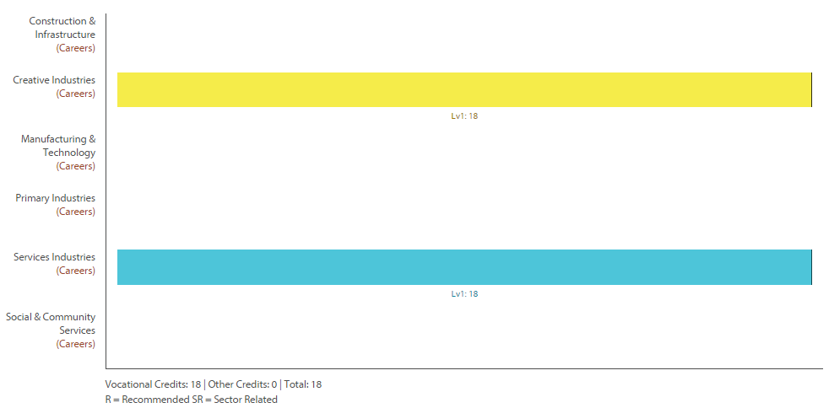

Level One Music Return To Contents
Purpose – To develop knowledge and skills in Music.
Pathway – This course can lead to Level Two Music.
Recommended Entry – Three years instrumental experience or a strength in singing.
Course Outline – The three main thrusts of the Level One Music course are performance, composition using computers technology, and musical analysis, all at a basic level. Students will have the opportunity to perform as soloists and in groups to gain credits, and to write and perform their own material. Music theory for beginners will be part of the course. This is not the course for students who wish to learn an instrument at the beginner level (see Mr Paton directly about arranging this). Also offered is a performing arts technology unit standard, sound system technology for performers.
Course Fees – $20.
Assessment Information – 30 Credits (8 External) -
26687 : Demonstrate and apply knowledge of sound technology for a performance context, Level 1, 4 credits
91090 : Perform two pieces of music as a featured soloist, Level 1, 6 credits
91091 : Demonstrate ensemble skills through performing a piece of music as a member of a group, Level 1, 4 credits
91092 : Compose two original pieces of music, Level 1, 6 credits
91094 : Demonstrate knowledge of conventions used in music scores, Level 1, 4 credits
91095 : Demonstrate knowledge of two music works from contrasting contexts, Level 1, 6 credits

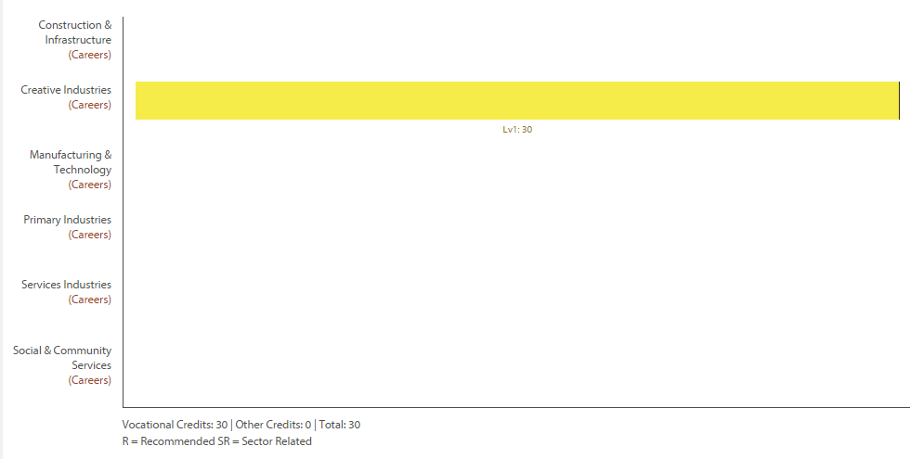

Level One Graphics (DVC) Return To Contents
Purpose – Graphics (aka Design and Visual Communication) develop knowledge and skills in designing Architecture and Products.
Pathway – This course can lead to Level Two Graphics and/or Level Two Building.
Recommended Entry – An interest in design.
Course Outline – This course challenges students to think about the fundamentals of design and how this is used in developing Products and Architecture. Briefs or units of work are used to solve Architecture and Product Design problems. Students will learn to use sketching techniques, produce formal drawings using instruments; computer presentation and computer based drawing programmes.
Course Fees – The purchase of their own equipment and stationery.
Assessment Information – 21 Credits (9 External these are assessed as a portfolio/evidence of work there will be no exam) -
91063 : Produce freehand sketches that communicate design ideas, Level 1, 3 credits
91064 : Produce instrumental, multi-view orthographic drawings that communicate technical features of design ideas, Level 1, 3 credits
91065 : Produce instrumental paraline drawings to communicate design ideas, Level 1, 3 credits
91066 : Use rendering techniques to communicate the form of design ideas, Level 1, 3 credits
91067 : Use the work of an influential designer to inform design ideas, Level 1, 3 credits
91068 : Undertake development of design ideas through graphics practice, Level 1, 6 credits

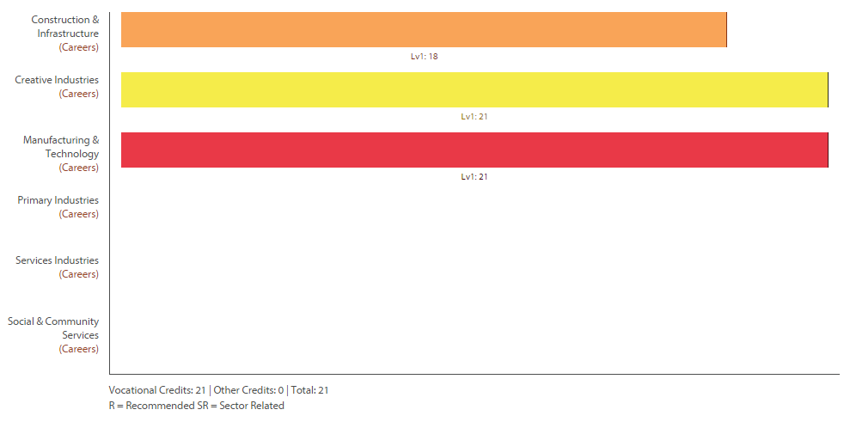

Level One Building and Construction Return To Contents
NOT OFFERED IN 2016

Purpose – To develop knowledge and skills in building and furniture making.
Pathway – This course can lead to Level Two Building.
Recommended Entry – An interest in making things.
Course Outline – This course is an industry based course for students wishing to follow a pathway into tertiary/trades related careers. Students will be introduced to power tools and machine tools. Completed projects along with workbook materials are submitted. Examples of work include design and construction of coffee tables, outdoor furniture and cupboards.
Course Fees – $55 for materials that are used in the projects. N.b. at the end of the course the finished products are the students to keep.
Assessment Information – 9 Level One Credits and 10 Level Two Credits (0 External all of the standards are unit standards and therefore only have maximum ‘Achieved’ level grades) -
2199 : Use and maintain hand tools for furniture making, Level 2, 4 credits
24355 : Demonstrate knowledge of construction and manufacturing materials used in BCATS projects, Level 1, 4 credits
25919 : Use hardware and fastenings for a BCATS project, Level 1, 2 credits
25920 : Use joints for a BCATS project, Level 1, 3 credits
25921 : Make a cupboard as a BCATS project, Level 2, 6 credits

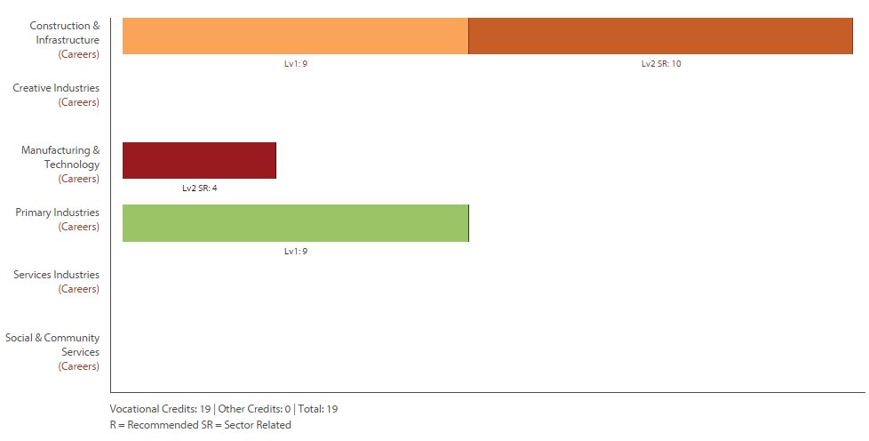

Level 1 & 2 Computer Programming Return To Contents
Purpose – To develop knowledge and skills in the programming language of computers. .
Pathway – This course can lead to opportunities to study extramurally National Certificate in Computing (Level Two & Level Three).
Recommended Entry – An interest and aptitude with computers, programming and software.
Course Outline – If you are interested in entering the world of the computer then this subject could. We will be working through the design process, creating games, programming APPS and scripts. If this makes sense then Level 1 Computer Programming may be for you. If you demonstrate strong capabilities in this subject then Level 2 Credits will be available in place of the level 1 standards.
Course Fees – There are no course costs.
Assessment Information – 21 Credits (4 External)
91075 : Construct a plan for a basic computer program for a specified task, Level 1, 3 credits
91076 : Construct a basic computer program for a specified task, Level 1, 3 credits
91077 : Demonstrate understanding of basic concepts used in the design and construction of electronic environments, Level 1, 3 credits
91078 : Implement basic interfacing procedures in a specified electronic environment, Level 1, 3 credits
91079 : Implement basic techniques in constructing a specified electronic and embedded system, Level 1, 3 credits
91080 : Demonstrate understanding of the common components of basic digital infrastructures, Level 1, 3 credits
91081 : Implement basic procedures for servicing a personal computer system, Level 1, 4 credits

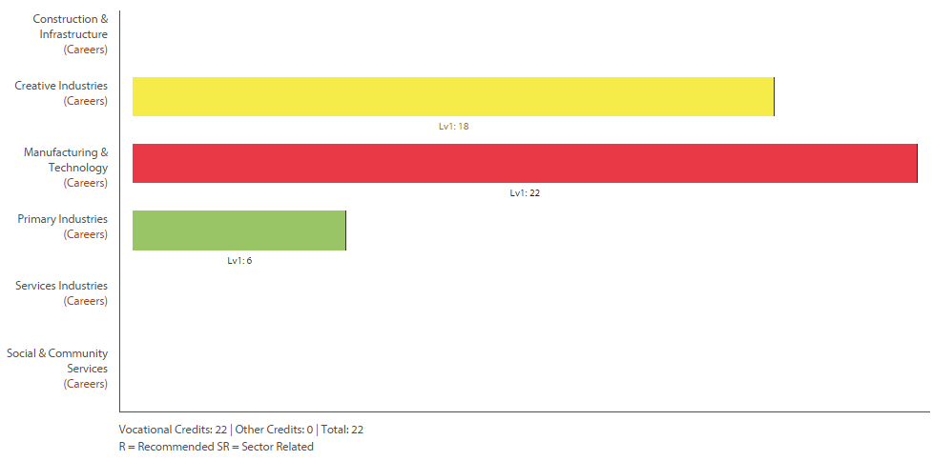

Level Two Standards are available for students successfully achieving Level One. Negotiated with teacher.

Level One Home Economics Return To Contents
Purpose – To develop knowledge and skills in food safety and nutrition.
Pathway – This course can lead to Level Two Catering.
Recommended Entry – An interest in food and food preparation.
Course Outline – Home Economics develops the students’ knowledge and understanding of food and nutrition with an emphasis on food for teenagers. Students will complete three achievement standards and one hospitality standard. They will also complete one external standard.
Course Fees – $50 for materials that are used in creating the meals.
Assessment Information – 21 Credits (4 External)
- 15921 : Prepare and cook a cake, a sponge and a batch of scones in the hospitality industry, Level 1, 3 credits
- 90956 : Demonstrate knowledge of an individual's nutritional needs, Level 1, 5 credits
- 90959 : Demonstrate knowledge of practices and strategies to address food handling issues, Level 1, 5 credits
- 90961 : Demonstrate understanding of how packaging information influences an individual's food choices and well-being, Level 1, 4 credits
- 91082 : Implement basic procedures to process a specified product, Level 1, 4 credits

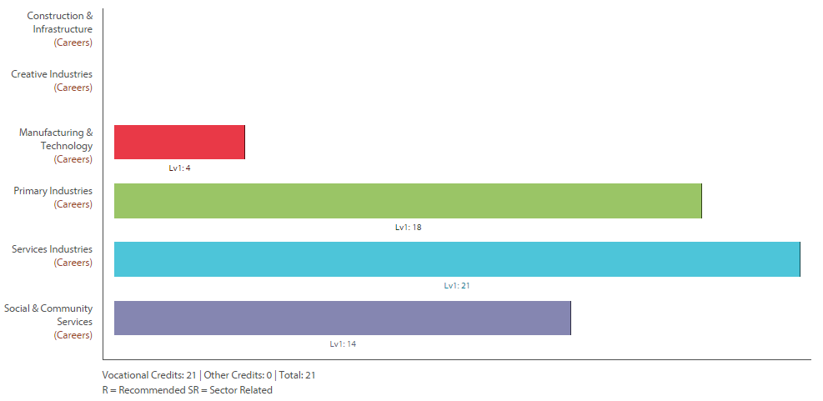
Level One Textiles Return To Contents
Purpose – To establish skills and understanding of technological practise with soft materials.
Pathway – This course can lead to Level Two Textiles.
Recommended Entry – A willingness to work with your hands and a keen interest in fabric and design.
Course Outline – This course starts off with basic understanding of patterns and the use of machines. Students will look at how designs are inspired, the use of design language and understanding of key aspects of design. Students will learn how to create some basic modified patterns.
Course Fees – $45 to cover the materials used in class, but students will need to provide additional materials for their assignment work as well.
Assessment Information – 17 Credits (4 External these are assessed as a portfolio/evidence of work there will be no exam)
91044 : Undertake brief development to address a need or opportunity, Level 1, 4 credits
91048 : Demonstrate understanding of how technological modelling supports decision-making, Level 1, 4 credits
91058 : Implement basic procedures using textile materials to make a specified product, Level 1, 6 credits
91096 : Make basic adaptations to a pattern to enable a design to fit a person or item, Level 1, 4 credits

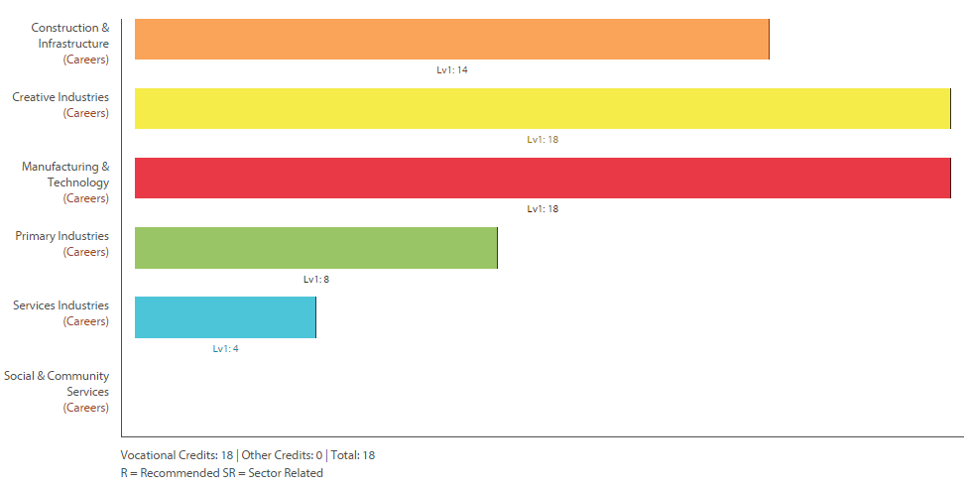

Level One Media Design Return To Contents
Purpose – To develop knowledge and skills with design programmes while learning the principles and elements of design.
Pathway – This course can lead to Level Two Media Design.
Recommended Entry – Year 10 ICT.
Course Outline – This course challenges the student to think about how we use Visual Design in our lives to communicate ideas. The students will have a chance to learn Dreamweaver, Photoshop and Microsoft products.
Course Fees – Usual fees and print credit.
Assessment Information – 20 Credits (3 External)
91047 : Undertake development to make a prototype to address a brief, Level 1, 6 credits
91053 : Demonstrate understanding of design elements, Level 1, 3 credits
91071 : Implement basic procedures to produce a specified digital info outcome, Level 1, 4 credits
91072 : Demonstrate understanding of basic concepts of digital media, Level 1, 3 credits
91073 : Implement basic procedures to produce a specified digital media outcome, Level 1, 4 credits

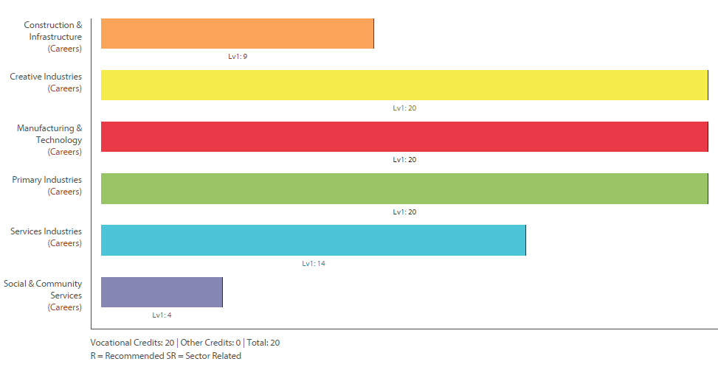

Level One Product Design Return To Contents
Purpose – This course is about students using creative ways to solve design based problems. They will learn a variety of techniques and theories to design and manufacture products as solutions to real world problems.
Pathway – This course can lead to Level Two Product Design and/or Level Two Building and/or Level Two Tools For Work.
Recommended Entry – A keen attitude and a willingness to create and design.
Course Outline – This course requires students to manufacture a specified product and develop that product to meet the needs of the intended user.
Course Fees – $55.
Assessment Information – 20 Credits (4 External these are assessed as a portfolio/evidence of work there will be no exam)
91044 : Undertake brief development to address a need or opportunity, Level 1, 4 credits
91047 : Undertake development to make a prototype to address a brief, Level 1, 6 credits
91049 : Demonstrate understanding of how materials enable technological products to function, Level 1, 4 credits
91057 : Implement basic procedures using resistant materials to make a specified product, Level 1, 6 credits

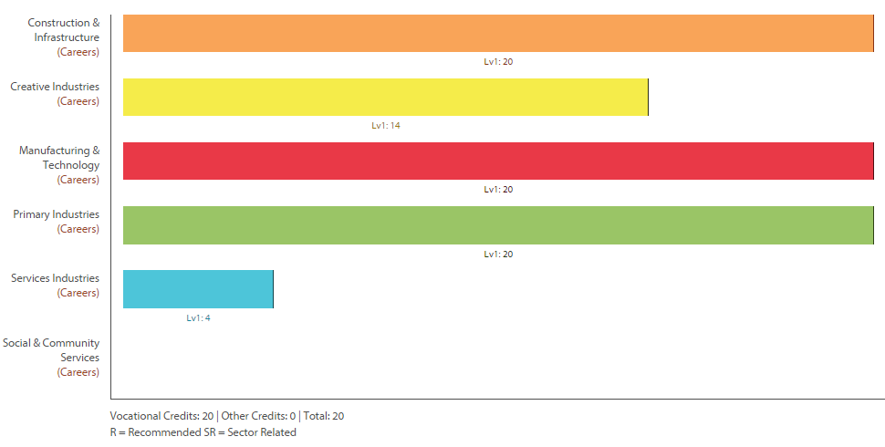

Level One SPEC Return To Contents
Purpose – SPEC stands for “Specific Preparation for Employment and Citizenship : Developing the Key Competencies” - To develop the key competencies (from the NZ Curriculum Document) and prepare the students for part time and/or full time employment.
Pathway – This course can lead to Level Two SPEC.
Recommended Entry – There is open entry to this course for all students.
Course Outline – This course challenges the students to identify their strengths and prove opportunities to demonstrate the “Key Competencies” (thinking, relating, participation & contribution, managing self and using language/symbols/text). This is done through a personal development programme. At year 11 students complete the SPEC ‘Shooting Star’ and ‘One Star Award’ which are part of the requirements for the NZQA approved “Certificate of Mainstream Studies Level One” which is completed over two years. Alongside these students complete unit standards based around preparation for employment. Gateway can also sit alongside the SPEC programme and additional unit standards may also be made available where needed.
Course Fees – $20 and print credit.
Assessment Information – 17 Level One Credits and 5 Level Two Credits (0 External)
497 : Demonstrate knowledge of workplace health and safety requirements, Level 1, 3 credits
504 : Produce a CV (curriculum vitae), Level 1, 2 credits
1285 : Make inquiries and complete practical transactions, Level 1, 4 credits
3501 : Demonstrate knowledge of and apply listening techniques, Level 1, 3 credits
3503 : Participate and communicate in a team or group to complete a routine task, Level 1, 2 credits
9707 : Demonstrate knowledge of workplace communications requirements, Level 1, 5 credits
17593 : Apply safe work practices in the workplace, Level 2, 4 credits

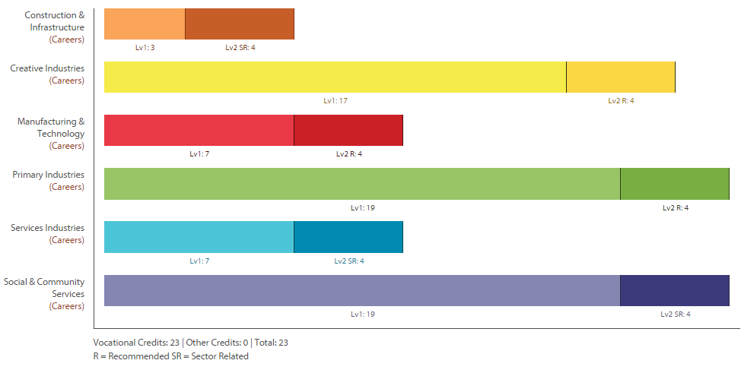
Level One Te Reo Maori Return To Contents
Purpose – To provide student with basic reading, writing and speaking skills in Te Reo.
Pathway – This course can lead to Level Two Te Reo.
Recommended Entry – Year 10 Te Reo Maori.
Course Outline – This Level One academic course includes the study of Te Reo Maori me Tikanga. The course provides students an opportunity to connect with the Maori culture and language.
Course Fees – There are no course fees.
Assessment Information – 24 Credits (12 External)
91085 : Whakarongo kia mohio ki te reo o tona ao, Level 1, 6 credits
91086 : Korero kia whakamahi i te reo o tona ao, Level 1, 6 credits
91087 : Panui kia mohio ki te reo o tona ao, Level 1, 6 credits
91088 : Tuhi i te reo o tona ao, Level 1, 6 credits

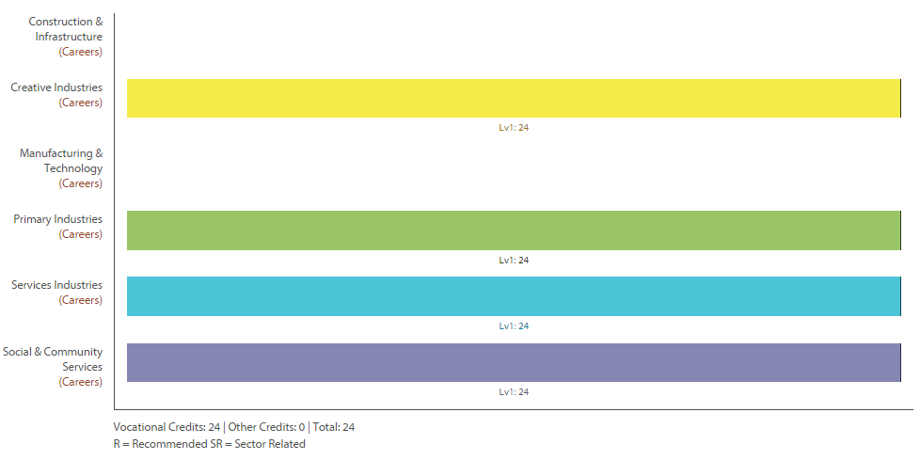

Level Two Accounting Return To Contents
Purpose – To develop knowledge and skills in Accounting.
Pathway – This course can lead to Level Three Accounting.
Recommended Entry – Level One Accounting or Mathematics (Advanced).
Course Outline – This course is aimed students who have completed Level One Accounting. Students who have not taken Level One Accountancy can do this course if they are sufficiently motivated and confident with Mathematics. The course is essentially a more in-depth study of what was learnt in Level One, regarding business and finance.
Course Fees 2016 – $10 Course Materials.
Assessment Information – 15 Credits (9 External) -
91175 : Demonstrate understanding of accounting processing using accounting software, Level 2, 4 credits
91176 : Prepare financial information for an entity that operates accounting subsystems, Level 2, 5 credits
91177 : Interpret accounting information for entities that operate accounting subsystems, Level 2, 4 credits
91179 : Demonstrate understanding of an accounts receivable subsystem for an entity, Level 2, 3 credits
91386 : Demonstrate understanding of an inventory subsystem for an entity, Level 2, 3 credits

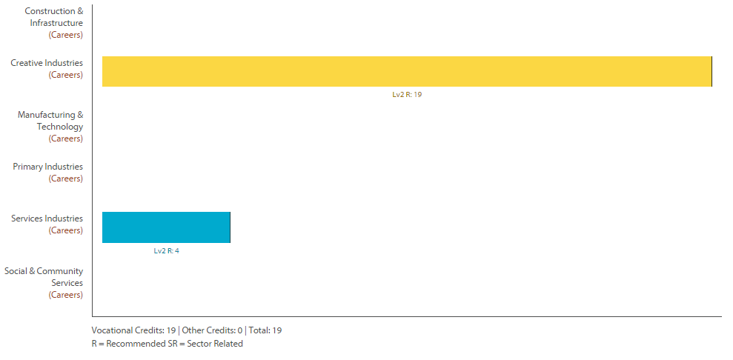

Level Two Advanced English Return To Contents
Purpose – English at Waihi College seeks to nurture the key skills you have, and develop then so that you can live and learning today and in the future. English is about thinking; using language, symbols and texts; participating and contributing; relating to others and managing self.
Pathway – This course includes University Entrance Literacy Standards and leads to Level Three English
Recommended Entry – Evidence of good passing grades in Level One Advanced English or Level One English – including at least one externally assessed Level One English standard.
Course Outline – This course is designed for students who may not easily achieve UE literacy across their other subjects. Credits gained can also contribute to a range of career pathways including, polytechnic course entrance requirements, and a range of vocational pathways. Preferably, students who take this course will have a minimum of 15 Level 1 English credits (this includes credits gained from an external). It is not suitable for those who wish to progress to Level 3 English and who may wish to study English or an associated subject at university level.
Course Fees – There are no course fees.
Assessment Information – possible 21 Credits (8 External) -
91099 : Analyse specified aspect(s) of studied visual or oral text(s), supported by evidence, L2, 4 crds (UE Writing)
91100 : Analyse significant unfamiliar written text(s) through close reading, with evidence, L2, 4 crds (UE Reading and Writing)
91101 : Produce a selection of crafted and controlled writing, Level 2, 6 credits (UE Writing)
91104 : Analyse significant connections across texts, supported by evidence, Level 2, 4 credits
91107 : Analyse visual and/or oral text(s) through close viewing and/or listening, supported by evidence, L2, 3 credits

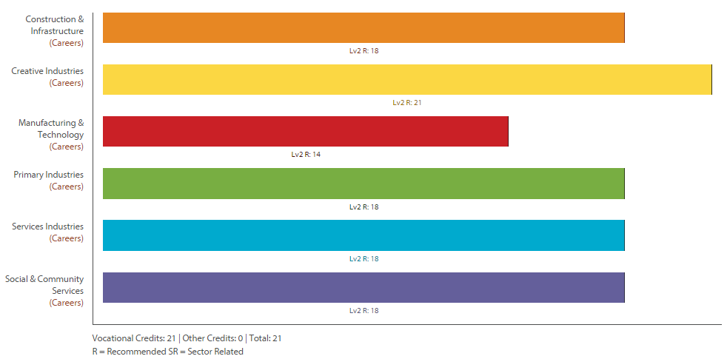

Level Two Advanced Mathematics Return To Contents
Purpose – To develop knowledge and skills of Mathematical Techniques
Pathway – This course leads into Level Three Calculus and/or Level Three Statistics.
Recommended Entry – Merit or Excellence grades from the Level One Algebra external (the MCAT).
Course Outline – This course is designed for students who are aiming for the highest grades in Mathematics. The course is highly recommended for students who wish to take Calculus in Level Three or University Mathematics. There is a strong focus on algebra and calculus along with other topics such as statistics, trigonometry and probability.
Course Fees – Workbooks (approximately $15) and a calculator (a graphical calculator is highly recommended).
Assessment Information – 20 Credits (13 External) The standards will be chosen from -
91258 : Apply sequences and series in solving problems, Level 2, 2 credits
91261 : Apply algebraic methods in solving problems, Level 2, 4 credits
91262 : Apply calculus methods in solving problems, Level 2, 5 credits
91265 : Conduct an experiment to investigate a situation using statistical methods, Level 2, 3 credits
91267 : Apply probability methods in solving problems, Level 2, 4 credits
91268 : Investigate a situation involving elements of chance using a simulation, Level 2, 2 credits

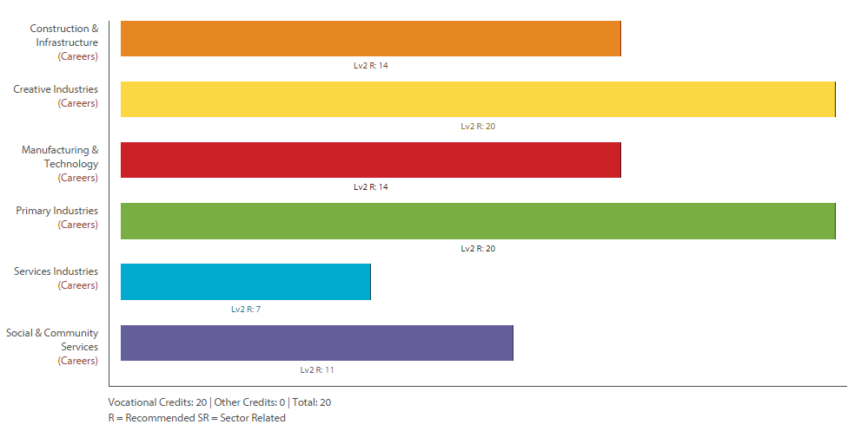

Level Two Building and Construction Return To Contents
Purpose – To develop knowledge and skills in building and furniture making.
Pathway – This course can lead to Level Three Building and Construction.
Recommended Entry – Level One Building and/or Level One Graphics and/or Level One Product Design.
Course Outline – This is a Building Industry based course for students who wish to take a pathway into tertiary or trade related courses/careers. Students will use a wide selection of power and machine tools. They will create more challenging projects. These may include; sheds, ‘cape cod’ chairs, tables, step ladders and stools. Assessed work with include both written material and finished products.
Course Fees – $55 for materials that are used in the outdoor furniture. N.b. at the end of the course the finished products are the students to keep.
Assessment Information – 14 Credits Compulsory and 19 Optional (0 External all of the standards are unit standards and therefore only have maximum ‘Achieved’ level grades) -
Compulsory Standards
12927 : Identify, select, maintain, and use hand tools for BCATS projects, Level 2, 6 credits
24350 : Identify, select, maintain, and use portable power tools for BCATS projects, Level 2, 6 credits
24358 : Plan and monitor the construction of a BCATS project, and quality check the product, Level 2, 2 credits
Optional Standards
12932 : Construct timber garden furniture and items of basic construction equipment as a BCATS project, Level 2, 8 credits
12936 : Construct a non-consent timber framed utility building as a BCATS project, Level 2, 8 credits
22607 : Read and interpret plans, working drawings and specifications for BCATS projects, Level 2, 3 credits

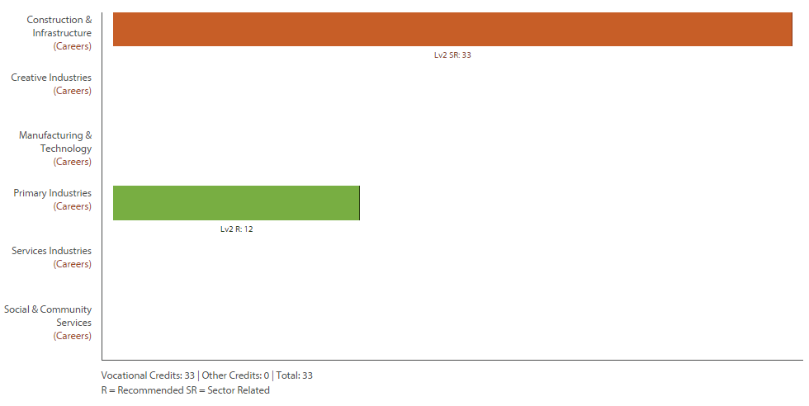
Level Two Automotive Return To Contents
Purpose – To develop knowledge and skills in automotive maintenance/structure/mechanics.
Pathway – This course can lead to Polytechnic type courses.
Recommended Entry – This course is open entry to any able and keen students.
Course Outline – This is a practically based course where students will learn about motor vehicles. Course learning will include: dismantling motors, complete vehicle maintenance, panel beating and painting. Student will gain Industry Standards so there is some theory work required.
Course Fees – There are no course fees.
Assessment Information – 12 Credits (0 External all of the standards are unit standards and therefore only have maximum ‘Achieved’ level grades) -
231 : Explain the operation of two and four stroke petrol and diesel engines, Level 2, 4 credits
16113 : Demonstrate knowledge of safe working practices in an automotive workshop, Level 2, 2 credits
21669 : Demonstrate knowledge of hand tools and workshop equipment for motor industry applications, Level 2, 2 credits
21674 : Demonstrate knowledge of terminology used in the motor industry, Level 2, 2 credits
21683 : Demonstrate knowledge of MIG welding in the motor industry, Level 2, 2 credits
21858 : Demonstrate good work habits and perform safe work practices in the motor and related industries, Level 2, 4 credits
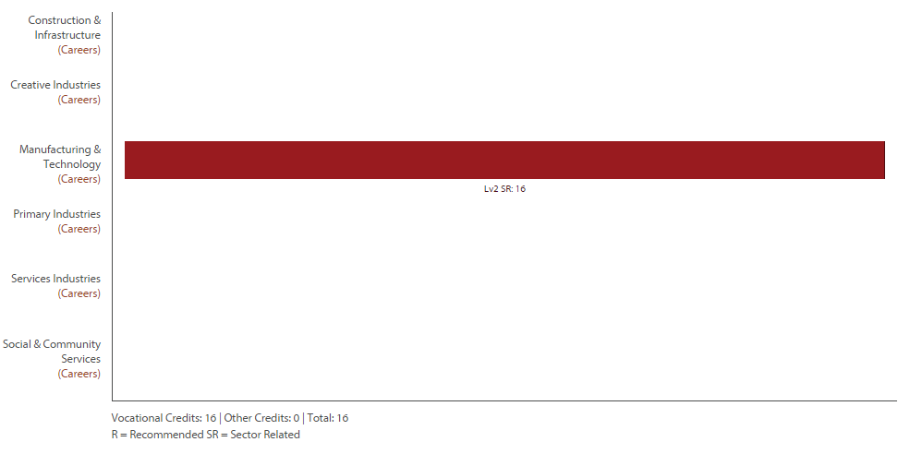

Level Two Catering Return To Contents
Purpose – To develop skills in cooking and presentation of food as well as nutrition and food safety.
Pathway – This course can leads to Level Three Catering.
Recommended Entry – Level One Home Economics is useful but not essential.
Course Outline – This course is a combination of Home Economics and Technology Achievement Standards and Service IQ Industry Unit Standards. The Service IQ standards include food safety, knife skills, baking and coffee appreciation. Not all students will do all standards – there is flexibility in this course so that students are able to do the standards that are most suited to their individual needs. Level Two Catering students are expected to help with catering for school functions and they may have the opportunity to run a café.
Course Fees – $65.
Assessment Information – 28 Credits (0 External) -
- 167 : Practise food safety methods in a food business, Level 2, 4 credits
- 13276 : Cook food items by grilling, Level 2, 2 credits
- 13283 : Prepare and present salads for service, Level 2, 2 credits
- 13285 : Handle and maintain knives in a commercial kitchen, Level 2, 2 credits
- 17285 : Demonstrate knowledge of commercial espresso coffee equipment and prepare espresso beverages under supervision, Level 2, 4 credits
- 17286 : Prepare and present pressed coffee for service, Level 2, 2 credits
- 17287 : Prepare and present filtered coffee for service, Level 2, 2 credits
- 91351 : Implement advanced procedures to process a specified product, Level 2, 4 credits
- 91356 : Develop a conceptual design for an outcome, Level 2, 6 credits
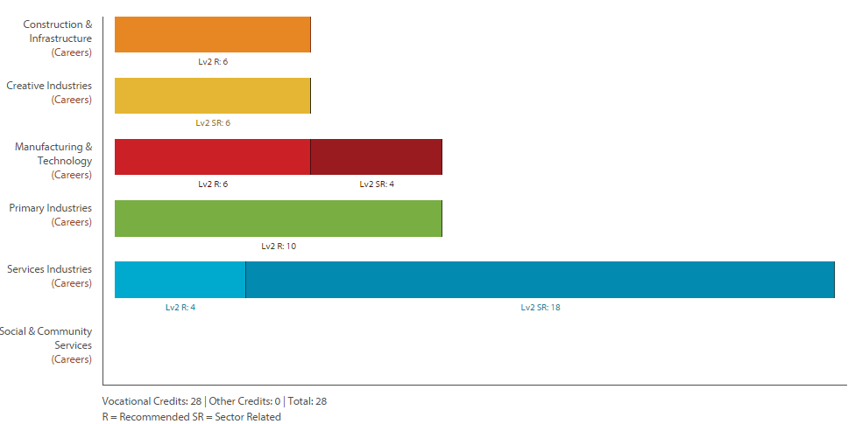

Level Two & Three Childcare Return To Contents
Purpose – Over a two year period students at Waihi College will be offered the chance to complete a ‘National Certificate in Early Childhood Care and Education’ (Level Three). This is done in conjunction with Gateway.
Pathway – This course leads to entry level certificates and diplomas such as Waikato University or Wintec or BOP Polytechnic.
Recommended Entry – Entry is open to any student with an interest in working with young people
Course Outline – There is a component of 80 hours of time spent in childcare centres in the area – this is to build up the skills needed to gain the standards (a further 13 Level Three credits). This is not compulsory but highly recommended.
Course Fees – No fee.
Assessment Information – 35 Credits (0 External) -
- 10019: Child Safety, (Internal 4 credits), Level Three
- 10020: Keep clean and safe, (Internal 2 credits), Level Two
- 10024: Promoting good health, (Internal 2 credits), Level Two
- 26712: Nutrition, (Internal 4 credits), Level Two
- 26708: Communication, (Internal 5 credits), Level Three
- 26709: Observation of a child, (Internal 3 credits), Level Three - Gateway Credits.
- 20407: Cultural diversity, (Internal 4 credits), Level Three
- 27145: Learning plans, (Internal 4 credits), Level Three - Gateway Credits.
- 26707: Play, (Internal 6 credits), Level Three - Gateway Credits.
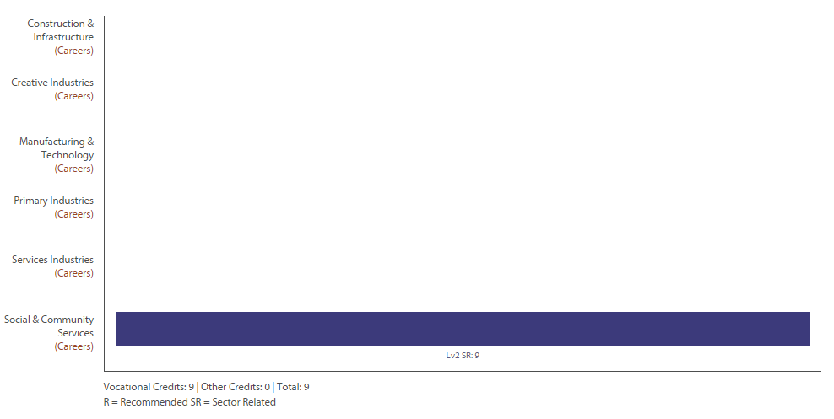
Note not all these standards were on the profile builder website

Level Two Drama Return To Contents
Purpose – To develop knowledge and skills in Drama. To establish academic and professional pathways.
Pathway – This course can lead to Level Three Drama.
Recommended Entry – Level One Drama is recommended, but not essential. Important to have an established interest in drama, production and/or live performance.
Course Outline – The Level Two Drama programme offers some workshops in Dramatic technique, script work, and devising. It provides students the opportunity to participate in significant productions and explores the links between classical and contemporary literature and contemporary physical theatre. Students will attend professional theatrical productions as a part of their coursework. The course continues the students’ academic pathways towards tertiary study and introduces a formal academic element to the work. The Level Two Drama course continues to build upon the students first hand experiences of Drama related professions and enables students to form professional relationships with potential employers. Students will be encouraged to extend their ideas towards developing their own business endeavours.
Course Fees – $20 and $48 Field Trip (Red Leap)
Assessment Information – 18 Credits of which 4 are externally assessed (note all standards offered in Level One Drama contribute to the Literacy component of NCEA level one). Additional performing arts technology units in areas such as lighting, construction and set design can be made available for students who signal their interest.
91213 : Apply drama techniques in a scripted context, Level 2, 4 credits
91214 : Devise and perform a drama to realise an intention, Level 2, 5 credits
91218 : Perform a substantial acting role in a scripted production, Level 2, 5 credits (UE Reading)
91219 : Discuss drama elements, techniques, conventions and technologies within live performance, Level 2, 4 credits (UE Writing)
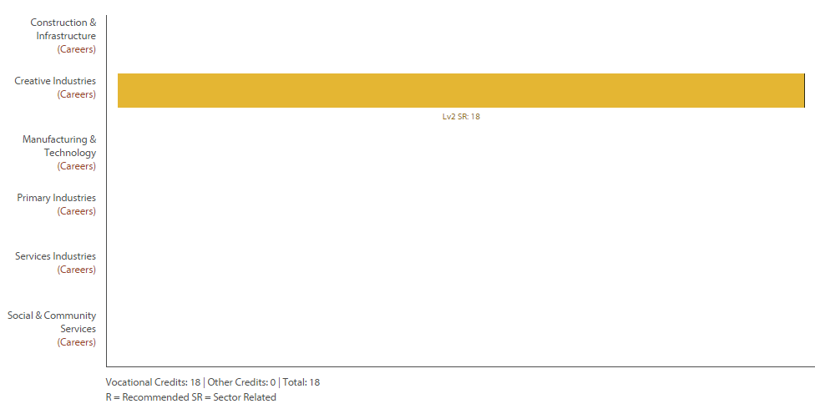
Level Two English (Targeting UE) Return To Contents
Purpose – English at Waihi College seeks to nurture the key skills you have, and develop them so that you can live and learning today and in the future. English is about thinking; using language, symbols and texts; participating and contributing; relating to others and managing self.
Pathway – This course includes University Entrance Literacy Standards and is intended to be the final year of English for able academic students (students wanting to do Level Three English should opt for Level Two Advanced English).
Recommended Entry – Evidence of passing grades in Level One Advanced English or Level One English – students must have a passing grade in external 90851 or 90850).
Course Outline – This course is designed for students who may not easily achieve UE literacy across their other subjects. Credits gained can also contribute to a range of career pathways including, polytechnic course entrance requirements, and a range of vocational pathways. It is not suitable for those who wish to progress to Level 3 English and who may wish to study English or an associated subject at university level.
Course Fees – There are no course fees.
Assessment Information – possible 17 Credits (8 External) -
91100 : Analyse significant aspects of unfamiliar written text(s) through close reading, supported by evidence, Level 2, 4 credits (UE Reading and Writing)
91101 : Produce a selection of crafted and controlled writing, Level 2, 6 credits (UE Writing)
91105 : Use information literacy skills to form developed conclusion(s), L2, 4 credits (UE Reading)
91107 : Analyse aspects of visual and/or oral text(s) through close viewing and/or listening, supported by evidence, Level 2, 3 credits
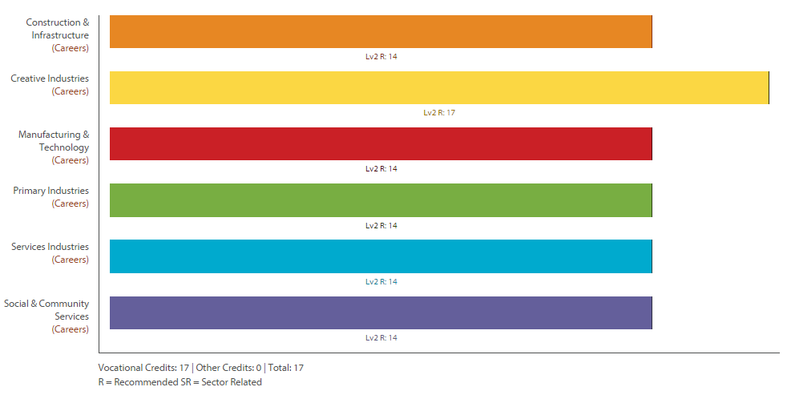

Level Two Geography Return To Contents
Purpose – Geography gives students a multidisciplinary or holistic view of the world, combining knowledge, skills, and understandings of the physical and social sciences. It fosters a curiosity about place and space, and provokes questions about natural and cultural environments and their interconnectedness. Geography provides opportunities through fieldwork for first-hand investigations of places, environments, and human activities. It helps students make sense of complex issues such as climate change, ageing populations, urban growth, land conflicts, globalisation, and sustainability.
Pathway – This course can lead to Level Three Geography.
Recommended Entry – Level One Geography.
Course Outline – The Level Two academic course has two broad themes. One is physical inter-relationship, using a case study of the South Island high country. Issues like deforestation and Pest Control are also examined. The second theme is about urban settlements and patterns around the world with case studies of various cities, and in particular Dubai. At the same time skills to do with using maps and a variety of other information sources are followed up and these are applied to research work. Other contexts include; the current New Zealand geographic issue of 1080 poison, and a global issue of desertification.
Course Fees – Fees for a field trip to the South Island $620.
Assessment Information – 22 Credits (8 External) -
91189 : Investigate geological processes in a New Zealand locality, Level 2, 4 credits
91240 : Demonstrate geographic understanding of a large natural environment, L2, 4crds (UE Reading and Writing)
91241 : Demonstrate geographic understanding of an urban pattern, Level 2, 3 credits
91243 : Apply geography concepts and skills to demonstrate understanding of environment, L2, 4 crds
91244 : Conduct geographic research with guidance, Level 2, 5 credits
91245 : Explain aspects of a contemporary New Zealand geographic issue, Level 2, 3 credits
91246 : Explain aspects of a geographic topic at a global scale, Level 2, 3 credits
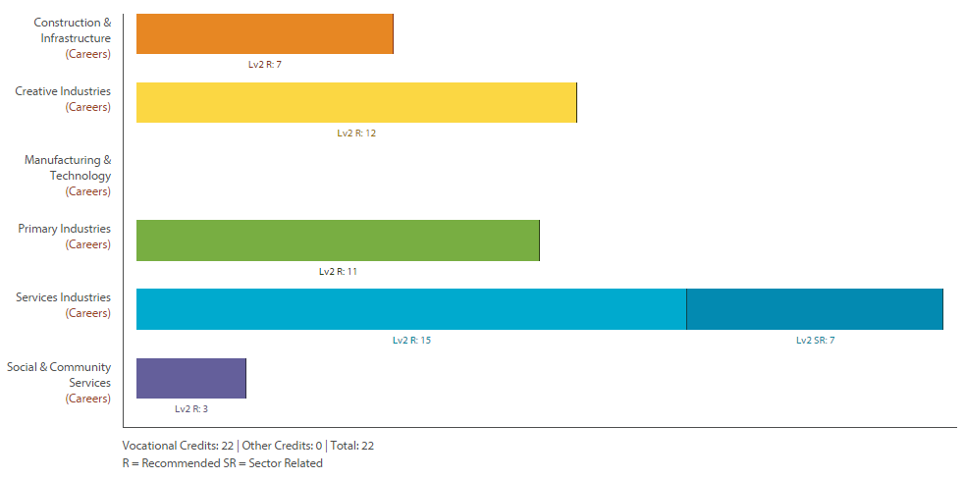
Level Two Horticulture Return To Contents
Purpose – To develop knowledge and skills in Horticulture.
Pathway – This course can lead to Level Three Agriculture.
Recommended Entry –Level One Horticulture would help but is not essential. Students do need to get their hands dirty and be enthusiastic.
Course Outline – Level Two Horticulture involves learning more about how plants grow and function, and factors that affect plant growth. The practical work involves producing new plants using a number of propagation techniques. This means learning ways to produce new plants from existing plants without growing them from seed. Care and maintenance of the new plants is also part of the course. We shall also be learning about the environmental impact of horticultural operations.
Course Fees – No fees.
Assessment Information – 24 Credits (0 External) -
22177 : Demonstrate knowledge of the structure and function of plants, Level 2, 5 credits
22183 : Plant out horticulture crops by hand, Level 2, 5 credits
22191 : Demonstrate knowledge of factors which influence plant growth, Level 2, 5 credits
27707 : Demonstrate knowledge of plant propagation by budding, grafting, layering and tissue culture, Level 2, 5 crds
91298 : Report on the environmental impact of the production of a locally produced primary product, Level 2, 4 credits

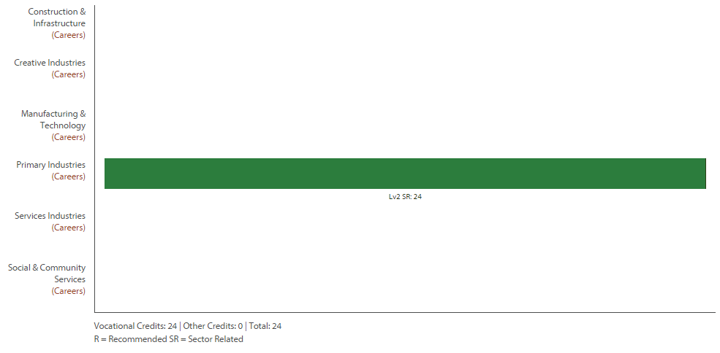

Level Two Biology Return To Contents
Purpose – To develop knowledge and skills in Biological Sciences.
Pathway – This course can lead to Level Three Biology.
Recommended Entry – Level One Science – achieved in all the biology standards.
Course Outline – Biology is the study of life. This course covers: practical investigations, interactions of humans, evolution, patterns in populations/communities, cell structure/function and genetics. There is a three day field trip to Goat Island marine reserve, Tiritiri Matangi, Kelly Tarltons, and the Miranda Bird Sanctuary.
Course Fees – Fees for a field trip to Goat Island $280 (approx.) plus workbook $29.70.
Assessment Information – 22 Credits (12 External) -
91155 : Demonstrate understanding of adaptation of plants or animals to their way of life, Level 2, 3 credits
91156 : Demonstrate understanding of life processes at the cellular level, Level 2, 4 credits
91157 : Demonstrate understanding of genetic variation and change, Level 2, 4 credits
91158 : Investigate a pattern in an ecological community, with supervision, Level 2, 4 credits
91159 : Demonstrate understanding of gene expression, Level 2, 4 credits
91160 : Investigate biological material at the microscopic level, Level 2, 3 credits

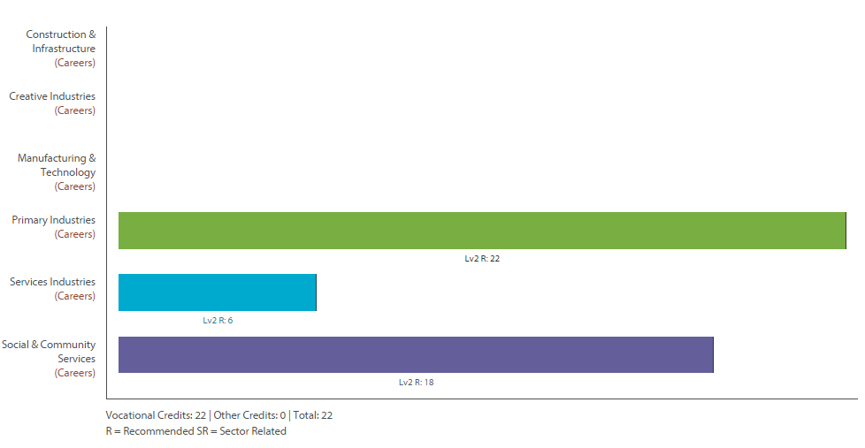

Level Two Chemistry Return To Contents
Purpose – To better understand the world around us at the molecular level. To more fully appreciate future challenges facing humankind – pollution, treatment of disease, climate change and the need for clean energy – and the opportunities presented by new technologies.
Pathway – This course can lead to Level Three Chemistry.
Recommended Entry – Level One Science – achieved in the external Science standard.
Course Outline – This course provides students with a good grounding in the basics of Chemistry. Students will do practical standards to identify unknown salts and to measure the strengths of acids and bases. A third internal looks at redox reactions. Theory topics include organic chemistry, bonding and structures in chemicals, and chemical reactions. Students will also carry out a research assignment on recent chemical technology.
Course Fees – Fees for course notes $10.
Assessment Information – 26 Credits (13 External – n.b. 1 of the 3 externals (91166) is optional)-
- 91161 : Carry out quantitative analysis, Level 2, 4 credits
- 91162 : Carry out procedures to identify ions present in solution, Level 2, 3 credits
- 91163 : Demonstrate understanding of the chemistry used in the development of a current technology, Level 2, 3 credits
- 91164 : Demonstrate understanding of bonding, structure, properties and energy changes, Level 2, 5 credits
- 91165 : Demonstrate understanding of the properties of selected organic compounds, Level 2, 4 credits
- 91166 : Demonstrate understanding of chemical reactivity, Level 2, 4 credits
- 91167 : Demonstrate understanding of oxidation-reduction, Level 2, 3 credits
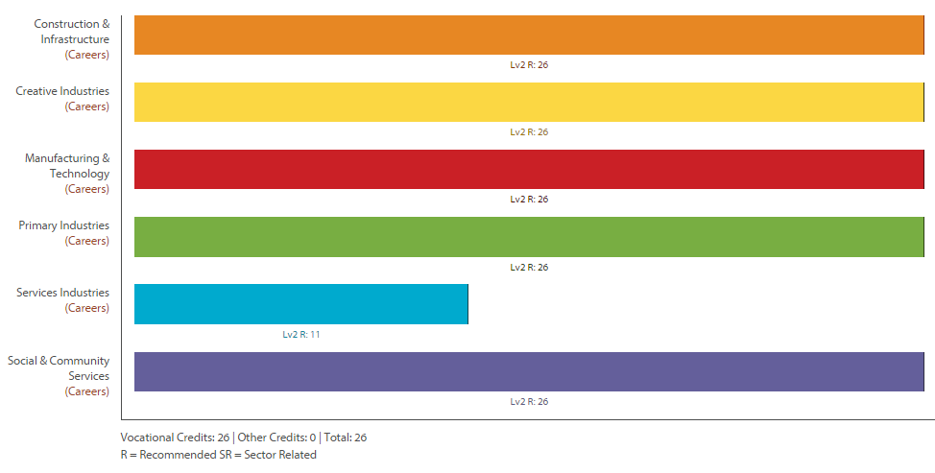

Level Two Graphics (DVC) Return To Contents
Purpose – Graphics (aka Design and Visual Communication) develop knowledge and skills in designing Architecture and Products.
Pathway – This course can lead to Level Three Graphics.
Recommended Entry – Level One Graphics.
Course Outline – This course challenges students to think about the fundamentals of design and how this is used in developing products and architecture. Briefs or units of work are used to solve architectural or design problems. Design skills, drawings skills, computers and presentation skills are all used to help solve these problems. Students will learn to use sketching techniques, produce formal drawings using instruments, computer presentations and computer drawing programmes.
Course Fees – Students will need subject specific equipment and stationery.
Assessment Information – 21 Credits (6 External these are assessed as a portfolio/evidence of work there will be no exam) -
91337 : Use visual communication techniques to generate design ideas, Level 2, 3 credits
91339 : Produce instrumental perspective projection drawings to communicate design ideas, Level 2, 3 credits
91340 : Use the characteristics of a design movement or era to inform own design ideas, Level 2, 3 credits
91341 : Develop a spatial design through graphics practice, Level 2, 6 credits
91342 : Develop a product design through graphics practice, Level 2, 6 credits

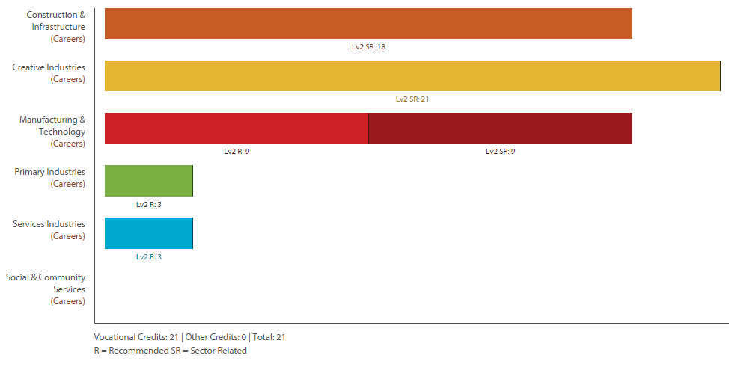

Level Two Art Painting Return To Contents
Purpose – To develop knowledge and skills in the field of Painting.
Pathway – This course can lead to Level Three Art Painting and/or Level Three Art Photography.
Recommended Entry – Level One Art Painting or Level On Art Photography.
Course Outline – This course challenges the student to develop art works and express ideas in a range of painting media and styles through the study of a number of artists’ working methods and ideas. Students expand their repertoire of drawing and painting skills, applying what they have learnt from practical studies of artist models. These skills are then applied in mixed media artworks which communicate ideas in an extended series of interrelated art works. The year’s work culminates in the two panel folio of work, the external assessment.
Course Fees – Materials and equipment fees of $40.
Assessment Information – 24 Credits (12 External these are assessed as a portfolio/evidence of work there will be no exam) -
91306 : Demonstrate an understanding of methods and ideas from established practice appropriate to painting., Level 2, 4 credits
91311 : Use drawing methods to apply knowledge of conventions appropriate to painting., Level 2, 4 credits
91316 : Develop ideas in a related series of drawings appropriate to established painting practice., Level 2, 4 credits
91321 : Produce a systematic body of work that shows understanding of art making conventions and ideas within painting., Level 2, 12 credits

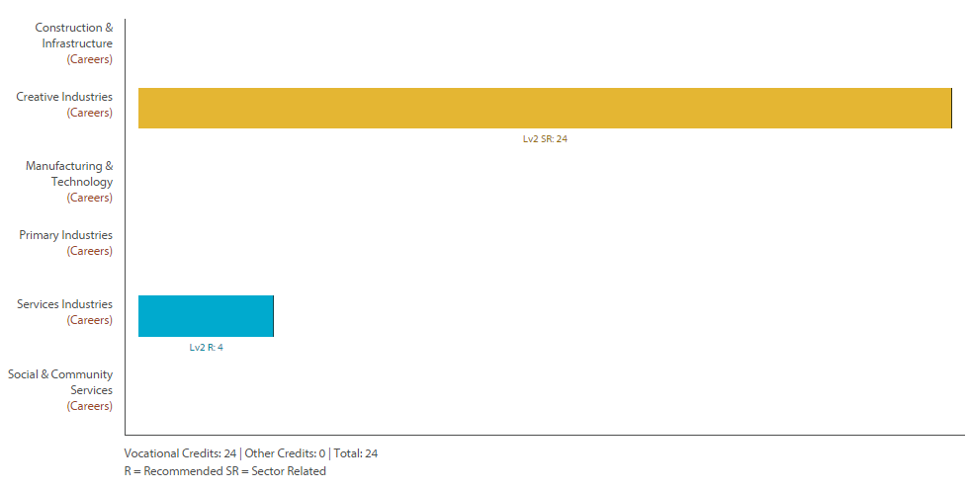

Level Two Health Education Return To Contents
Purpose – To develop knowledge of key Health components.
Pathway – This course can lead to Level Three Health Education.
Recommended Entry – Level One Health Education.
Course Outline – This course will offer you the opportunity to experience and participate in a wide range of activities in a variety of contexts. The main focus of this course is to equip you with the foundation knowledge of health if you wish to pursue this area in the future as well as improving a variety of interpersonal skills which will be useful in any context.
Course Fees – There are no course fees.
Assessment Information – 20 Credits (5 External) -
91235 : Analyse an adolescent health issue, Level 2, 5 credits
91236 : Evaluate factors that influence people's ability to manage change, Level 2, 5 credits
91237 : Take action to enhance an aspect of people's well-being within the school or wider community, Level 2, 5 credits
91239 : Analyse issues related to sexuality and gender to develop strategies for addressing the issues, Level 2, 5 credits

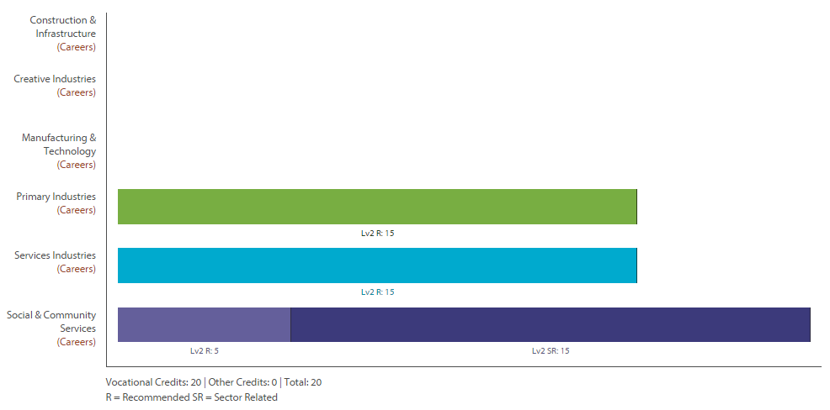

Level Two History Return To Contents
NOT OFFERED 2016
Purpose – To develop knowledge and skills in History.
Pathway – This course can lead to Level Three History or Level Three Classics.
Recommended Entry – Level One History or Level One English or Level One Advanced English.
Course Outline – This course involves units on the origins of World War One, Russia 1892-1926, Germany – Nazism and Vietnam. The internal assessments cover research, the writing of reports and radio broadcast. This course will appeal to students who are interested in current affairs and historical fiction. Skills from History are applicable in many other fields where organisation and essay skills are required.
Course Fees – There are no course fees.
Assessment Information – 23 Credits (9 External) -
91229 : Carry out an inquiry of an historical event or place that is of significance to New Zealanders, Level 2, 4 credits
91230 : Examine an historical event or place that is of significance to New Zealanders, Level 2, 5 credits
91231 : Examine sources of an historical event that is of significance to New Zealanders, Level 2, 4 credits
91232 : Interpret different perspectives of people in an historical event that is of significance to New Zealanders, Level 2, 5 credits
91233 : Examine causes and consequences of a significant historical event, Level 2, 5 credits

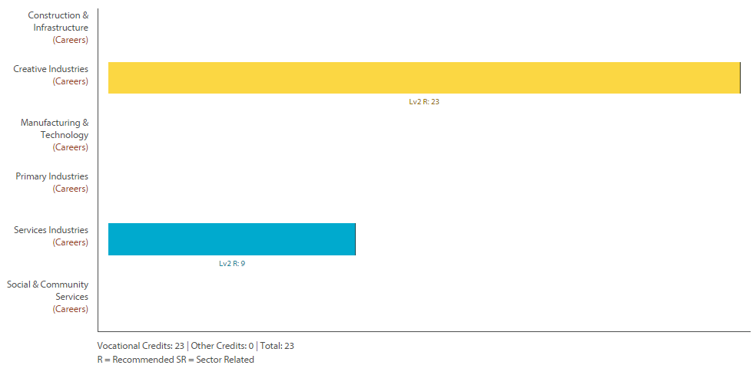

Level Two Te Reo Maori Return To Contents
Purpose – To provide students with basic reading, writing and speaking skills in Te Reo.
Pathway – This course can lead to Level Three Te Reo.
Recommended Entry – Level One Te Reo Maori
Course Outline – This Level Two academic course continues and includes the study of Te Re Maori me Tikanaga.
Course Fees – There are no course fees.
Assessment Information – 22 Credits (12 External) -
91284 : Whakarongo kia mohio ki te reo o te ao torotoro, Level 2, 4 credits
91285 : Korero kia whakamahi i te reo o te ao torotoro, Level 2, 6 credits
91286 : Panui kia mohio ki te reo o te ao torotoro, Level 2, 6 credits
91287 : Tuhi i te reo o te ao torotoro, Level 2, 6 credits

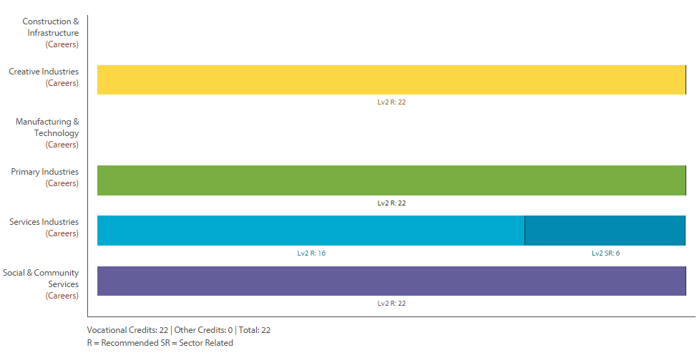

Level Two Mathematics Return To Contents
Purpose – To develop knowledge and skills of Mathematical Techniques.
Pathway – This course can lead to Level Three Statistics.
Recommended Entry – Numeracy obtained through Achievement Standards.
Course Outline – This course is designed for students who have done well at Level One and wish to continue studying mathematics at Level Two. This course will provide an opportunity for students who wish to study Level Three Statistics. Topics taught include statistics, trigonometry, probability simulations, sequences, probability and experiments. There is also a possibility of completing an additional external assessment on calculus.
Course Fees – $10 for a revision book and a scientific calculator.
Assessment Information – 18 Credits (4 External) -
91258 : Apply sequences and series in solving problems, Level 2, 2 credits
91259 : Apply trigonometric relationships in solving problems, Level 2, 3 credits
91260 : Apply network methods in solving problems, Level 2, 2 credits
91264 : Use statistical methods to make an inference, Level 2, 4 credits
91265 : Conduct an experiment to investigate a situation using statistical methods, Level 2, 3 credits
91267 : Apply probability methods in solving problems, Level 2, 4 credits
91268 : Investigate a situation involving elements of chance using a simulation, Level 2, 2 credits

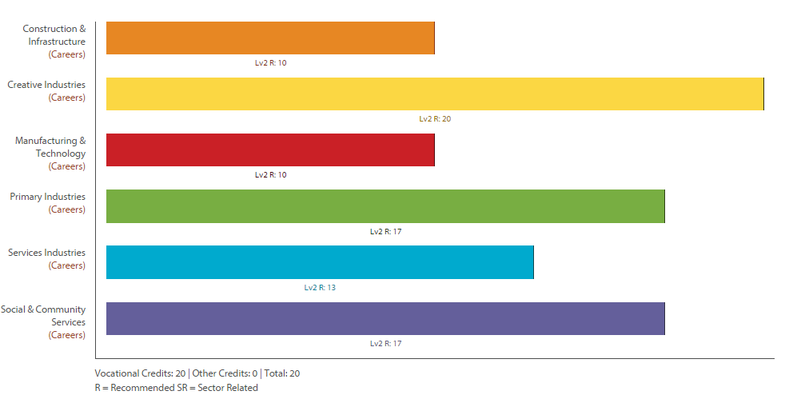

Level Two Media Design Return To Contents
Purpose –To develop knowledge and skills with design programmes while learning the principles and elements of design to enable students to apply for Tertiary study.
Pathway – This course can lead to Level Three Media Design.
Recommended Entry – Level One Media Design.
Course Outline – Students will be working closely with clients to develop a variety of outcomes. These may include print, website, animation or possible film. The students will have a chance to develop skills in Dreamweaver, Illustrator, Photoshop, Lash, Sony Vegas and Microsoft products.
Course Fees – Usual fees and print credit.
Assessment Information – 24 Credits (12 External) -
- 91305 : Demonstrate an understanding of methods and ideas from established practice appropriate to design., Level 2, 4 credits
- 91310 : Use drawing methods to apply knowledge of conventions appropriate to design., Level 2, 4 credits
- 91315 : Develop ideas in a related series of drawings appropriate to established design practice., Level 2, 4 credits
- 91320 : Produce a systematic body of work that shows understanding of art making conventions and ideas within design., Level 2, 12 credits

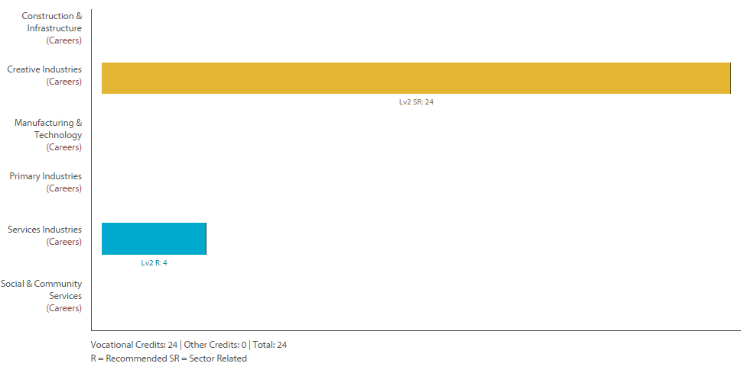

Level Two Music Return To Contents
Purpose – To develop knowledge and skills in Music.
Pathway – This course can lead to Level Three Music.
Recommended Entry – Level One Music (or through an interview with TIC of Music).
Course Outline – Level Two Music builds directly on the material covered in Level One and the course is almost the same but the required level of achievement is at a higher level. Students will perform, compose (using Sibelius software), Guitar Pro and research musical genre. Musical arranging is introduced at this level. Students will elect a variety of the available standards based on their level of interest and ability in different aspects of this course.
Course Fees – $20.
Assessment Information – Most students in L2 Music will do 22 Credits (0 External) -
91270 : Perform two substantial pieces of music as a featured soloist, Level 2, 6 credits
91271 : Compose two substantial pieces of music, Level 2, 6 credits
91272 : Demonstrate ensemble skills by performing a substantial piece of music as a member of a group, Level 2, 4 credits
91277 : Demonstrate understanding of two substantial contrasting music works, Level 2, 6 credits

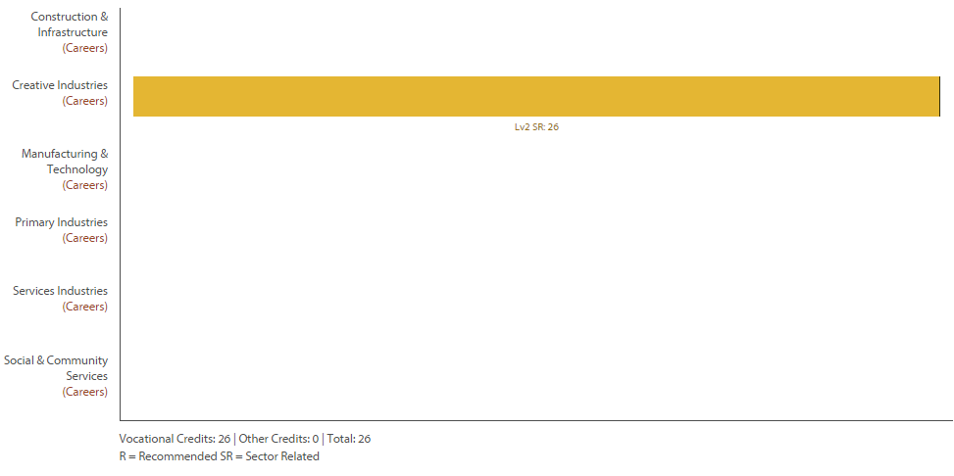

There is the option to pick up extra credits in the following…
91273 : Devise an instrumentation for an ensemble, Level 2, 4 credits
91274 : Perform a substantial piece of music as a featured soloist on a second instrument, Level 2, 3 credits
91276 : Demonstrate knowledge of conventions in a range of music scores, Level 2, 4 credits

Level 2 Outdoor Education Return To Contents
Purpose – To develop knowledge, skills and experience in a range of outdoor pursuits.
Pathway – This Level 2 course provides experience and expertise leading to increased competence and confidence in a wide range of outdoor activities. It provides 20 Level 2 credits and 5 Level 3 credits which come an Outdoor First Aid Certificate. This course leads to Level 3 Outdoor Education.
Recommended Entry – Level 1 Outdoor Education
Course Outline – Extending on from the Level 1 course, this course aims to increase student’s skills and confidence in a broader range of activities and extending beyond our local environment. The course is based on specific unit standards at aimed at teaching students both the practice and theory required for each discipline. As well as specific skills in the outdoors, students will increase their understanding in leadership in the outdoors, risk management and hazard identification.
Course Fees – $600.00 (plus optional $550 for a PADI dive course)
Assessment Information – This course uses both achievement standards and unit standard at both level 2 and 3. (Level 2, 16 credits; Level 3, 5 credits)
431 : Navigate in good visibility on land, Level 2, 3 credits 424 1st Aid in remote location, Level 3, 5 credits
444 : Demonstrate basic rock climbing movement, Level 2, 1 credits
457 : Mountain bike on intermediate to expert terrain, Level 2, 2 credits
476 : Roll a kayak, Level 2, 2 credits
485 : Demonstrate rafting skills on sheltered or slow-moving water, Level 2, 3 credits
20157 : Demonstrate the use of basic rope systems for top rope rock climbing and abseiling, Level 2, 3 credits
20159 : Gather and apply weather information to an outdoor recreation activity, Level 2, 2 credits

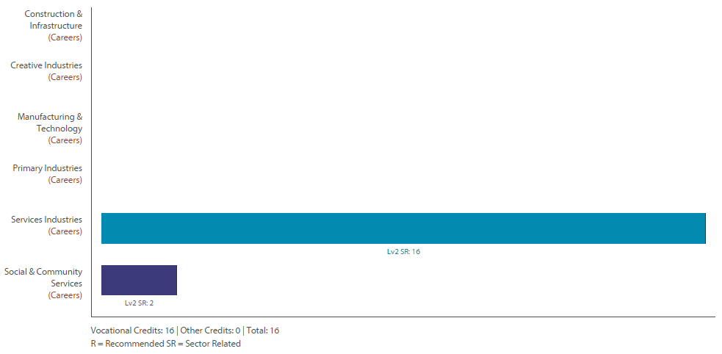
n.b not all standards on this graph.
Level Two Art Photography Return To Contents
Purpose – To develop knowledge and skills in the field of Photography.
Pathway – This course can lead to Level Three Art Painting and/or Level Three Art Photography.
Recommended Entry – Level One Art Painting or Level On Art Photography.
Course Outline – This course challenges the student to develop photographic art works and express ideas in a range of photographic styles through the study of a number of art photographers’ working methods and ideas. Students expand their repertoire of photography skills, applying what they have learnt from practical studies of artist models. These skills are then applied in mixed media artworks which communicate ideas in an extended series of interrelated art works. The year’s work culminates in the two panel folio of work, the external assessment.
Course Fees – $30 (subject fee) materials and equipment fees of $15 plus ongoing costs of print credit.
Assessment Information – 24 Credits (12 External these are assessed as a portfolio/evidence of work there will be no exam) -
91307 : Demonstrate an understanding of methods and ideas from established practice appropriate to photography., Level 2, 4 credits
91312 : Use drawing methods to apply knowledge of conventions appropriate to photography., Level 2, 4 credits
91317 : Develop ideas in a related series of drawings appropriate to established photography practice., Level 2, 4 credits
91322 : Produce a systematic body of work that shows understanding of art making conventions and ideas within photography., Level 2, 12 credits

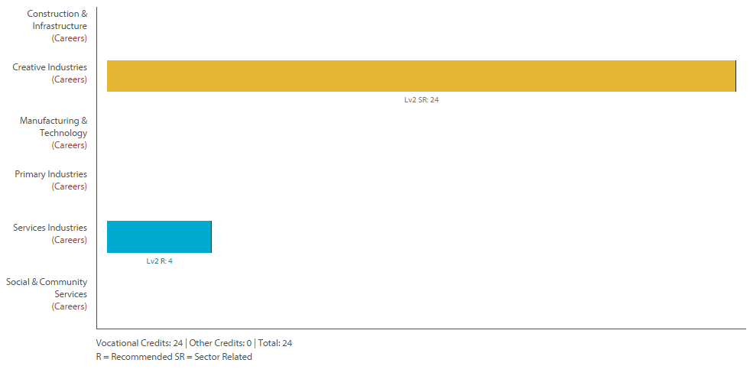

Level Two Physical Education Return To Contents
Purpose – To develop knowledge and skills in Physical Education.
Pathway – This course can lead to Level Three Physical Education.
Recommended Entry – Level One Physical Education or Level Sports Education or Level One Outdoor Education
Course Outline – This course challenges the student to think about how the body responds to movement. Students will explore the local coastline in kayaks as well as volleyball, badminton and touch. Theory topics will include anatomy, exercise, physiology, skill learning and fitness studies. Students will also gain a certificate in first aid.
Course Fees – $5 snorkelling/kayaking
Assessment Information – 19 Credits (0 External) -
91328 : Demonstrate understanding of how and why biophysical principles relate to the learning of physical skills, Level 2, 5 credits
91330 : Perform a physical activity in an applied setting, Level 2, 4 credits
91332 : Evaluate leadership strategies that contribute to the effective functioning of a group, Level 2, 4 credits
91333 : Analyse the application of risk management strategies to a challenging outdoor activity, Level 2, 3 credits
91334 : Consistently demonstrate social responsibility through applying a social responsibility model in physical activity, Level 2, 3 credits

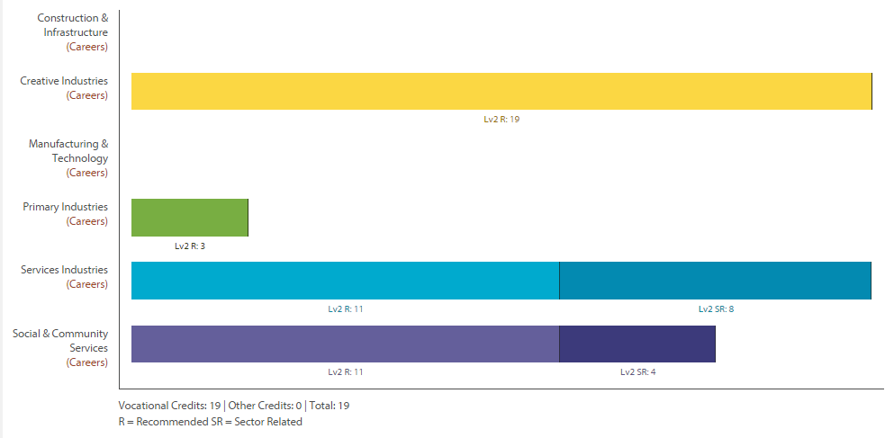

Level Two Product Design Return To Contents
Purpose –To design and manufacture a product in response to a design based problem.
Pathway – This course can lead to Level Three Technology (Product) or Level Three Building and Construction.
Recommended Entry – Level One Product Design with completed Level One External.
Course Outline – This course not only requires students to manufacture a specified product but to develop that product to meet the specified needs of the intended user.
Course Fees – $55 and print credit.
Assessment Information – 20 Credits (4 External) –
91344 : Implement advanced procedures using resistant materials to make a specified product with special features, Level 2, 6 credits
91354: Undertake brief development to address an issue, (Internal 4 credits), Generic Technology 2.1
91356 : Develop a conceptual design for an outcome, Level 2, 6 credits
91359 : Demonstrate understanding of the role of material evaluation in product development, Level 2, 4 credits

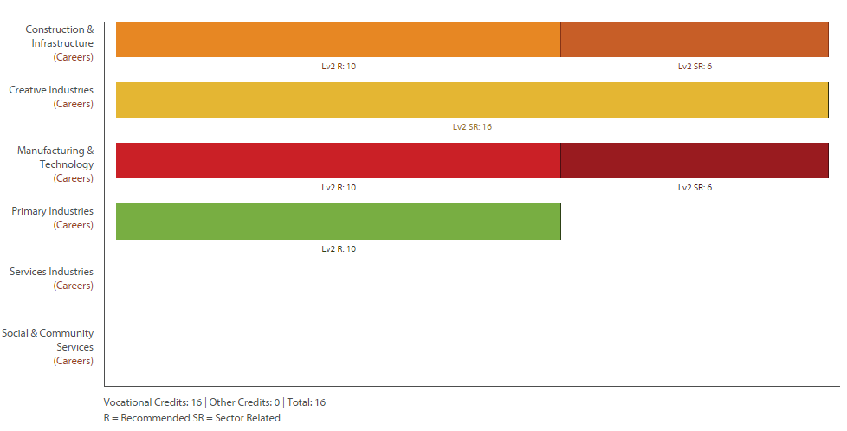
n.b. 91354 is not on the Vocational Pathway Builder

Level Two Physics Return To Contents
Purpose –To further develop knowledge and understanding of Physical Science.
Pathway – This course can lead to Level Three Physics.
Recommended Entry – Level One Science (specifically 1.1 Mechanics 90940 or 1.2 Algebra MCAT 91027).
Course Outline – Physics involves the study of matter and its motion through space and time, along with concepts such as energy and force in order to understand how the universe behaves. The Level Two course will continue with the basics of Mechanics and introduce Electromagnetism, Radioactivity and the behaviour of Waves and Light. Physics is used in a wide range of careers such as Architecture, Aviation, Broadcasting, Communications, Computing, Design, Engineering, Geology, Health Industry, Meteorology, Science, Surveying and Transport.
Course Fees – There is a class trip to Rainbow’s End theme park. Cost yet to be decided.
Assessment Information – 26 Credits (16 External) -
91168 : Carry out a practical physics investigation that leads to a non-linear mathematical relationship, Level 2, 4 credits
91169 : Demonstrate understanding of physics relevant to a selected context, Level 2, 3 credits
91170 : Demonstrate understanding of waves, Level 2, 4 credits
91171 : Demonstrate understanding of mechanics, Level 2, 6 credits
91172 : Demonstrate understanding of atomic and nuclear physics, Level 2, 3 credits
91173 : Demonstrate understanding of electricity and electromagnetism, Level 2, 6 credits

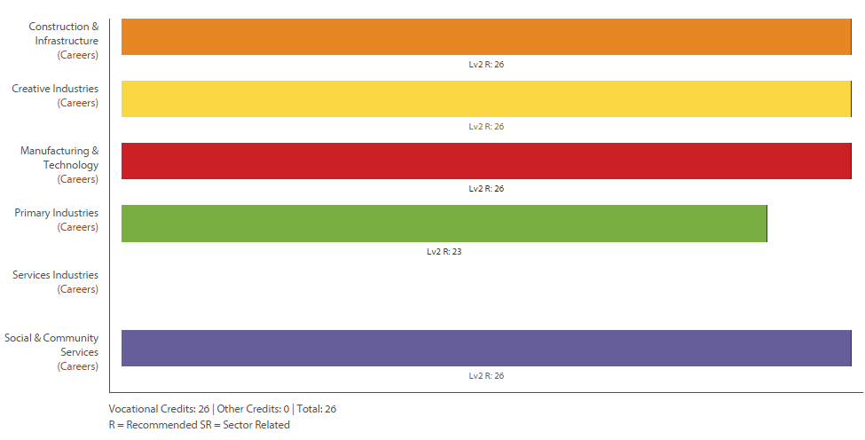

Level Two Tools For Work Return To Contents
Purpose –To learn practical mechanical skills by manufacturing a mini-bike as part of a team.
Pathway – This course provides students with an opportunity to experience work in a machinery workshop. It can lead to tertiary courses such as Wintec or BOP Polytechnic.
Recommended Entry – Level One Product Design. This is actually a challenging course that requires a mixture of motivation, creativity, keen problem solving mind and a positive attitude.
Course Outline – This course requires students to follow a blue print and manufacture a mini bike. The bike components come as a kitset. They will work as a team to complete a mini-bike (will not build an individual bike).
Course Fees – $450 up front for the mini bike kit (each student will get a completed mini bike at the end of the course).
Assessment Information – 21 Credits (0 External) -
2387 : Assemble mechanical components under supervision, Level 2, 2 credits
2395 : Select, use, and care for, engineering hand tools, Level 2, 4 credits
2396 : Select, use and maintain portable hand held engineering power tools, Level 2, 4 credits
4435 : Select, use, and care for engineering dimensional measuring equipment, Level 2, 3 credits
4436 : Select, use, and care for engineering marking-out equipment, Level 2, 4 credits
20917 : Demonstrate basic knowledge of engineering materials, Level 2, 2 credits
21911 : Demonstrate knowledge of safety on engineering worksites, Level 2, 2 credits

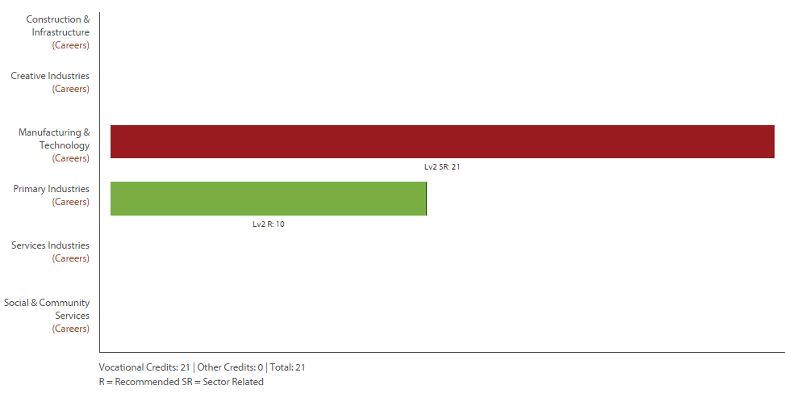

Level Two SPEC Return To Contents
Purpose – SPEC stands for “Specific Preparation for Employment and Citizenship : Developing the Key Competencies” - To develop the key competencies (from the NZ Curriculum Document) and prepare the students for part time and/or full time employment.
Pathway – This course is designed to prepare students for tertiary study or the work force. There is a Level Three Spec Course.
Recommended Entry – This course is open to all students.
Course Outline – This course challenges the students to identify their strengths and prove opportunities to demonstrate the Key Competencies through a personal development programme. At Level Two students complete the SPEC ‘One Star Award’ and individual modules which are part of the requirements for the NZQA approved ‘Certificate of Mainstream Studies Level One’ which is completed over two years. Alongside these students complete unit standards based around preparation for employment. Gateway can also sit alongside the SPEC programme and additional unit standards may also be made available where needed
Course Fees – $20 for course notes.
Assessment Information – 18+ Credits (0 External) -
One Off Courses in Fire Safety Couse 10 Credits L2 & First Aid Course 4 Credits L2
1294 : Be interviewed in a formal interview, Level 2, 2 credits
1299 : Be assertive in a range of specified situations, Level 2, 4 credits
4252 : Produce a targeted resume, Level 2, 2 credits
7123 : Apply a problem solving method to a problem, Level 2, 2 credits
10781 : Produce a plan for own future directions, Level 2, 3 credits
12349 : Demonstrate knowledge of time management, Level 2, 3 credits
24699 : Make an informed decision relating to personal income and evaluate its consequences, Level 2, 2 credits

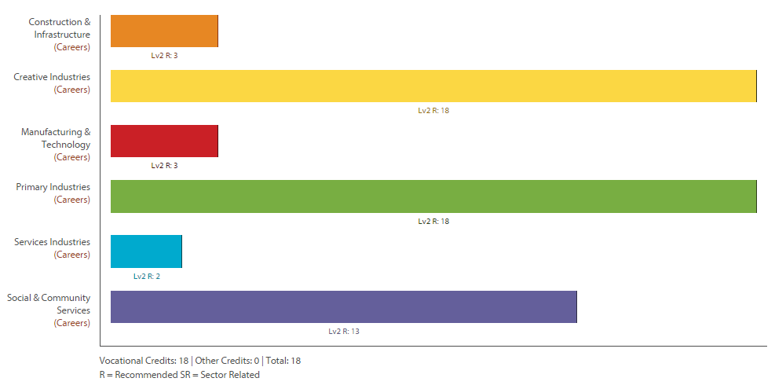
Level Two Travel and Tourism Return To Contents
Purpose –To develop skills and knowledge in Travel and Tourism. This course is designed to help students take the first step into careers in travel and tourism industries: aviation, travel, tourism, museums, retail, wholesale and hospitality.
Pathway – This course leads to Level Three Travel and Tourism.
Recommended Entry – NCEA Level One. This course is open to all students.
Course Outline – This course aims to cover an introduction to the tourism industry and to provide scope for travel investigations. The tourism industry topics cover things such as job roles and basic skills and attitudes required in these jobs, while the travel section requires you to investigate transport, accommodation, government regulation and attractions in various tourist destinations. Credit counts towards the ‘National Certificate in Travel and Tourism’. This can be done as a one or two year course (as at least 41 credits are needed to achieve the National Certificate).
Course Fees – there are no course fees.
Assessment Information – 27 Credits (0 External) -
24726 : Describe and compare social and cultural impacts of tourism, Level 2, 3 credits
24727 : Describe and compare impacts of tourism on the physical environment, Level 2, 3 credits
24728 : Demonstrate knowledge of work roles in tourism, Level 2, 3 credits
24729 : Demonstrate knowledge of world tourist destinations, Level 2, 4 credits
24730 : Demonstrate knowledge of the business of tourism, Level 2, 4 credits
24731 : Demonstrate knowledge of destination New Zealand, Level 2, 4 credits
24732 : Demonstrate knowledge of tourist characteristics and needs, Level 2, 3 credits

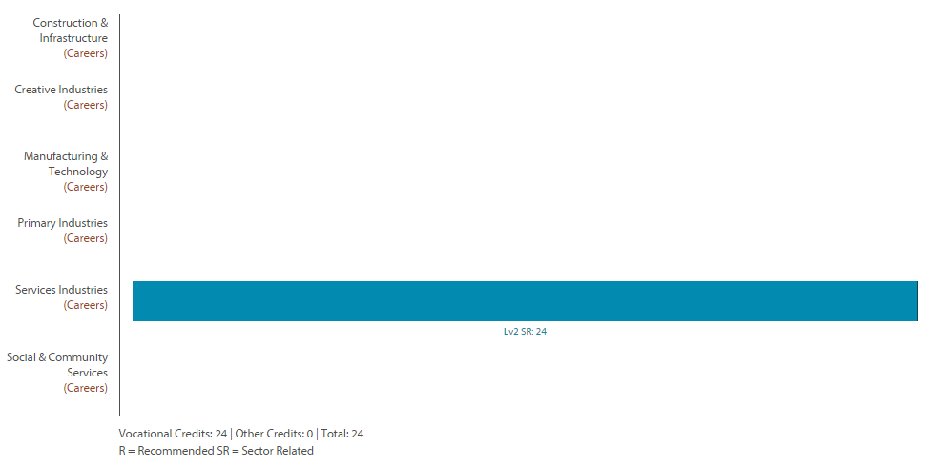

Level Two Sports Education Return To Contents
Purpose –To develop skills and knowledge in Physical Education.
Pathway – This course leads to Level Three Physical Education
Recommended Entry – Level One Physical Education or Level One Sports Education.
Course Outline – This course involves 70% practical and 30% theoretical study. Students will snorkel the local coastlines as well as participate in a range of sports/topics including: volleyball, touch , coaching and social responsibility. Students will also gain a first aid certificate.
Course Fees – Fees for first aid and snorkelling trip.
Assessment Information – 14 Level Two Credits and 4 Level One Credits (0 External) -
91330 : Perform a physical activity in an applied setting, Level 2, 4 credits
91332 : Evaluate leadership strategies that contribute to the effective functioning of a group, Level 2, 4 credits
91333 : Analyse the application of risk management strategies to a challenging outdoor activity, Level 2, 3 credits
91334 : Consistently demonstrate social responsibility through applying a social responsibility model in physical activity, Level 2, 3 credits

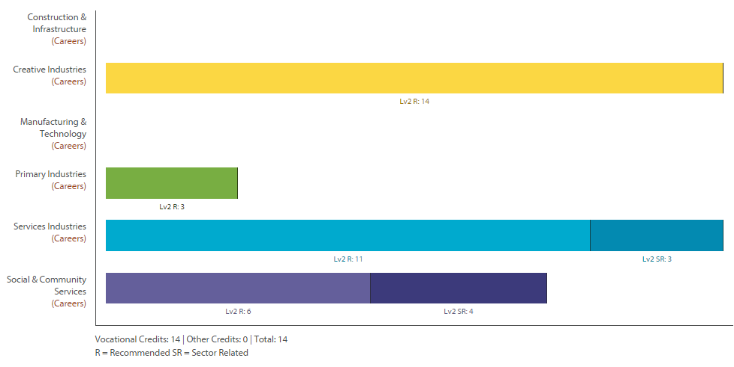

Level Two Sustainability Return To Contents
Purpose – To help gain students an understanding of their place in the world and to expose them to an area of interest that is growing in importance in our modern society. There is a variety of practical work and applying skills from other subject areas.
Pathway – This course provides a full endorsed course with possibility to move onto a Level 3 course eligible for university entrance
Recommended Entry – There is no requirement but should be prepared to work independently or in groups.
Course Outline – This course enables students to actively plan and implement projects in the school or local community projects.
Course Fees – No fees, but there will be opportunities for outside school visits.
Assessment Information – 22 Credits (0 External) -
- 90810 : Plan, implement and evaluate a personal action that will contribute towards a sustainable future, Level 2, 6 credits
- 90811 : Describe the consequences of human activity within a biophysical environment in relation to a sustainable future, Level 2, 4 credits
- 90814 : Describe aspects of sustainability in relation to a sustainable future, Level 2, 4 credits
- 91733 : Demonstrate understanding of initiatives that contribute to a sustainable future, Level 2, 4 credits
- 91734 : Develop a collaborative response that promotes a sustainable future, in relation to a current issue, Level 2, 4 credits
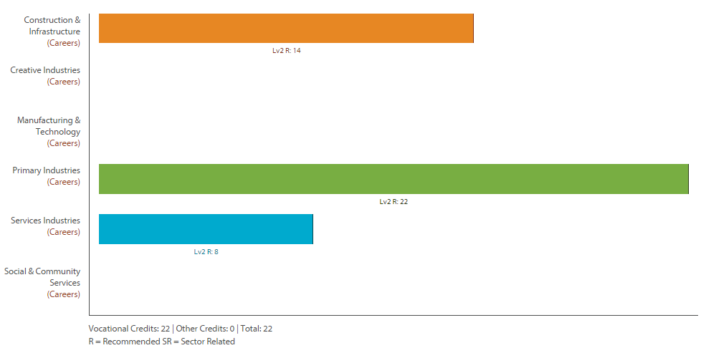
Level Two & Three Fitness/Weight Training
Return To Contents
Purpose –To develop skills and knowledge in Physical Education.
Pathway – This course leads to a career as a personal trainer or working in a gym – through the BOP Polytechnic.
Recommended Entry – An interest in personal development, health and fitness.
Course Outline – This course is available for year 12 and or year 13 students that would like to combine their training with NCEA standards. Primarily study will involve weight training techniques, safety, and nutrition. Students work through the provided workbooks which will complement the training in the school weights room. This course is limited to 16 students due to the size of the weights room.
Course Fees – $30 for visits to gymnasiums.
Assessment Information – 21 Level Two Credits (0 External) -
21791 : Relate human anatomy and movement to gym equipment and static stretching, Level 2, 4 credits
21792 : Demonstrate knowledge of health risk factors and disease, and monitor exercise stress, Level 2, 4 credits
21793 : Demonstrate correct technique when using basic gym equipment, Level 2, 2 credits
21794 : Demonstrate, instruct, and monitor static stretching, Level 2, 3 credits
21795 : Demonstrate, instruct, and monitor safe and correct use of cardiovascular exercise equipment, Level 2, 3 credits
91328 : Demonstrate understanding of how and why biophysical principles relate to the learning of physical skills, Level 2, 5 credits

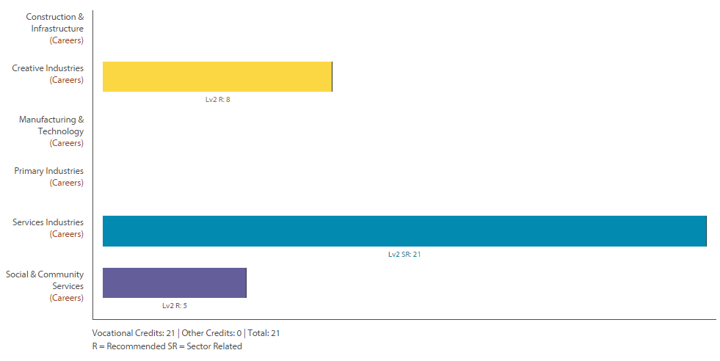

Level Two Textiles Return To Contents
Purpose –To build on skills and understanding of technological practise with soft material.
Pathway – This course leads to Level Three Textiles.
Recommended Entry – Level One Textiles, or proven experience with patterns and sewing.
Course Outline – This course starts off with building on the skills learnt previously. Then add by looking at design era influences and more advanced adaptations of patterns.
Course Fees – $45 to cover materials used in class, but you will need to provide materials for your assignments.
Assessment Information – 18 Credits (4 External these are assessed as a portfolio/evidence of work there will be no exam) -
91345 : Implement advanced procedures using textile materials to make a specified product with special features, Level 2, 6 credits
91354 : Undertake brief development to address an issue, Level 2, 4 credits
91350 : Make advanced adaptations to a pattern to change the structural and style features of a design, Level 2, 4 credits
91358 : Demonstrate understanding of how technological modelling supports risk management, Level 2, 4 credits

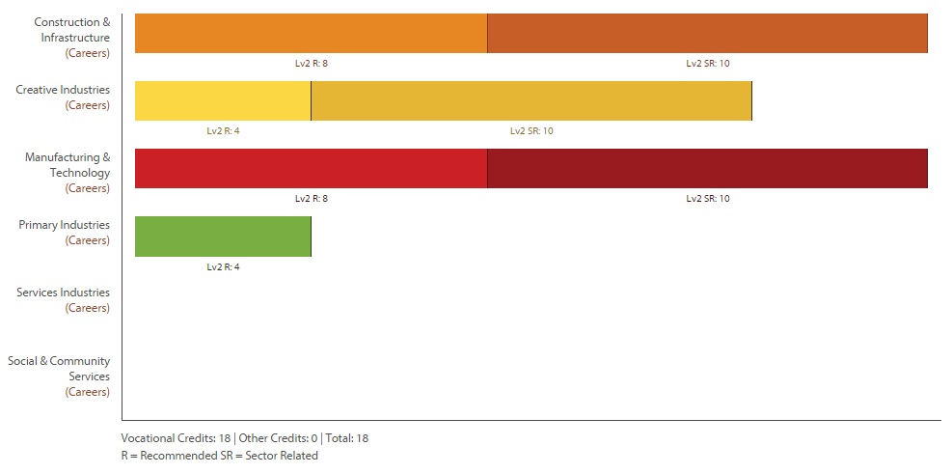

Level Two Urban Farming Return To Contents
NOT OFFERED 2016
Purpose – To develop skills in intensive food production for local supply. Students will learn how to produce large amounts of organic food from small urban spaces, using only local materials. Local marketing and distribution is also taught, so that students can develop their own small business while they are on the course, as well as supplying their family with food.
Pathway – This course leads to Level Three Urban Farming, which adds more skills, particularly in planning a commercial operation. However, students will have the skills to start earning an income from home before the course is complete. Highly-motivated students in this course will have the opportunity to sit any unit from the level three course.
Recommended Entry – Open
Course Outline – Local food supply is becoming more and more important as oil prices continue to rise in the long term, and as people become more aware of the economic and health benefits of locally-produced food. Students learn how to produce top quality compost from local materials, grow annual and perennial crops, control pests using non-toxic methods, and sell produce to the public.
Course Fees – There are no course fees. Students will be expected to sometimes work in the rain, we have some spare wet weather gear but students are expected to have their own and keep it at the farm unit. We can supply gumboots.
Assessment Information – 19 Level 2 credits, 5 Level 3 credits, (0 External) -
- US 23541 Safety in the rural workplace (practical, with report) 5 Credits
- US 19138 Monitor and interpret weather information (theory) 4 Credits
- US 20571 Care for nursery crops (practical) 10 Credits
- US 21045 Composting (practical and theory) 5 Credits, L391340: Use the characteristics of a design movement or era to inform own design ideas, (Internal 3 credits), Design and Visual Communication 2.33

Level Three Accounting Return To Contents
Purpose –To build on skills and understanding in Accounting.
Pathway – This course leads to tertiary study like Waikato University or Wintec.
Recommended Entry – Level Two Accounting, or Level One Accounting
Course Outline – This course is aimed at students who have completed some base study in Accounting. They will need to have a good understanding of the process of bookkeeping and how to compile and interpret financial statements. The course looks at doing the accounts for different types of business.
Course Fees – $10 Course Materials.
Assessment Information – 22 Credits (9 External) -
91405 : Demonstrate understanding of accounting for partnerships, Level 3, 4 credits
91406 : Demonstrate understanding of company financial statement preparation, Level 3, 5 credits
91407 : Prepare a report for an external user that interprets the annual report of a New Zealand reporting entity, Level 3, 5 credits (UE Reading and Writing)
91408 : Demonstrate understanding of management accounting to inform decision-making, Level 3, 4 credits
91409 : Demonstrate understanding of a job cost subsystem for an entity, Level 3, 4 credits
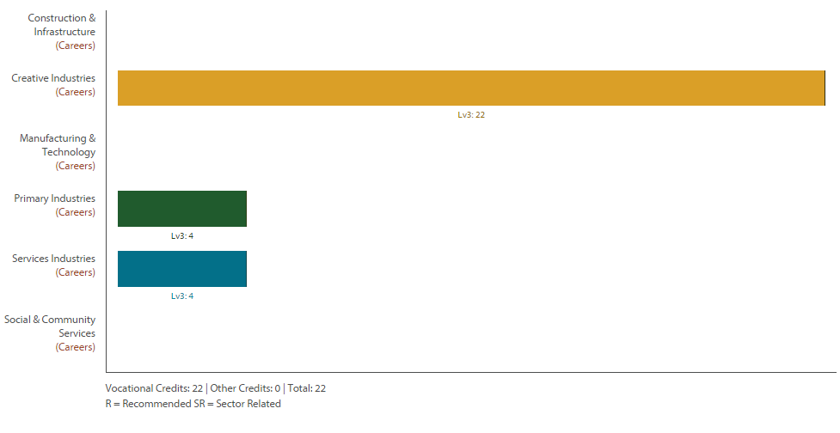

Level Three English Return To Contents
Purpose – English at Waihi College seeks to nurture the key skills you have, and develop them so that you can live and learning today and in the future. English is about thinking; using language, symbols and texts; participating and contributing; relating to others and managing self.
Pathway – This course leads to tertiary study like Waikato University or Wintec.
Recommended Entry – Level Two English, or Level Two Advanced English - including at least one external standard.
Course Outline – This academic course is based around the in-depth study of English literature and language, and is designed for students who wish to study English, or an associated subject, at university level. An opportunity for students to enter for the English Scholarship Examination will be available.
Course Fees – There are no fees with this course.
Assessment Information – Selected from possible 21 Credits (8 External) -
91473 : Respond critically to specified aspect(s) of studied visual or oral text(s), supported by evidence, Level 3, 4 credits
(UE Writing)
91474 : Respond critically to significant aspects of unfamiliar written texts through close reading, supported by evidence, Level 3, 4 credits (UE Reading and Writing)
91475 : Produce a selection of writing which develops, sustains, & ideas, L3, 6crds (UE Writing)
91476 : Create & deliver fluent & coherent oral text develops, sustains, & structures ideas, L3, 3crds
91479 : Develop informed understanding of literature and/or language texts, L3, 4crds (UE Reading)
91480 : Respond critically to significant aspects of visual and/or oral text(s) through close reading, supported by evidence, Level 3, 3 credits

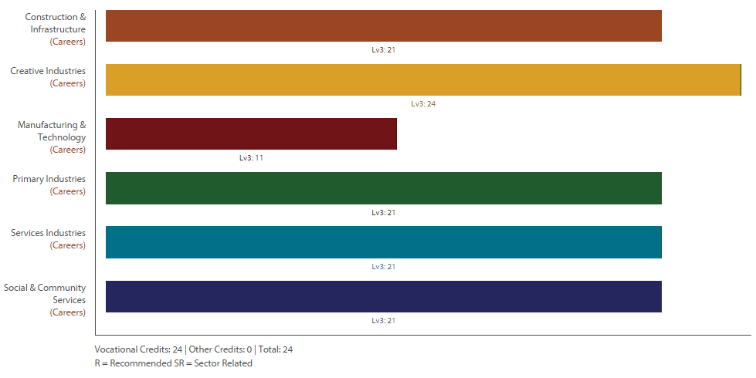

Level Three Agriculture Return To Contents
Not Available 2016
Purpose – To develop theoretical knowledge and scientific skills in agriculture.
Pathway – This course leads to tertiary study like Waikato University or Wintec.
Recommended Entry – Level Two Agriculture
Course Outline – This course introduces scientific study to the practice of farming. It also introduces theoretical study of the market forces that affect sup and demand for primary produce, and an investigation into the business model for primary product. Students can also opt for a Level Three dairy Gateway addition to this course. This involves earning Level Three Dairy units by working one day per week on a dairy farm helping with milking, for at least ten days. There is an expectation that the student will have a rain coat that they are prepared to wear in wet weather. There is a very high degree of maturity required with regard to farm safety.
Course Fees – There are no fees with this course. But students will be expected to help with the Waihi College farm fundraising efforts. They will need to have wet weather gear which they can keep at the farm unit. .
Assessment Information – 15 Credits (5 External) compulsory and 12 credits optional …
Compulsory Standards
91528 : Carry out an investigation into an aspect of a New Zealand primary product or its production, Level 3, 4 credits
91529 : Research and report on the impact of factors on the profitability of a New Zealand primary product, Level 3, 6 credits (UE Reading)
91530 : Demonstrate understanding of how market forces affect supply of and demand for New Zealand primary products, Level 3, 5 credits (UE Reading and Writing)
19115: Handle and move livestock. 6 credits Internal
24619: Handle and treat cattle. 6 credits Internal.
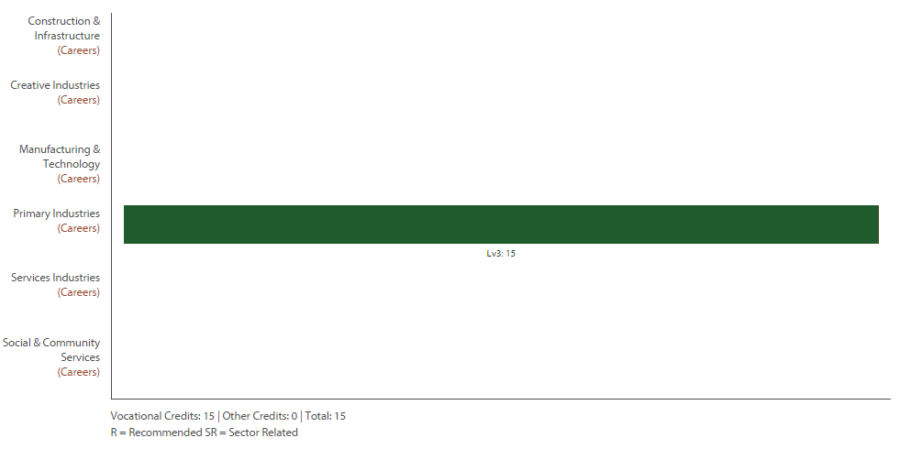
n.b. not all standards were on the profile builder
Level Three Building and Construction Return To Contents
NOT OFFERED 2016 – Gateway placements with local contractors can be arranged.

Purpose – To provide a trade based option for students wishing to continue in the Building industry.
Pathway – This course leads to tertiary study like Wintec an apprenticeship like BCITO.
Recommended Entry – Level Two Building and Construction or Level Two Product Design.
Course Outline – This is a practical and theory based course for those students considering working in the traces or entering Tertiary Education. This is a school based programme that has been planned in conjunction with the Bay of Plenty Polytechnic. Students are expected to enter a Gateway programme as well as completing projects at school. The course also involves visits to building sites and the Bay of Plenty Polytechnic in Tauranga.
Course Fees – $50 for own project materials.
Assessment Information – 13 Credits (0 External) -
- 13000 Knowledge of portable power tools 4 credits Internal
- 24378 Perform building calculations 4 credits Internal
- 13032 Demonstrate knowledge of non-mechanical construction equipment 1 credits External
Optional
- 24354 Demonstrate knowledge of safe work practices in a BCAT workplace. 4 credits Internal

Level Three Mathematics with Calculus Return To Contents
Purpose – To develop knowledge and skills of Calculus Techniques.
Pathway – This course leads to tertiary study like Waikato University or Auckland University.
Recommended Entry – Level Two Advanced Mathematics - including Calculus (91262) and Algebra (91261).
Course Outline – Mathematics with Calculus is the most advanced Mathematics course offered at Waihi College. Trigonometry and simultaneous equations are assessed internally. There are three external topics including differentiation, integration and complex numbers.
Course Fees – $25 for a course book and a graphical calculator (which is essential at this level of maths).
Assessment Information – 24 Credits (17 External) -
91573 : Apply the geometry of conic sections in solving problems, Level 3, 3 credits
91575 : Apply trigonometric methods in solving problems, Level 3, 4 credits
91577 : Apply the algebra of complex numbers in solving problems, Level 3, 5 credits
91578 : Apply differentiation methods in solving problems, Level 3, 6 credits
91579 : Apply integration methods in solving problems, Level 3, 6 credits
91587 : Apply systems of simultaneous equations in solving problems, Level 3, 3 credits

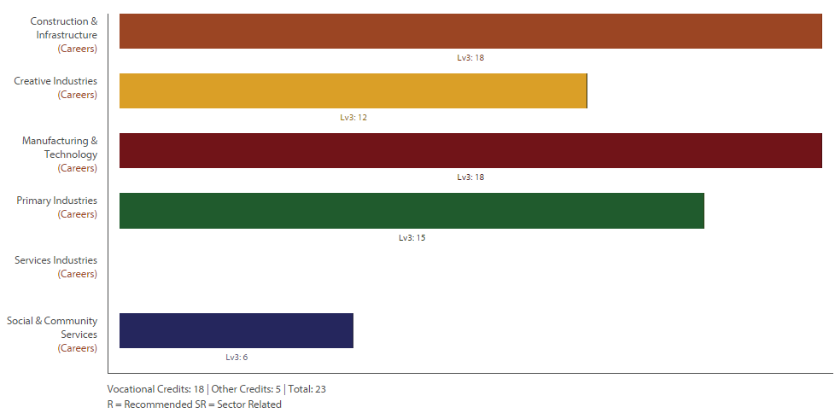

Level Three Chemistry Return To Contents
Purpose – To better understand the world around us at the molecular level. To more fully appreciate future challenges facing humankind – pollution, treatment of disease, climate change and the need for clean energy – and the opportunities presented by new technologies.
Pathway – This course leads to tertiary study like Waikato University or Auckland University.
Recommended Entry – Level Two Chemistry (including passing external papers from 91164, 91165, 91166)
Course Outline – This course continues to provide a good grounding in the basics of Chemistry. Students will do a practical investigation into the levels of a chemical (e.g. vitamin C – ascorbic acid) and carry out a research assignment on a chemical process. A third internal standard looks at Electrochemistry. Theory topics will include bonding and enthalpy changes, organic chemistry, and aqueous equilibria. The course can lead to further studies of Sciences and a huge range of study and career opportunities.
Course Fees – $10 for a course book.
Assessment Information – 25 Credits (15 External – the 3rd external (aqueous) is optional) -
91387 : Carry out an investn in chemistry involving quantitative analysis, Level 3, 4 credits (UE Writing)
91389 : Demonstrate understanding of chemical processes in the world around us, Level 3, 3 credits (UE Reading and Writing)
91390 : Demonstrate understanding of thermochemical principles and the properties of particles and substances, Level 3, 5 credits
91391 : Demonstrate understanding of the properties of organic compounds, Level 3, 5 credits
91392 : Demonstrate understanding of equilibrium principles in aqueous systems, Level 3, 5 credits
91393 : Demonstrate understanding of oxidation-reduction processes, Level 3, 3 credits 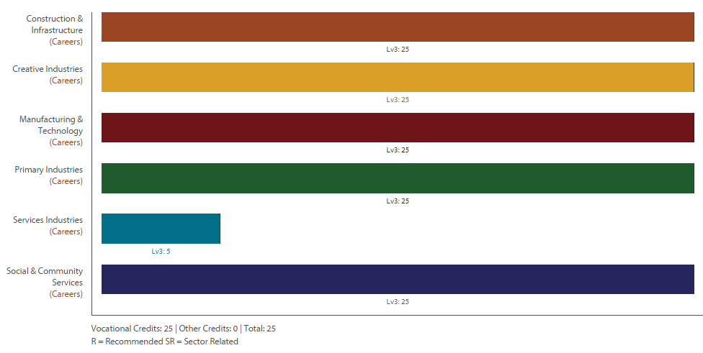

Level Three Drama Return To Contents
Purpose – To develop knowledge and skills in Drama and establish academic and professional pathways.
Pathway – This course leads to tertiary study like Auckland University or Unitec.
Recommended Entry – Level Two Drama (recommended) or an established interest in the subject area.
Course Outline – The Year 13 Drama programme is a year of increasing self-reliance, self-discipline and experimentation through a range of dramatic opportunities culminating in the Individual Project. The course offers workshops in Extended Dramatic Technique, Genre Exploration and Devising. Students will attend professional theatrical productions as a part of their coursework. It also completes the student’s preparation for entry into tertiary study and continues to offer first hand experiences of Drama related professions and enables students to form professional relationships with potential employers. It also encourages students to realise their plans for their own business endeavours.
Course Fees – $20 and $48 Field Trip (Red Leap)
Assessment Information – 18 Credits (4 External) -
91512 : Interpret scripted text to integrate drama techniques in performance, Level 3, 4 credits (UE Reading)
91513 : Devise and perform a drama to realise a concept, Level 3, 5 credits
91517 : Perform a substantial acting role in a significant production, Level 3, 5 credits (UE Reading)
91518 : Demonstrate understanding of live drama performance, Level 3, 4 credits (UE Writing)

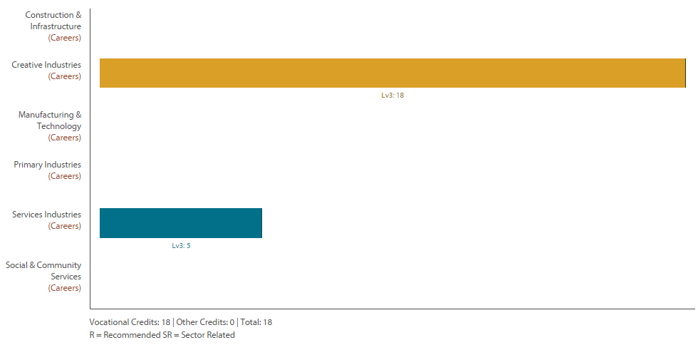

Level Three Catering Return To Contents
Purpose – To further develop skills in the cooking and presentation of food as well as nutrition and food safety.
Pathway – This course leads to tertiary study like Wintec or BOP Polytechnic.
Recommended Entry – Level Two Catering is useful but not essential.
Course Outline – Level Three Catering is a combination of Technology Achievement Standards and Service IQ Industry Standards. The Technology Achievement Standards include one which relates to the Processing of Cream Puffs plus two others which will culminate in the students running a café. One Service IQ standard focusses on healthy eating and the other on culinary products and terms. This course is flexible and will depend on what the students’ needs are so Level Two Service IQ Cookery Skills units can be added to this course if needed. Level Three Catering students are expected to help with catering for school functions and they will be involved in the running of at least one café throughout the year.
Course Fees – $70.
Assessment Information – 29 Credits (0 External) - Standards will be chosen from…
- 13343 Demonstrate knowledge of basic nutrition in commercial catering (Internal 5 Credits)
- 18497 Unit Demonstrate knowledge of culinary products and terms (Internal 8 Credits)
- 91609 : Undertake project management to support technological practice, Level 3, 4 credits
- 91611 : Develop a prototype considering fitness for purpose in the broadest sense, Level 3, 6 credits
- 91643 : Implement complex procedures to process a specified product, Level 3, 6 credits

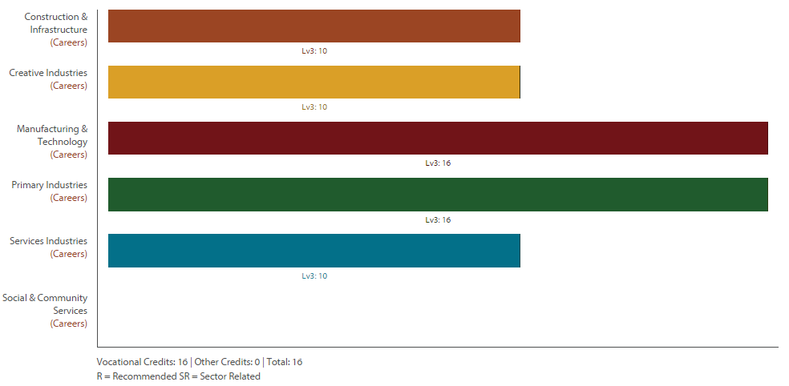
n.b two of these standards were not on the profile builder at the time of printing this document.

Level Three Ecological Studies Return To Contents
NOT AVAILABLE IN 2016
Purpose – To prepare students for study, and a career as an environmental consultant, sustainability consultant or biological farming consultant, assisting farms and other businesses to become more sustainable. This is also a valuable area of knowledge for any business management role.
Pathway – This course leads to tertiary study in ecological science, sustainability or biological farming. Courses in these subjects are available at every New Zealand University.
Nearly all businesses are now aware of the need to use sustainable practices: to reduce costs, to ensure the long-term supply of their raw materials, to give them a marketing advantage and to increase their income. Every human activity, be it social or business, is dependent on the ecology for survival. Most of the ecological zones on Earth are deteriorating in their ability to support life, and we are losing thousands of species to extinction every year. You could be one of the people fixing the most important problems on the planet.
Recommended Entry – Students who have achieved in any Level 2 English achievement standard, or Merit in any Level 1 English achievement standard will be given priority. Ideally you will have studied Biology.
Course Outline – Students will complete three projects:
• Design and implement a pest control system for Waihi College (especially the farm unit and Hollis Bush) to control rats, possums and mustelids.
• Investigate a local biophysical environment and discover the inter-relationships between people, businesses, plants, animals and the land itself. Make recommendations about how the local community could ensure their environment stays healthy, and continues to provide them, including businesses, with all their ecological needs.
• Work with a business or organisation of your choice, to improve their sustainability, or help them to promote sustainable practices in the community (depending on the type of organisation you choose). This will be a real-life research project with real-life results.
You will be given support and tuition in a range of skills and knowledge, but you will need to be self-motivated and ready to take on a challenge. These are the support topics we will be covering: What is “sustainability”? (This includes a study of soils, which is the key concept in sustainable practices.) What is a “biophysical environment”? What are “different social perspectives”? How to interview and survey scientifically and safely; risk management; report writing & log keeping; critical thinking; self-directed learning; researching & academic referencing; wildlife surveying; formal communication to groups; planning and project management.
Course Fees – There are no course fees.
Assessment Information – 25 Level 3 credits, all internal.-
- US 22175 Soil properties and their effect on plant growth (theory) 10 Credits
- AS 90828 A personal sustainable action (practical and theory) 6 Credits
- AS 90829 The interrelationships in a biophysical environment (practical and theory) 4 Credits
- AS 90832 Develop a sustainable strategy for an organisation (practical and theory) 5 Credits

Level Three Geography Return To Contents
Purpose – Geography gives students a multidisciplinary or holistic view of the world, combining knowledge, skills, and understandings of the physical and social sciences. It fosters a curiosity about place and space, and provokes questions about natural and cultural environments and their interconnectedness. Geography provides opportunities through fieldwork for first-hand investigations of places, environments, and human activities. It helps students make sense of complex issues such as climate change, ageing populations, urban growth, land conflicts, globalisation, and sustainability.
Pathway – This course leads to tertiary study like Waikato University or Auckland University.
Recommended Entry – Level Two Geography.
Course Outline – The Year 13 course expands and broadens students understanding of natural and cultural environments. The course focuses on coastal processes, tourism development, population studies, global topics, geographic issues and research skills. There are a variety of case studies from NZ and around the world eg. Rotorua, Nepal. This is an achievement standard course, which includes both internal and external assessments.
Course Fees – $2500 approx (Fiji trip).
Assessment Information –22 Credits (8 External) -
91427 : Demonstrate understanding cultural process shapes Geo environment(s), L3, 4 crds (UE Reading and Writing)
91428 : Analyse a significant contemporary event from a geographic perspective, L3, 3 crds (UE Reading)
91429 : Demonstrate understanding of a given environment(s) through selection and application of geographic concepts and skills, Level 3, 4 credits (UE Reading and Writing)
91430 : Conduct geographic research with consultation, Level 3, 5 credits
91431 : Analyse aspects of a contemporary geographic issue, Level 3, 3 credits (UE Reading)
91432 : Analyse aspects of a geographic topic at a global scale, Level 3, 3 credits

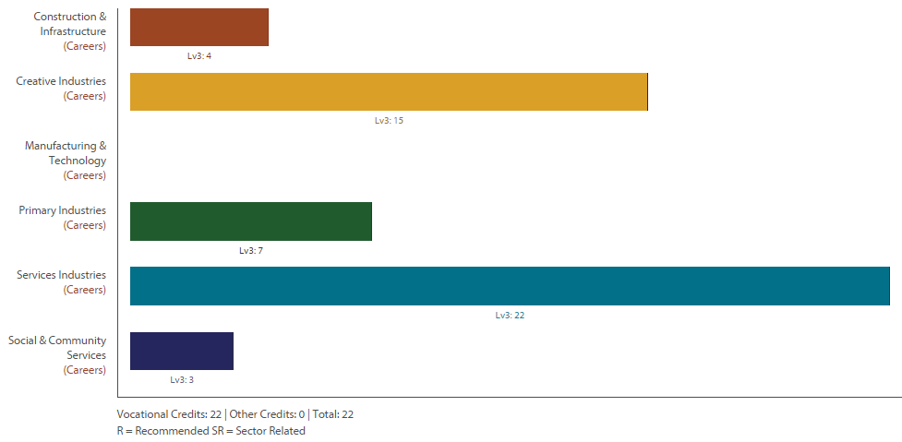

Level Three Graphics (DVC) Return To Contents
Purpose – Graphics (aka Design and Visual Communication) develop knowledge and skills in designing Architecture and Products. .
Pathway – This course leads to tertiary study like BOP Polytechnic or Auckland University.
Recommended Entry – Level Two Graphics.
Course Outline – This course challenges students to think about the fundamentals of design and how this is used in developing Products and Architecture. Briefs or units of work are used to solve Architecture and Product design problems. Design Skills, Drawing Skills, Computers, and Presentation Skills are all used to help solve these design problems. Students will Learn to use sketching techniques, produce formal drawings using instruments, computer presentation and computer drawing programmes.
Course Fees – Own equipment and stationery.
Assessment Information –22 Credits (10 External) -
91627 : Initiate design ideas through exploration, Level 3, 4 credits
91629 : Resolve a spatial design through graphics practice, Level 3, 6 credits
91630 : Resolve a product design through graphics practice, Level 3, 6 credits
91631 : Produce working drawings to communicate production details for a complex design, Level 3, 6 credits

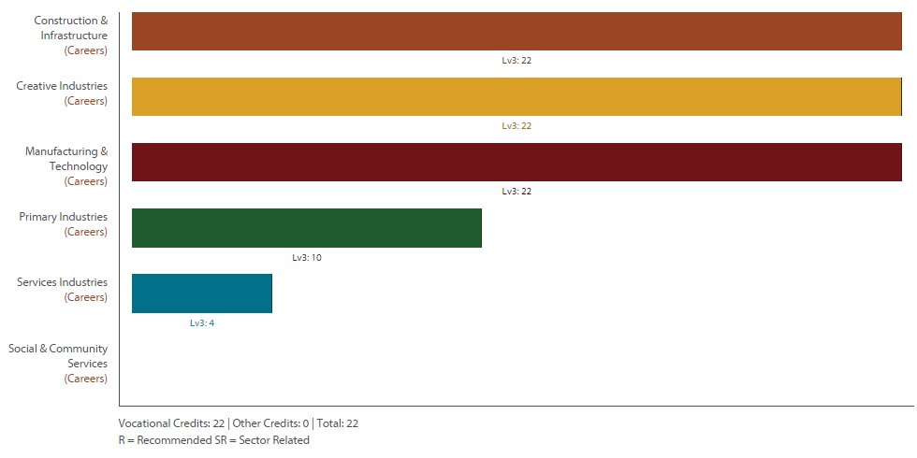

Level Three Health Education Return To Contents
Purpose – To develop knowledge and understanding of Health Issue in NZ and the wider society.
Pathway – This course leads to tertiary study like BOP Polytechnic or Waikato University.
Recommended Entry – Level Two Health.
Course Outline – This subject looks in greater depth at the topics covered in level 2 building on student’s prior knowledge and experience. Subjects covered include sexuality, relationships, dealing with stress and communication.
Ideally this course is designed for students that have an aim to go into medical/health vocations. There is an emphasis on the differences of traditional western medicine and alternative medical treatments.
Course Fees – $50 for a one day field trip.
Assessment Information –19 Credits (5 External) -
91461 : Analyse a New Zealand health issue, Level 3, 5 credits (UE Reading)
91462 : Analyse an international health issue, Level 3, 5 credits (UE Reading and Writing)
91463 : Evaluate health practices currently used in New Zealand, Level 3, 5 credits (UE Reading)
91464 : Analyse a contemporary ethical issue in relation to well-being, Level 3, 4 credits (UE Reading)

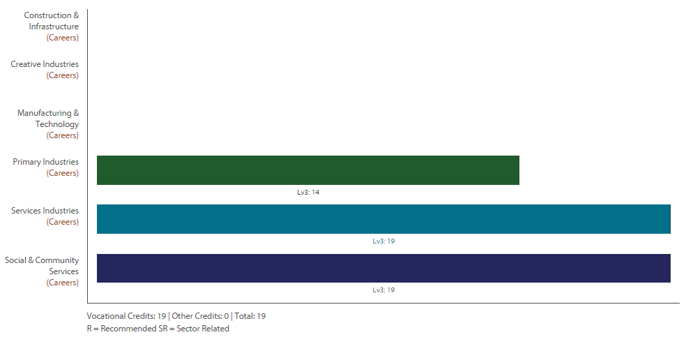

Level Three History Return To Contents
NOT OFFERED 2016
Purpose – To develop knowledge and skills in History.
Pathway – This course leads to tertiary study like Auckland University or Waikato University.
Recommended Entry – Level Two History or Level Two English.
Course Outline – Good literacy and previous History experience will be helpful for success but not essential. Good English skills and background in current affairs are also assets. There are fifteen internal credits available for research and script writing. External assessment focuses on resource interpretation and essay writing. The main course centres on Tudor-Stuart England 1588 – 1666 while there is a NZ component in internal assessment. There are many tertiary courses for which history is valuable preparation, particularly in essay writing.
Course Fees – There are no course fees.
Assessment Information –25 Credits (6 External) -
91434 : Research an historical event or place of significance to New Zealanders, using primary and secondary sources, Level 3, 5 credits
91435 : Analyse an historical event, or place, of significance to New Zealanders, Level 3, 5 credits
91436 : Analyse evidence relating to an historical event of significance to New Zealanders, Level 3, 4 credits
91437 : Analyse different perspectives of a contested event of significance to New Zealanders, Level 3, 5 credits
91438 : Analyse the causes and consequences of a significant historical event, Level 3, 6 credits

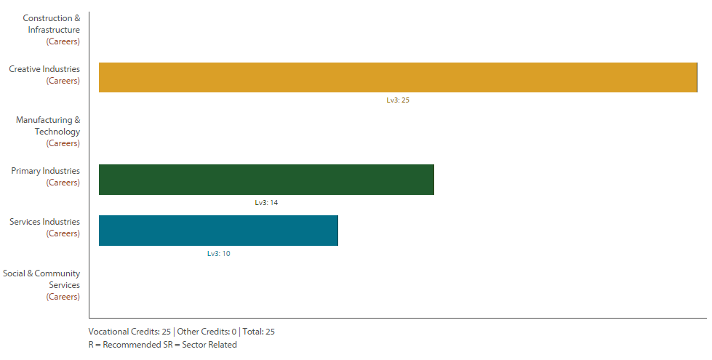

Level Three Media Design Return To Contents
Purpose – To develop knowledge and skills with design programmes while learning the principals and elements of design to enable students to apply for Tertiary Study.
Pathway – This course leads to tertiary study like BOP Polytechnic or Waikato University.
Recommended Entry – Level Two Media Design.
Course Outline – Students will be working closely with clients to develop a variety of outcomes. These may include print, website, or moving image. The students will have a chance to develop skills in Dreamweaver, Illustrator, Photoshop, Flash, Sony Vegas and Microsoft products.
Course Fees – Usual fees and print credit.
Assessment Information – 26 Credits (14 External) -
- 91440 : Analyse methods and ideas from established design practice, Level 3, 4 credits
- 91445 : Use drawing to demonstrate understanding of conventions appropriate to design, Level 3, 4 credits
- 91450 : Systematically clarify ideas using drawing informed by established design practice, Level 3, 4 credits
- 91455 : Produce a systematic body of work that integrates conventions and regenerates ideas within design practice, Level 3, 14 credits

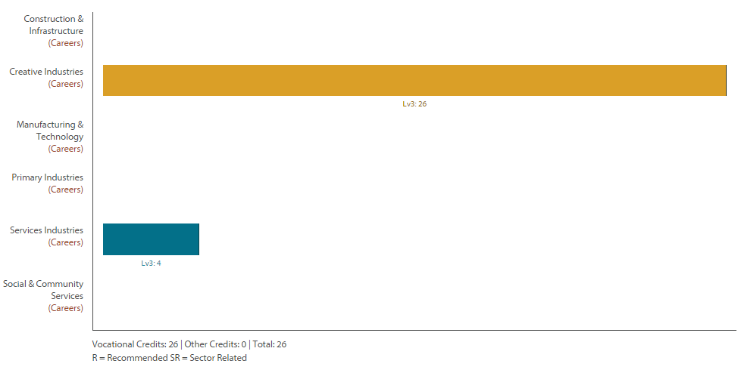

Level Three Music Return To Contents
Purpose – To develop knowledge and skills in Music.
Pathway – This course leads to tertiary study like the New Zealand School of Music or Auckland University or Waikato University.
Recommended Entry – Level Two Music (or through an interview with TIC of Music).
Course Outline – Level 3 Music is an advanced course around performance and composition. Students will be expected to produce portfolio of work based around performing their own music and that of others. This may be done in a number of formats, which will be decided in discussion with teacher at the start of year. More credits will be available through involving in group performance. Students will select which standards they wish to complete based on their strengths and fields of interest.
Course Fees – $25.
Assessment Information – Most students will do (other standards available depending on interest) -
91416 : Perform two programmes of music as a featured soloist, Level 3, 8 credits
91418 : Demonstrate ensemble skills by performing two substantial pieces of music as a member of a group, Level 3, 4 credits
91419 : Communicate musical intention by composing three original pieces of music, Level 3, 8 credits
91423 : Examine the influence of context on a substantial music work, Level 3, 4 credits
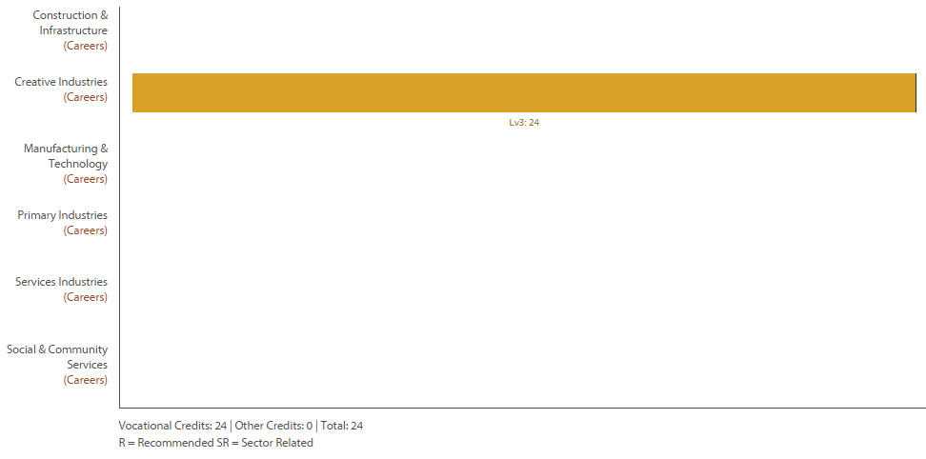
Level 3 Outdoor Education Return To Contents
Purpose – To develop knowledge, skills and experience in a range of outdoor pursuits. It prepares individuals with the skills needed for outdoor such jobs as park rangers, pest control operators, Search and Rescue.
Pathway – This Level 3 course provides experience and expertise leading to increased competence and confidence in a wide range of outdoor activities. It provides 20 Level 3 credits.
Recommended Entry – This is a full on outdoor experience course. Students joining this course can expect to be challenged physically and mentally in the best that mother nature provides.
Course Outline – Waihi College will be offering a Level 3 Outdoor Education course however at the time of print, the course content has not yet been finalised. The course will offer a minimum of 20 Level 3 Unit Standards, focusing on preparing individuals to operate safely and competently in outdoor environments. Course content will include: Risk Management, Environmental Sustainability, Personal Safety, Personal Competency. Students will choose to work in a range of contexts from the following list: Abseiling, Rock Climbing, Tramping, Kayaking, Sea-kayaking, High and/or Low Ropes, and Mountain biking
Course Fees – $550.00. This covers the cost of transport, equipment hire as needed and expert providers.
Assessment Information – This course uses unit standard at Level 3.
This course is the first part of a New Zealand Certificate in Outdoor Experiences (click here). The New Zealand Certificate is 40 Level Three Credits. What will be offered here at the college will be at least half of these standards (these will contribute to Level Three NCEA)…
- Prepare for their own outdoor experience, taking into account equipment, weather, terrain, and logistic requirements 5 credits
- Manage themselves safely while undertaking an outdoor experience in low risk environments 15 credits

Level Three Art Photography Return To Contents
Purpose – To develop knowledge and skills in the field of Photography.
Pathway – This course leads to tertiary study like Waikato University or Wintec or BOP Polytechnic.
Recommended Entry – Level Two Art Photography or Level Two Art Painting.
Course Outline – This course challenges the student to develop photographic art works and express ideas in a range of photography styles through the study of a number of art photographers’ working methods and ideas. Students expand their repertoire of photography skills, applying what they have learned from practical studies of artist models. These skills are then applied in mixed media artworks which communicate ideas in an extended series of interrelated art works. This culminates in the three panel folio board, the external assessment
Course Fees – Materials and equipment fee: 20 On going costs: print credit.
Assessment Information – 26 Credits (14 External these are assessed as a portfolio/evidence of work there will be no exam) -
91442 : Analyse methods and ideas from established photography practice, Level 3, 4 credits
91447 : Use drawing to demonstrate understanding of conventions appropriate to photography, Level 3, 4 credits
91452 : Systematically clarify ideas using drawing informed by established photography practice, Level 3, 4 credits
91457 : Produce a systematic body of work that integrates conventions and regenerates ideas within photography practice, Level 3, 14 credits

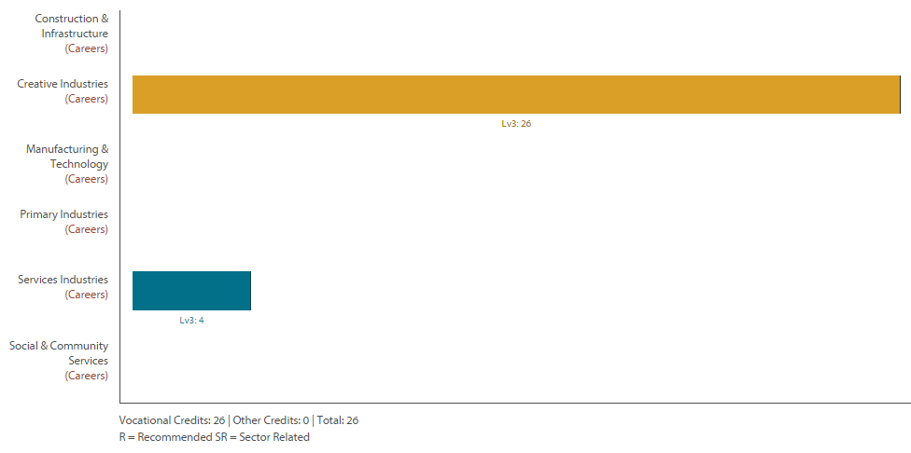

Level Three Art Painting Return To Contents
Purpose – To develop knowledge and skills in the field of Painting.
Pathway – This course leads to tertiary study like Wintec or BOP Polytechnic.
Recommended Entry – Level Two Art Photography or Level Two Art Painting.
Course Outline – This course challenges the student to develop art works and express ideas in a range of painting media and styles through the study of a number of artists’ working methods and ideas. Students expand their repertoire of drawing and painting skills, applying what they have learned from practical studies of artist models. These skills are then applied in mixed media artworks which communicate ideas in an extended series of interrelated art works. The year’s work culminates in the three panel folio board, the external assessment.
Course Fees – Materials and equipment fee: $45.
Assessment Information – 26 Credits (14 External these are assessed as a portfolio/evidence of work there will be no exam) -
91441 : Analyse methods and ideas from established painting practice, Level 3, 4 credits
91446 : Use drawing to demonstrate understanding of conventions appropriate to painting, Level 3, 4 credits
91451 : Systematically clarify ideas using drawing informed by established painting practice, Level 3, 4 credits
91456 : Produce a systematic body of work that integrates conventions and regenerates ideas within painting practice, Level 3, 14 credits

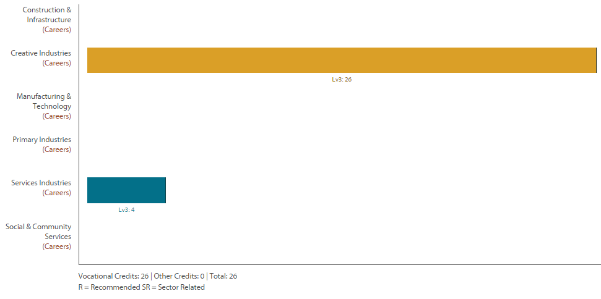

Level Three Physical Education Return To Contents
Purpose – To develop knowledge and skills in Physical Education.
Pathway – This course leads to tertiary study like Waikato University or BOP Polytechnic.
Recommended Entry – Level Two Physical Education
Course Outline – This course focuses on Level 8 of the Health and Physical Education curriculum. It will offer you the opportunity to experience and participate in a wide range of physical activities, in a variety of contexts. You will study how the body moves and responds to physical activity, as well as be able to develop your interpersonal skills in a variety of settings. The main focus of this course is to equip you with the necessary skills to maintain and develop your interpersonal skills in a variety of settings. This is to maintain and develop your personal well-being, both now and in the future; as well as prepare you for future academic and vocational opportunities.
Course Fees – Fees for Mt Biking Camp.
Assessment Information – 18 Credits (4 External) -
91498 : Evaluate physical activity experiences to devise strategies for lifelong well-being, Level 3, 4 credits
91499 : Analyse a physical skill performed by self or others, Level 3, 3 credits
91501 : Demonstrate quality performance of a physical activity in an applied setting, Level 3, 4 credits
91502 : Examine a current physical activity event, trend, or issue and its impact on New Zealand society, Level 3, 4 credits (UE Reading)
91504 : Analyse issues in safety management for outdoor activity to devise safety management strategies, Level 3, 3 credits

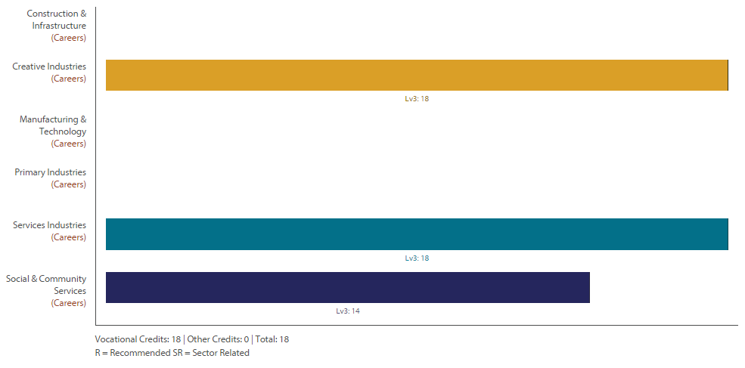

Level Three Physics Return To Contents
Purpose – To expand knowledge and skills in the Physical Sciences.
Pathway – This course leads to tertiary study like Waikato University or Auckland University
Recommended Entry – Level Two Physics specifically in AS91171 (Mechanics) and AS91173 (Electromagnetism)
Course Outline – Physics involves the study of matter and its motion through space and time, along with concepts such as energy and force in order to understand how the universe behaves. In Level Three we bring our understanding of Physics closer to the modern era. Students will further develop their understanding of motion, force, rotation, oscillations, electricity, magnetism, waves and nuclear physics. We will also get a first look into the quantum nature of the atomic world. Physics is used in a wide range of careers such as Architecture, Aviation, Broadcasting, Communications, Computing, Design, Engineering, Geology, Health Services, Meteorology, Research Science, Resource Management, Surveying, Teaching and Transport.
Course Fees – There are no course fees.
Assessment Information – 23 Credits (16 External) -
91521 : Carry out a practical investigation to test a physics theory relating two variables in a non-linear relationship, Level 3, 4 credits
91523 : Demonstrate understanding of wave systems, Level 3, 4 credits
91524 : Demonstrate understanding of mechanical systems, Level 3, 6 credits
91525 : Demonstrate understanding of Modern Physics, Level 3, 3 credits
91526 : Demonstrate understanding of electrical systems, Level 3, 6 credits

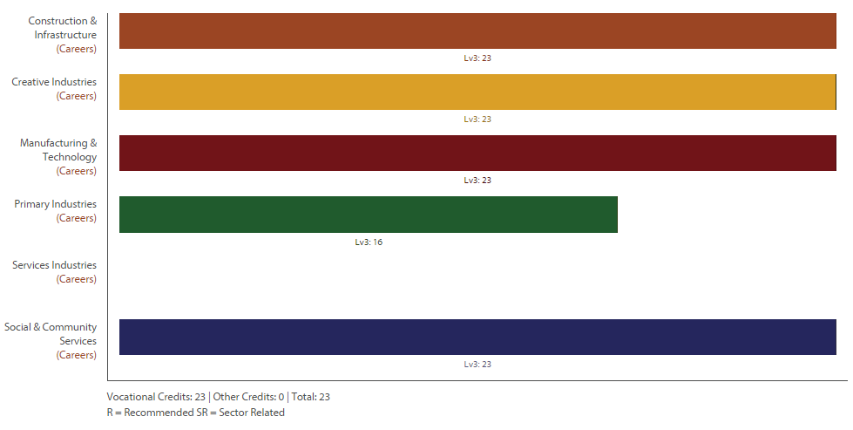

Level Three SPEC Return To Contents
Purpose – SPEC stands for “Specific Preparation for Employment and Citizenship : Developing the Key Competencies” - To develop the key competencies (from the NZ Curriculum Document) and prepare the students for part time and/or full time employment. .
Pathway – This course leads to readiness for employment.
Recommended Entry – Level Two SPEC but this course is open to all students.
Course Outline – This course challenges the students to identify their strengths and prove opportunities to demonstrate the Key Competencies through a personal development programme. At Level Three students are worked with in final preparations for entry into the workforce. Gateway can also sit alongside the SPEC programme and additional unit standards may also be made available where needed
Course Fees – There are no course fees.
Assessment Information – 9 Credits (0 External) -
- 3494: Take notes and write minutes for a formal meeting Level 3 Credits 3
- 1312: Give oral instructions in the workplace Level3 Credits 3
- 1279: Write in plain English Level 3 Credit 3
- Assortment of other Level 3 Unit Standards that students can choose to complete according to their interests and fit in with their Spec Booklets1

Level Three Biology Return To Contents
Purpose – To expand knowledge and skills in the Biological Sciences.
Pathway – This course leads to tertiary study like Waikato University or Auckland University or BOP Polytechnic.
Recommended Entry – Level Two Biology
Course Outline – Biology is the greatest show on Earth – how could you possibly miss the opportunity to study ‘LIFE’. This course covers: modern controversial issues eg stem cells etc; animal and plant relationships to the environment, human evolution (what were our ancestors like and where did I come from); and general evolution. This course prepares you for further studies in the Biology field or just to clarify our place in the natural world.
Course Fees – Course book $32.30 and Trip to Waikato University $16.
Assessment Information – 22 Credits (13 External) -
91602 : Integrate biological knowledge to develop an informed response to a socio-scientific issue, Level 3, 3 crds (UE Reading and Writing)
91603 : Demonstrate understanding of the responses of plants and animals to their external environment, Level 3, 5 crds (UE Reading and Writing)
91604 : Demonstrate understanding of how an animal maintains a stable internal environment, Level 3, 3 credits (UE Reading)
91605 : Demonstrate understanding of evolutionary processes leading to speciation, Level 3, 4 credits (UE Reading and Writing)
91606 : Demonstrate understanding of trends in human evolution, Level 3, 4 credits (UE Reading and Writing)
91607 : Demonstrate understanding of human manipulations of genetic transfer & its implications L3,3crds (UE Reading)
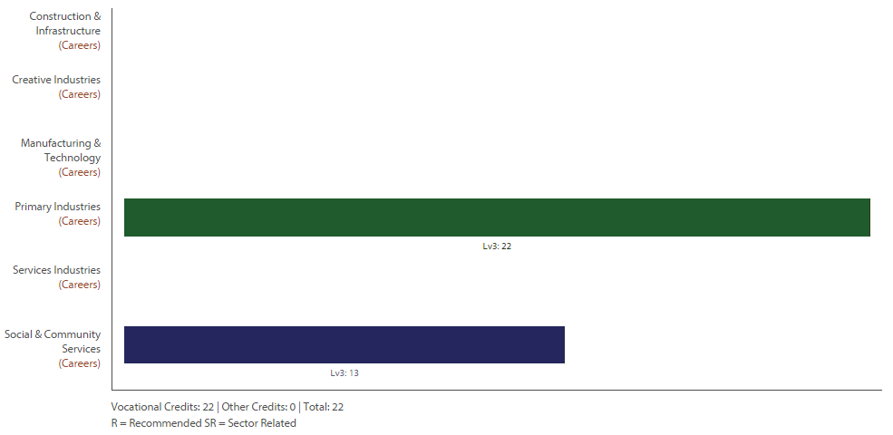

Level Three Mathematics with Statistics Return To Contents
Purpose – To develop knowledge and skills of Statistical Analysis.
Pathway – Statistics at stage one is the most common paper taken at New Zealand Universities. It is a core component of Bachelors of Science, Business, and Medicine. You can study pure a pure statistics qualification at tertiary level in courses like at Waikato University or Auckland University.
Recommended Entry – Level Two Mathematics or Level Two Advanced Mathematics This course has a high Literacy element. Students must have good written communication skills and a high reading and understanding ability.
Course Outline – This course is mostly internally assessed. The only external is Probability Distributions. The internal papers cover, Time Series Data Analysis, Bivariate Data and Formal Inferences and Experiments. Significant time is spent using Excel Spread sheets and new computer software and then writing reports.
Course Fees – Course books $25 and a calculator (graphical calculator is an advantage).
Assessment Information – 19 Credits Compulsory (4 External) – Some students up to 23* Credits.
91574 : Apply linear programming methods in solving problems, Level 3, 3 credits
91580 : Investigate time series data, Level 3, 4 credits
91581 : Investigate bivariate measurement data, Level 3, 4 credits
91582 : Use statistical methods to make a formal inference, Level 3, 4 credits
91583 : Conduct an experiment to investigate a situation using experimental design principles, Level 3, 4 credits
91586 : Apply probability distributions in solving problems, Level 3, 4 credits (*available to some students).

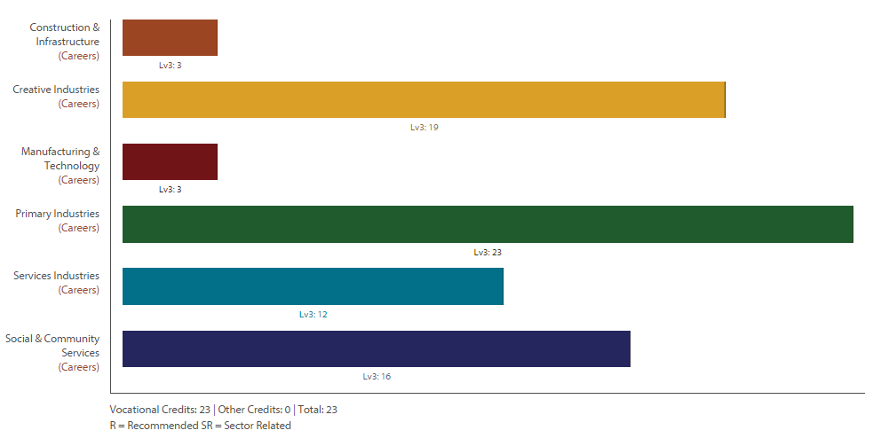

Level Three Technology (Product)
Purpose –To design and manufacture a product in response to a design based problem.
Pathway – This course can lead to Tertiary Programmes.
Recommended Entry – Level Two Product Design with completed Level Two External. Alternative entry can be negotiated with Mr Gerbich.
Course Outline – This course not only requires students to manufacture a specified product but to develop that product to meet the specified needs of the intended user.
Course Fees – $55 and materials related to projects.
Assessment Information – 20 Credits (4 External) –
91608 : Undertake brief development to address an issue within a determined context, Level 3, 4 credits
91610 : Develop a conceptual design considering fitness for purpose in the broadest sense, Level 3, 6 credits
91613 : Demonstrate understanding of material development, Level 3, 4 credits
91620 : Implement complex procedures to integrate parts using resistant materials to make a specified product, Level 3, 6 credits

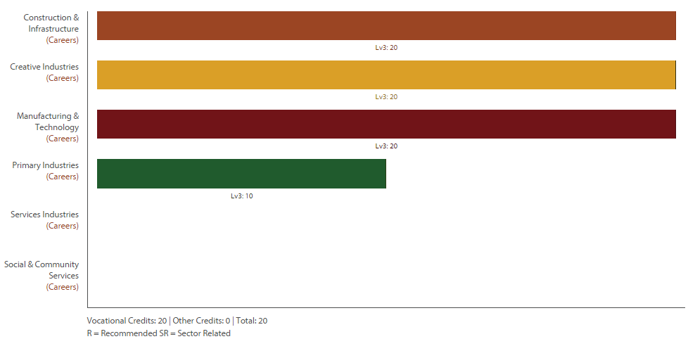

Level Three Textiles Return To Contents
Purpose – To build on skills and understanding of technological practise with soft materials.
Pathway – This course leads to tertiary study like Wintec or BOP Polytechnic.
Recommended Entry – Level Two Textiles.
Course Outline – This course will be tailor made to suit the individuals taking it. It will vary depending on what direction they want to take. An external can be included at the teacher’s recommendation.
Course Fees – $45 to cover materials used in class, and you will need to provide materials for your assignment work. Possibility of visiting local Polytech.
Assessment Information – 18 Credits (0 External) -
91621 : Implement complex procedures using textile materials to make a specified product, Level 3, 6 credits
91626 : Draft a pattern to interpret a design for a garment, Level 3, 6 credits
91643 : Implement complex procedures to process a specified product, Level 3, 6 credits

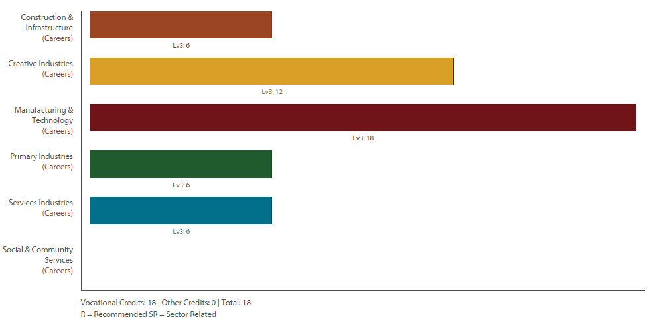

Level Three Travel and Tourism Return To Contents
Purpose – To develop knowledge and skills in Travel and Tourism. This course is designed to help students take the first step into careers in travel and tourism industries: aviation, travel, tourism, museums, retail, wholesale and hospitality.
Pathway – This course leads to tertiary study like NZ School of Tourism or Wintec or BOP Polytechnic.
Recommended Entry – Level Two Travel and Tourism
Course Outline – This course, based around Unit Standards, aims to deepen students’ understanding of the Travel and Tourism Industry. It is designed for students who are serious about a career in the industry and builds from Level Two. The course involves thorough research of different destinations, plus a closer look at how the industry operates. Credits count towards the National Certificate in Travel & Tourism.
Course Fees – Fees for first aid.
Assessment Information – 18 Credits (0 External) -
24725 Unit Describe and analyse the economic significance of tourism 4 Credits
24733 Unit Describe and promote a New Zealand tourist destination 4 Credits
3727 Unit Demonstrate knowledge of Pacific Island countries as visitor destinations 5 Credits
18221 Unit Complete tourism and travel administration tasks and use office equipment 3 Credits

