Waihi College
Charter
2017
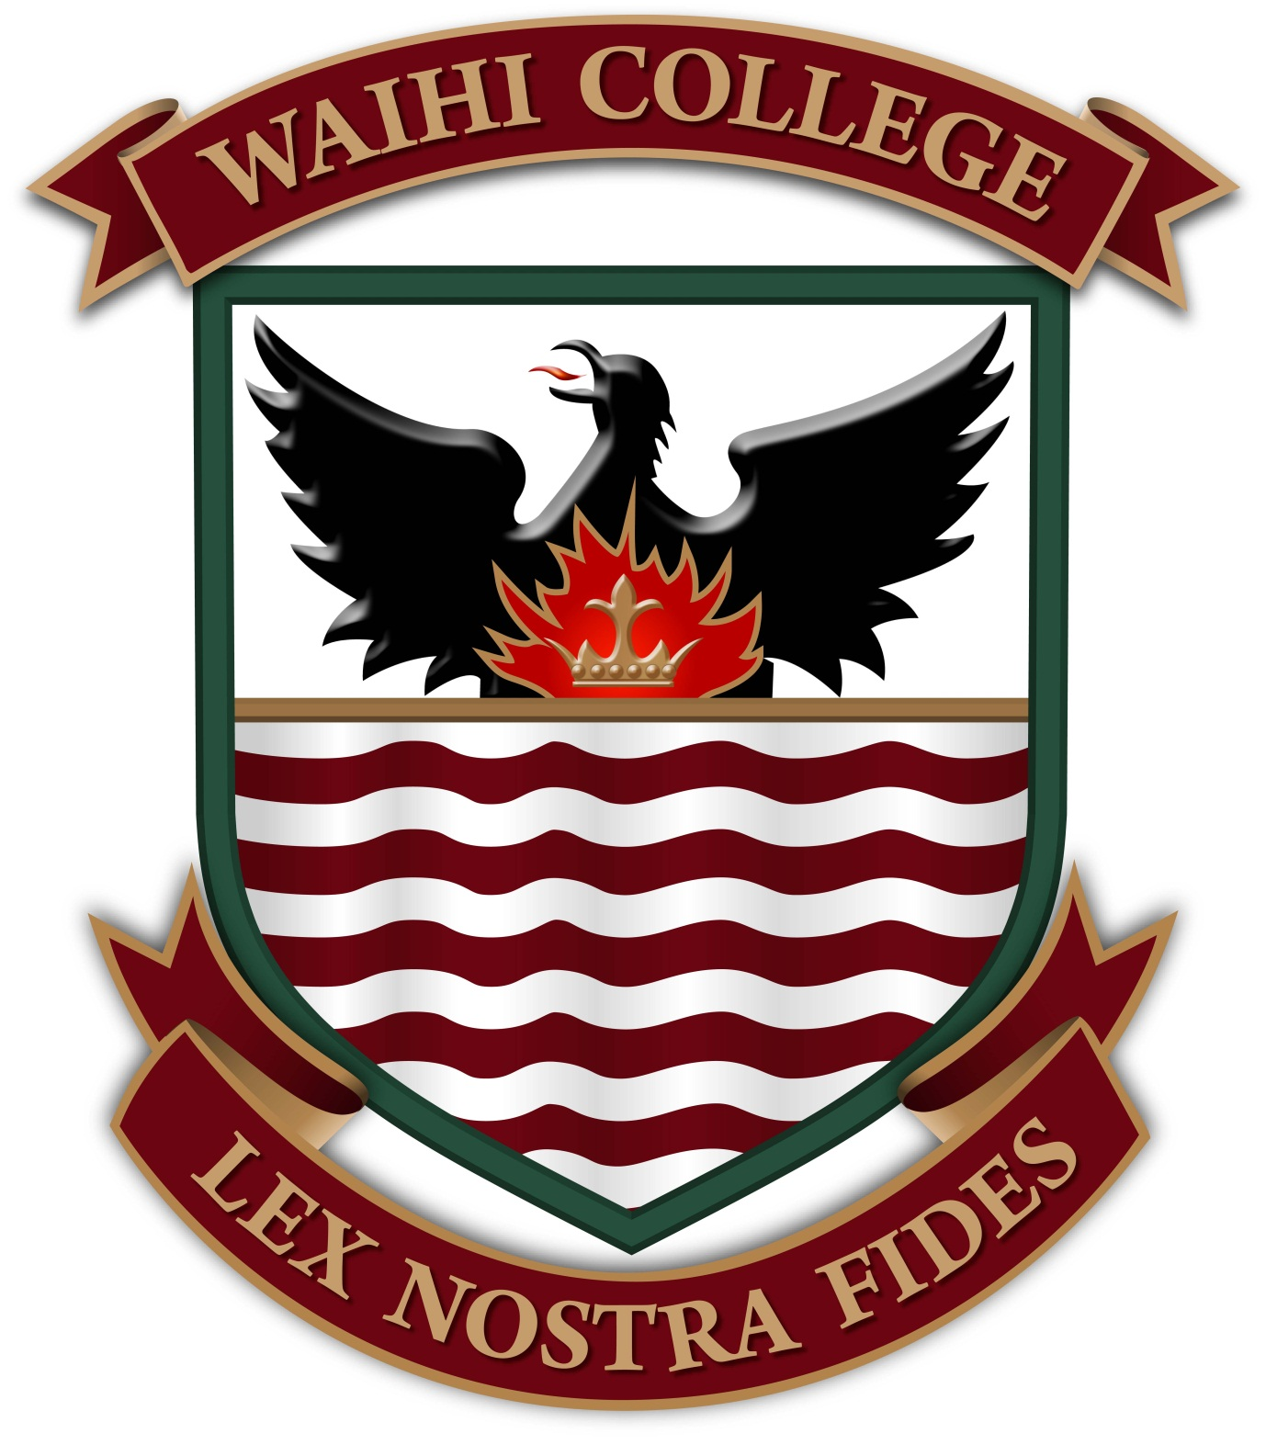
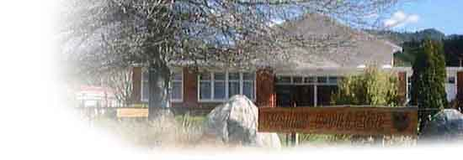

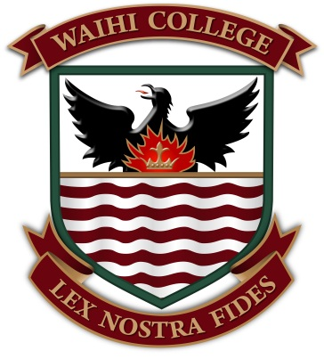

WAIHI COLLEGE
Charter
2017

Mission Statement
“Waihi College supports students on their life long journey to develop the knowledge, skills and characteristics that form the foundation of success today and in the future.
Cornerstone to the success of our students is the strength of relationships formed between the school, whanau and community which support each student to reach excellence in their chosen field of endeavour”.

Vision
Our continuing challenge is to master the art of blending the old with the new that sees the transformation of our teaching and learning environments and programmes to better meet the needs of our 21st Century learners.
Our students will construct their learning with our support, using transferable skills to solve problems using critical thinking strategies, working both collaboratively and independently, to become confident effective communicators, as they pursue their goals of achieving excellence, while remaining loyal to the values our school is built on.
Our school will commit to an on-going programme of self-reflection and review that pursues improvement in all that we do. Central to this improvement will be the professional learning of our staff as they challenge themselves to be passionate educators committed to the success of our students.
The success our students achieve will be forged on strong relationships between themselves, our school, whānau, and the community as we contribute to meeting each student’s personalised learning plan.

Our school welcomes diversity and will provide opportunities for all learners to learn and achieve in an inclusive and supportive environment. We acknowledge that our vision cannot be achieved alone and we will be actively seeking the support of parents, families, whanau and the wider community.
Value Statements and Principles

To achieve our Mission/Vision Waihi College will focus on:

VALUES:
- Manaakitanga/Respect (Ourselves, Others and Environment)
- Excellence/Step it Up (High Standards/’the best that you can be”)
- Connectedness/Always be prepared (engaging with the world around us)
- Collaboration (working in partnership with others)
- Innovation (taking risks with positive intent)

Supporting these values the following Principles will be woven into the culture of learning in our school as we endeavour to produce young adults who will become contributing citizens to our society.

PRINCIPLES
- Our Community
  - Citizenship
- A caring supportive and friendly environment
- Are treated with respect and consideration
- Honesty, courtesy and reliability are key values that are expected and encouraged and everyone is expected to be accountable for their actions
- To develop a sense of belonging for all
  - Participation
- Participation in a wide range of activities, both in school and in the wider community
- To involve themselves in work and activities that are for the common good of the community
- Learning experiences (local, national & global) that make connections with the lives of our students and are supported by the community and society
- A responsibility to involve ourselves in community activities and to share in the development of public/community opinion
  - Cultural Heritage
- Recognises that Waihi is a unique community and reflects our bicultural heritage and our multicultural society in all our practices

- Our Learning
  - Authentic (Active participation – enrichment – connections)
- Learning to Learn is the purpose of the school
- Students are taught to learn and to become active, confident, creative and innovative learners and thinkers
- Learning is an enjoyable process
- Students are prepared to be lifelong learners who possess the qualities of Resilience, Resourcefulness, Reflectiveness and Reciprocity
- Future Focus
  - Coherence
- Clear learning pathways and guidance to enable seamless transitions through the school and into further education and employment
  - Future Focus
- Every individual is continually challenged to be open minded to others views and contributing their opinions towards thinking about the future

Treaty of Waitangi Commitments:
Waihi College aims to develop and implement policies and practices that reflect being part of a bicultural and multicultural community and the unique position that Māori has in New Zealand culture. All reasonable steps are taken to provide instruction in tikanga Māori and te reo Māori for full time students whose parents ask for it.

Te taonga tino rangatira hei koha. Ki nga rangatahi. Ko tono reo ano ma tona reo ano Ka taea e ia te nanao atu nga taonga a ona matua tupuna. Kia taunga ai tana tu i mua i tana iwi whanui o tenei ao, me a rato tikanga hoki.
The richest gift children can receive is the gift of their own language. Through it they can draw on the heritage of their people, stand tall in others’ presence and reach out to share it with people of other cultures.

Our Graduates will be:
C

Other Documents that inform this Charter include:
- Board of Trustees Governance Policies
- Board of Trustees Operational Procedures
- 5 Year Property Plan and 10 Year Maintenance Plan
- ERO and Annual reporting
- Curriculum planning and review reports
- Audited Financial Reports.
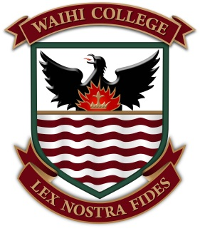
GENERAL DESCRIPTION OF THE SCHOOL AND COMMUNITY

Waihi College is a Year 7-13, co-educational state secondary school situated in Kensington Road off State Highway 2, 64 km north of Tauranga and 94 km east of Hamilton.

The roll of the school at 1st March 2017 was 718. (Including 35 Foreign Fee Paying Student)
The students are predominantly European with a current Māori roll of 34%. Families come from varied socio-economic groups and we are a Decile 4 school. In recent years we have seen a significant increase in the number of International Fee paying students.

Students are drawn from between the Athenree and the Karangahake Gorges. Waihi has an approximate population of 4000, with Waihi Beach providing another 3000. Other educational institutions in the area are: Play Centre, Kohanga Reo, Kindergarten and six Primary Schools.

The school is 56 years old and has had numerous Capital Works upgrades over the last ten years. The school has expansive grounds (11 hectares), with the most obvious special physical feature being the Farm Unit. 8.2 hectares of agricultural-horticultural land has been leased for over 40 years from the Department of Conservation.

The Waihi District is a dynamic one which continues to undergo change and the school’s community is representative of the local community. Waihi and district is a mixture of mining, farming, horticulture and electronic industry backgrounds. In recent years there has also been some growth in tourism and small business development.

Waihi College is a part of the Waihi Community of Learning/Kahui Ako. The Community of Learning covers the wider Waihi Basin and Beach and encompasses six schools, over 100 teachers and over 1600 students. Alistair Cochrane is the Lead Principal for the Waihi Community of Learning/Kahui Ako.

The ethnic composition of the district is mainly European with many long established farming and mining families. The Māori community in Waihi is well established, but has no single tribal affiliation. However we align our local protocols clearly with Hauraki Māori and are working to develop a set of Hauraki Māori Cultural standards which will guide our developments into the future. The Community Marae serves as a focal point for community sentiments and provides facilities to enable local people to embrace all things Māori .

Community expectations of the College are high and the College strives to fulfil those expectations. Relationships between the College and the community are strong and College facilities are made available at all times, at the discretion of the Board of Trustees, for wide-ranging community use. These activities will continue to be encouraged. Community/School relations are generally very good and there is no shortage of support for school activities.

Waihi College Strategic Plan 2017 - 2019

Strategic Goals | 2017 Goal | 2017 Target | 2018 Goal | 2019 Goal
Goal 1: Curriculum and Assessment  Implement the intent of NZC  Improve student achievement and progress | - Improved NCEA Level 1 to 85%  - NCEA Level 2 85%  - Y7-10 Connected curriculum learning programme (Inquiry based and Key competencies infused)  - Improve Māori and Pasifika achievement rates (from 67 to 85%)  - Improve individual learning pathways through and beyond school | - Identified at risk students achieve NCEA L1  - Improved Y7/8 NS achievement for Māori in Reading, Writing and Maths  - Embed inquiry based approaches in all Y7-10 classes  - All Learning Advisors (Pouako) develop IEP’s with all students in their advisory | - NCEA level 1 85%  - NCEA Level 2 85%  - NCEA Level 3 60%  - UE 100% of those who intend on going to Uni  - Embed Y7-10 Connected curriculum learning programme (Inquiry based and Key competencies infused)  - Improve Māori and Pasifika achievement rates  - Improve individual learning pathways through and beyond school | - NCEA level 1 85%  - NCEA Level 2 85%  - NCEA Level 3 60%  - UE 100% of those who intend on going to Uni  - Expand Y7-10 Connected curriculum learning programme (Inquiry based and Key competencies infused)  - Consolidate Māori and Pasifika achievement rates  - Improve individual learning pathways through and beyond school
Strategic Goals | 2017 Goal | 2017 Target | 2018 Goal | 2019Goal
Goal 2: Self Review and Reporting  - Implement a Policy review to align school operation and Curriculum aligns with NZC and MOE Priorities  - Improve National Standards achievement | - Continue Curriculum Reviews – Mapped Learning Objectives.  - Increase the number of students at or above NS in Reading, Writing and Maths.  - All TiC’s and HoD’s to review their results from 2016. | - Review all Curriculum Procedures by June 2018  - Complete curriculum reviews in Focus on Writing Y7/8 | - Continue Curriculum Reviews  - Increase the number of students at or above NS in Maths  - Align the Waihi College goals with that of the Waihi Community of Learning/Kahui Ako. | - Continue Curriculum Reviews  - Increase the number of students at or above NS in Maths  - Develop within the Waihi Community of Learning/Kahui Ako standard practices of moderation around NS.
Strategic Goals | 2017 Goal | 2017 Target | 2018 Goal | 2019 Goal
Goal 3: Personnel  - Improve teacher capability to implement NZC, National priorities (NCEA, Māori /Pasifika, NS and Special needs) and improve student achievement | - Improve professional learning and development opportunities for staff  - Improve observation and judgement tools to monitor student engagement  - Continue development of the teachers Appraisal programme | - All staff actively complete appraisal programme and develop a positive approach to: Inquiry Based approaches  - Inquiry Based approaches  - Cultural diversity, competencies and responsiveness  - Key Competencies  - Registered Teacher Criteria | - Continue professional learning and development opportunities for staff on Inquiry Learning  - Improve observation and judgement tools to monitor student engagement  - Monitor me and my school data | - Continue professional learning and development opportunities for staff on Inquiry Learning  - Improve observation and judgement tools to monitor student engagement  - Monitor me and my school data
Strategic Goals | 2017 Goal | 2017 Target | 2018 Goal | 2019 Goal
Goal4: Property and Finance  - Improve classroom infrastructure to support modern learning pedagogies and environments | Improve the teaching and learning facilities to support students achievement:  - Upgrade Walkways  - Upgrade Heating Mains  - Develop Special needs support space | Complete the following facility upgrades  - Y7/8 outdoor learning spaces  - Upgrade Walkways  - Upgrade Heating Mains  - Develop Special needs support space | Complete the following facility upgrades  - English Department resource space | Whatever is on the redeveloped 5YA

Strategic Goals | 2017 Goal | 2017 Target | 2018 Goal | 2019 Goal
Goal 5: Health and Safety  - To provide a safe and stimulating learning environment for all students and staff | To improve the consistency of teacher judgements and student behaviour in the learning environment across the school.  - Continue to embed PB4L  - Improve safety procedures in the school  - Upgrading of the fire alarm systems (one unified system for whole school) | To reduce the number of withdrawals from class  To increase engagement rates of students in class  To increase the % attendance rate  Strategies include:  - Overtly teaching PB4L values during LA  - Overtly teaching NZC values and competencies during LA  - Regular practice emergency evacuations  - Development of Tier 2 PB4L | To reduce the number of withdrawals from class  To increase engagement rates of students in class  To increase the % attendance rate  Strategies include:  - Overtly teaching PB4L values during LA  - Overtly teaching NZC values and competencies during LA  - Regular practice emergency evacuations  - Development of Tier 2 PB4L | To reduce the number of withdrawals from class  To increase engagement rates of students in class  To increase the % attendance rate  Strategies include:  - Overtly teaching PB4L values during LA  - Overtly teaching NZC values and competencies during LA  - Regular practice emergency evacuations  - Development of Tier 3 PB4L
Strategic Goals | 2017 Goal | 2017 Target | 2018 Goal | 2019Goal
Goals 6: Legislation  Improved attendance to help learning and achievement | Improve school wide attendance rates | - 95% attendance for all students  - Reduce the number of At risk students targeted (RockOn and Attendance services) | - 95% attendance for all students  - Reduce the number of At risk students targeted (RockOn and Attendance services) | - 95% attendance for all students  - Reduce the number of At risk students targeted (RockOn and Attendance services)

Waihi College Annual Plan Summary 2017
Nag 1: Curriculum and Assessment (Student Achievement and Progress)
- To continue to develop a “Connected Curriculum” approach to learning in the Y7-10 area of the school that focus on inquiry-based learning approaches that incorporate the Key Competencies throughout all programmes of learning
- To ensure a school wide focus on Literacy and Numeracy achievement
- To ensure a school wide focus on an 85% achievement target for Year 12 NCEA Level 2.
- To continue to implement and review National Standards
- Evaluate all school programmes to ensure their congruency with meeting the needs of Maori and Pacifika students
  - Track the performance of priority learners
  - Support teachers to develop strategies and understanding that support Priority Learners
Nag 3: Personnel (Effective Teaching and School Leadership)
- Continue to develop a programme of professional learning and development for staff that covers: Key competencies, Integrated Learning, Inquiry Based learning and how best to support Maori and Pasifika students (Learning Advisory)
- Establish professional learning communities to support teachers in areas including culturally responsive teaching, ICT, Inquiry-based and integrated learning (PLD)
- Develop observational tools to measure the success of inquiry based learning approaches (LL)
- Implement ‘Me and my school’ survey to measure student engagement. (LL)
- Establish a teacher improvement cycle to support teachers practice using the Registered Teacher Criteria (PLD)
- Develop the capability and capacity of SLT and Middle Leaders to support the implementation of “Connected Curriculum” approaches including integrated, inquiry-based culturally responsive approaches (PLD)
Nag 2: Self Review, Planning and Reporting (Governance)
- To implement the aligned College Charter to reflect NZC and the direction of the school
- To implement a programme of Policy Review at BOT level to ensure alignment with the College Charter
- To support the Senior Leadership Team to ensure alignment with the College Charter
- To continue a programme of Curriculum Review to ensure alignment with the College Charter
2a: National Standards
- To enhance National Standards assessment practices and reporting to the parent community.

Nag 4: Property and Finance (Infrastucture)
Property (as per the 5YA 2015-20)
- Develop Special needs support space
Finance
- Establish budgets consistent with the implementation of programmes of learning
- Report regularly to the BOT on actual spend against budget
Nag 5: Health and Safety (School Culture)
- To continue to focus on student attendance to maximise opportunities for students to achieve
- Review and develop pastoral support programmes that focus on Positive Behaviour 4 Learning

Nag 6: Legislation

- To continue to focus on student attendance to maximise opportunities for students to achieve

Community and Whanau
- Collaboration and Communication with whanau to ensure personalised learning plans are achieved and enhanced
  - BOT, Information Evening, Contributing school liaison, Whanau Meetings, Community Surveys
  - Website, Parent conferences, Newsletters, Information Evenings, Prospectus, Surveys, Charter, Annual report, Student reports, Local Media Articles and advertising

Annual Foci for Improving Student Achievement 2017

All staff will focus on providing quality Teaching and Learning opportunities for students. This will take the following priorities:

- Connected Curriculum, Contextual and Inquiry Based Approaches
All Year 7-10 classes will develop programmes and learning opportunities which incorporate cross curricular connections through real life contextual and inquiry based learning. These will be reflected in the teachers Learning Intentions.

- NCEA
All teachers will strive to ensure that 85% of all students of Waihi College students attain NCEA Level 2.

- Priority Learners:
Teachers will further develop culturally responsive teaching practices that recognise the special place of Māori and Pacifika with the aim of raising academic achievement.

Waihi College Achievement Targets 2017

Goal A: Connected Curriculum/Inquiry based approaches
- All Year 7-10 classes will develop programmes and learning opportunities which incorporate cross curricular connections and inquiry learning.

Annual Aims:
- To embed ‘Connected Curriculum’ strategies across all curriculum areas and levels and ensure all staff and Learning Areas are actively involved in the programmes.
- Increase in Literacy and Numeracy rates.

2017 Targets:
- Y7-10 - To move each student up two sub levels (AsTTle Assessments)
- To accelerate the progress of Maori and Pasifika students who are below NS
- improve teacher and student capabilities to understand and implement learning via real life context.
Cohort Data:
 | 2011 | 2012 | 2013 | 2014 | 2015 | 2016
Stand downs | 26 | 13 | 16 | 19 | 15 | 12
Suspensions | 6 | 1 | 7 | 3 | 4 | 3
Attendance | 90.5% | 94.4% | 93.5% | 93.8% | 84.3%

Analysis: Statistics indicate that the reduction in Stand downs and Suspensions and an increase in Attendance rates are validating our priority attention on providing learning programmes which are more engaging and enjoyable for students. Further developments in school wide strategies such as Learning Inquiry and Learning Advisory’s and PB4L should further enhance these statistics as we work to include the achievement of all students (Inclusivity) that make them engaged in their learning.
Budget:
Separate budgets given to learning teams to target learning priorities
Led by:
Deputy Principals (JHA), Learning Leaders (JCO, DCA, KMO) and Curriculum Leaders
Curriculum Leaders
Time Frames:
Reviewed throughout the year
Actions to achieve Targets:
- The make coordinated use of the ‘Learning Progressions’ to advance students/cohort learning, through increased teacher capabilities.
- Providing transparent learning intentions and success criteria to empower the students’ learning. Developing exemplars that reflect the rubrics used in each unit.
- Make use of Literacy experts within staff to provide opportunities to develop consistent practices around improving students’ literacy levels.
- Learning Area Leaders ensure their planning and teaching aligns with the Connected Curriculum overview.
- That the intent of NZC (Values, Competencies, Learning Objectives etc) is overtly reflected in the planning and teaching.
- Consistency in administering common assessment tasks in each Learning Area, which are moderated to ensure consistency in teacher judgements.
- Continued use of appropriate assessment to provide diagnostic data across Y7-10 for cohort data.
- To build teacher capabilities around Connected Curriculum approaches (Best Practice, TKI, Guest Speakers etc).
- Individual tracking and mentoring by Pouako, Learning Leaders, Deans and DP’s.
- Identification of ‘at risk’ students by the end of Y10 for alternative program at L1
- Continuation of a Y10 Achievement Certificate to raise standards and acknowledge high achievers.
- Increase awareness and knowledge of NCEA for year 10 students in preparation for 2018 with the continuation of APPs tasks and NCEA language in the classroom.
Baseline Data: Implementation of the intent of NZC across all learning programmes in the school with a focus on Competencies, Values and Attitudes
Time Frames:
Reviewed before the end of 2017
Actions to achieve Targets:
- To target (via discussion by LA and LL) the marginal students in Year 12 and 13 who:
  - Have marginally missed out on their preceding NCEA level. (ART program)
  - Are capable of Merit, Excellence and Scholarship.
- To ensure that all courses have a minimum of 18 credits. To streamline courses across the lines to better facilitate a balanced timetable.
- For Learning Areas and individual subjects to analyse the 2016 results and identify areas where improvement is needed. These will be both written and verbally presented.
- Encourage teachers to seek feedback regularly on their students progress to generate accurate progress grades.
- Pouako and LL to have open lines of communication with under achieving students/akonga and their whanau/families to make some changes.
- Encourage teachers to use worked examples to aid their progress.
- Encourage a culture of high expectation and NOT labelling students.
- Embed the Y10 achievement certificate (APPs) to better prepare Y10 students for NCEA next year. Educate the Year 10’s about the expecations around NCEA.
- Encourage students to set personal goals of at least 12/14 credits per subject. Teachers to promote and facilitate endorsement in assessments and target the overall endorsement.
- Students are cognisant of the pathways that exist around NCEA and Vocational Pathways.
Budget:
Led by:
Deputy Principals JHa and Learning leaders KMO, DCA, JCO

Cohort Data: NCEA Data 2016 (Roll Based)
71% of all Y11 students gained NCEA L1. 3 gained an Excellence endorsement and 8 a Merit endorsement
78% of all Y12 gained L2. 7 gained an excellence endorsement and 13 a merit endorsement
46% of all Y13 students gained L3. 2 gained an excellence endorsement and 5 a merit endorsement.
Annual Aims:
Teachers will strive to ensure that 85% of all Y12 students of Waihi College students attain NCEA Levels 2 as a minimum.

Goal B: NCEA
To ensure the % of Waihi College students attaining NCEA (Levels 1, 2 and 3) to match or exceed the National Average for schools.

Baseline NCEA Data:
2014: L1 70.9%, L2 80.5%, L3 75% 2015: L1 84.8%, L2 85.2%, L3 75.5% 2016: L1 80.2%, L2 86.9%, L3 77.1%.

2017 Targets:
      - Level 1 NCEA
85% of all students achieve L1 in Year 11
- 85% of Maori Students achieve L1 in Yr11
- 85% to achieve Literacy and Numeracy.
- 5 x E, 21 x M endorsements
- Level 2 NCEA
- 85% of Y12 students to achieve L2 in Y12
- 5 x E, 15 x M endorsements
- Level 3 NCEA
- 60% of Y13 students to achieve L3 in Y13
- 3 x E and 6 X M endorsements
- 95% achievement at L1 for all students who leave Waihi College aged 18
- UE (Lit/Num)- 95% of all Y13 students who plan to study at University

Analysis: 2016 results for NCEA were at similarly strong position they were in 2015. Progress was made regarding the number of Maori students gaining Level Two, which is a good reflection on the YG Achievement Retention and Transition programmes. Increased Secondary Tertiary Partnership opportunities saw students able to access learning in rich vocational settings.
Waihi College Achievement Targets 2017

Waihi College Achievement Targets 2017
2017 Targets:
- To develop a 5 year Strategic Plan for Maori/Pasifika Achievement
- To reduce the truancy rate of Maori/Pasifika students in Year 9 and 10 to 2%.
- To increase the retention rates for 17 ¹/₂ year old Maori/Pasifika students.
- To increase the Maori/Pasifika school leavers with NCEA level 2 to match National results for Decile Four Schools.
- Your board's aims, objectives, directions, priorities and targets for student achievement, including the assessment of students against any national standard.
- Targets clearly identify numbers and needs, and the action plan addresses learning needs of priority students.
- …. Special Needs…
- COL

Aims:
- To increase Maori/Pasifika student achievement levels to match or exceed all other students at Waihi College.

Goal C: Priority Learners:
- Teachers will continue to develop culturally responsive teaching practices that recognise the special place of Maori and Pacifika students have as Priorty Learners to maximize to effect of learning relationships with students.
- Special Needs students…

Analysis: Recent improvements have been made in regards to NCEA passrates for Maori students at both L1 (up 6%) and L2 (up 8%) which are very pleasing. For L3 there as a decrease of 9% (off a record high). Maori students perform .
Time Frames:
Reviewed throughout the year
Budget:
Separate budgets given to learning leaders to target learning priorities
Led by:
Principal, Deputy Principals and Learning Leaders
Deans
Cohort Data:
Maori students are performing at a level below their non-Maori counterparts.
2014 NCEA L1 All 72%, Maori 65%, L2 All 80%, Maori 69%, L3 All 78%, Maori 67%
2015 NCEA L1 All 85%, Maori 74%, L2 All 85%, Maori 75%, L3 All 76%, Maori 88%
2016 NCEA L1 All 80%, Maori 80%, L2 All 87%, Maori 83%, L3 All 77%, Maori 69%
National Standards (year 7&8)
 | W Below All (Maori) | Below: All (Maori) | At: All (Maori) | Above: All (Maori)
Reading | 5.7% (5.8%) | 26.5%(31.4%) | 51.2%(46.5%) | 16.6%(16.3%)
Writing | 8.1%(7.1%) | 29.2%(35.3%) | 55.0%(47.1%) | 7.7%(10.6%)
Maths | 12.9%(14.1%) | 32.4%(42.4%) | 45.2%(34.1%) | 9.5%(9.4%)

Actions to achieve Targets:
- Staffing. The active employing of staff who are able to understand tikanga and maori culture and are able to promote relationsips with Akonga and Whanau.
- Curriculum. To provide increasing opporutnites for Te Reo and Tikanga for both students and staff. Embed kawa into Waihi College everyday practices.
- Plan and implement deliberate programmes and strategies for Maori/Pasifika students within all classrooms.
- Iwi and Community – review of what they want to see reflected in our programmes and practices. To develop their knowledge and participation in their child’s learning.
- Develop along with the Community of Learning joint strategies for students and whanau.
- Help develop resources that reflect Waihi Colleges rich community. That will better inform our curriculum and classroom practices.
- To set benchmarks and targets for achievement at various levels and groups (Maori/Pasifika) in the school based on the National Curriculum levels.
- Actively engage with the local Rohe (Ngati Waihi).
- For Learning Leaders and Subject teachers to set specific goals and targets and report against them.
- To prioritise Maori Achievement Professional Development for all staff in: Te Reo, Te Pumaomao, Registered Teacher Criteria, Cultural Diversity and Competency.
- Consistent strategies and protocols of Tikanga and Te Reo Maori across all schools, Tikanga and basic Te Reo Maori in the classroom.
- All staff to participate in PB4L.
- Mentoring possibilities.
- Support those teachers appointed to the CoL/Kahui Ako ‘in school’ and ‘across school’ roles.

Waihi College
FIVE YEAR PROGRAMME OF SELF REVIEW

MAJOR AREA | 2017 | 2018 | 2019 | 2020 | 2021
- Curriculum & Assessment  - Learning Area Review  - Issues Review | Science  Technology (Hard)  Overall Curriculum balance + key skills analysis | Special needs  - At Risk  - Gifted  - Remedial  - ORRS  Co-curricular  Farm unit  Māori achievement | English  EOTC  ICT/MDS  Accounting/  Economics  Outdoor Education | The Arts  - Drama  - Music  - Visual Arts  Maths  PE/Health  Careers | Soc. Science  Technology Soft  Languages  Assessment/  Reporting
- Documentation Self Review | Charter and Strategic Goals  Policy reviews  BOT Operations | Charter and Strategic Goals  Policy reviews  Community Consultation | Charter and Strategic Goals  Policy reviews  Self-Review | Charter and Strategic Goals  Policy reviews | Charter and Strategic Goals  Policy reviews
- Personnel | Performance management | Leadership/Management structures | Induction  Staff Manual | EEO Programme  Professional Development | Recruitment/  retention
- Assets  - Finance  - Property | Asset Register + insurance  Furniture |  | Accounting/Cash handling | Office administration  Asset Register  5YPA  Long Term Maintenance  Annual maintenance  ICT Equipment plan | Budget Procedures  Cleaning  Income streams (inc foreign students & general fees)
- Health & Safety | Safety (hazards, accidents, civil defence, evacuation drills, first aid) | School routines (Calendar) | PB4L | Bus Transport Guidance | Discipline
- Legislative Compliance | Statute Laws:  Open for instruction (length of day, year | Prospectus | Enrolment | Attendance | Key legislation compliance check

Waihi College Board of Trustees Self Review Work Plan 2016

 | Feb  20th | Mar  20th | May  15th | June  19th | Aug  21st | Sept  19th | Oct  16th | Nov  20th
NAG 1  Curriculum | Achievement Data (NCEA/NS/ASTTLE)  Learning Leader Reports |  | Māori /Pasifika Achievement | LA Reports | Culturally Responsive Teaching | Connected Curriculum
NAG 2  Self-Review | BOT Responsibilities  Charter  Annual/Variance Report |  | Governance Policies  Special Needs | Farm Unit |  |  | National Standards | Goals for 2018
NAG 3  Personnel |  | Leadership and Management Structures |  | Professional Development  R.T.C.
NAG 4  Property and Finance | Budget 2017 |  | Property  5YA |  | Operational Procedures
NAG 5  Health and Safety |  | Emergency Procedures |  |  |  | Enrolment procedures and Attendance | PB4L
NAG 6  Legislation |  | Community Consultation |  |  |  |  |  | School Hours
Special

